Lola’s Calculus Travels!

Meet Lola! She is a spunky girl who loves mathematics. Her parents are world travelers, and they decided to take some time off to travel the world. Lola is super excited, but also sad because she couldn’t study calculus at school. Being the good Samaritan that you are, you offer to teach Lola calculus as she travels so she can continue her beloved math studies!



Lola is on board with this super cool idea! She wants to master one calculus topic during each visit to a different country! She refuses to leave to country until she has learned all of the material successfully,. Each visit to a country takes one day, but if you get a question wrong on the “Lola tries” problems, you must stay an extra day! Your challenge is to be back to North Carolina in 120 days, the earlier the better, in time for Lola’s cousin, Dora the Explorer’s birthday!



Lola loves to play hide and seek, and so she will be hidden in certain places throughout the manual! See how many times you can find her. Yes, you can count the Lola on this page as the first time you see her! The amount of times Lola is in the whole manual will be posted at the end of the Answer Key at the back!

Table of Contents

Welcome to North Carolina! 4

Guided Practice 5

Lola Tries 5

Welcome to Mexico! 6

Guided Practice 7

Lola Tries 7

Welcome to Costa Rica! 8

Guided Practice 9

Lola Tries 9

Welcome to Panama! 10

Guided Practice 11

Lola Tries 11

Welcome to Brazil! 12

Guided Practice 14

Lola Tries 14

Welcome to Peru! 15

Guided Practice 16

Lola Tries 16

Welcome to Argentina! 17

Guided Practice 18

Lola Tries 18

Welcome to South Africa! 19

Guided Practice 20

Lola Tries 20

Welcome to Madagascar! 21

Guided Practice 22

Lola Tries 22

Welcome to Kenya! 23

Guided Practice 26

Lola Tries 26

Welcome to Nigeria! 27

Guided Practice 29

Lola Tries 30

Welcome to Morocco! 31

Guided Practice 32

Welcome to Egypt! 34

Guided Practice 35

Lola Tries 35

Welcome to Ethiopia 36

Guided Practice 4

Lola Tries 4

Welcome to the United Arab Emirates! 5

Guided Practice 2

Lola Tries 3

Welcome to Saudi Arabia! 4

Guided Practice 6

Lola Tries 6

Welcome to Turkey! 7

Guided Practice 9

Lola Tries 10

Welcome to Iran! 11

Guided Practice 13

Lola Tries 14

Welcome to India! 15

Guided Practice 17

Lola Tries 17

Welcome to Sri Lanka! 18

Guided Practice 20

Lola Tries 21

Welcome to Australia! 22

# Welcome to North Carolina!

What is a limit?

**The limit (L) of a function, f(x), as “x” approaches “a” refers to the behavior of the function as x-values get closer and closer to the values “a”. We do not care what actually happens at x=a, just the behavior of the graph as we get closer and closer to it. It is mathematically written as $\lim_{x→a}{f(x)}=L$. This limit only exists if $\lim_{x→a-}{f(x)}=L$ and $\lim_{x→a+}{f(x)}=L$. L would be your y value. This basically means that the limit from the left (a-) must equal the limit from the right (a+) for the limit to exist. Let’s investigate this idea further!

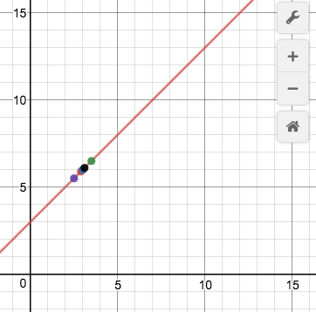 This is the graph of the function, $f(x)=x+3$. Let’s see what happens to the behavior of the function as we approach the x-value of 3 on this function from the left. We can look at a point somewhat close to x= 3 from the left, at x=2.5. In this case, the coordinate would be (2.5,5.5). But, we can do even better! What about at x=2.9? The coordinate for this point would be (2.9, 5.9). We can choose x values closer and closer to 3, without ever actually reaching it. In fact, there are an infinite number of numbers that get awfully close to the coordinate at x=3, (3,6), without ever touching it. This helps us determine the behavior of the graph as we get closer and closer to x=3 from the left. The y coordinates for x=2.5 and x=2.9 are getting closer and closer to a y value of 6, which would mean that the $\lim_{x→3-}{f(x)}=6$.

Great! We are halfway done. To find the overall limit, we must also look from at the behavior as x approaches 3 from the right. Let’s choose a number that is a bit larger than 3, x=3.5. The coordinate would be at (3.5, 6.5). If we chose an x-value a little closer, perhaps at x=3.1, our coordinate would be (3.1, 6.1). Again, as we get closer and closer to x=3, our y value is getting closer to 6. This means that the $\lim_{x→3+}{f(x)}=6$. Since the limit from the left equals the limit from the right, we know that the $\lim_{x→3}{f(x)}=6$. Again, we do not care what the actual coordinate is at x=3, just what the behavior of f(x) is from either side of x=3.

## Guided Practice

1. What does $\lim_{x→1-}{f(x)}=2$ mean? What does $\lim_{x→1+}{f(x)}=3$ mean? Does the overall limit exist?
   1. As x-values get closer and closer to the 1 from the left, the function f(x) is getting closer and closer to 2. As x-values get closer and closer to 1 from the right, the function f(x) is getting closer and closer to 3. The overall limit does not exist because the limit from the left does not equal the limit from the right!
2. The function $f\left(x\right)=x^{2}$ is shown on the right. What is the $\lim_{x→0}{f(x)}$?
   1. 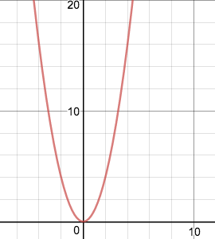To determine the limit, we would look at the behavior of the graph as we choose x-values closer and closer to x=0. First, we would have to look at the limit from the left. If we chose an x-value a bit smaller than 0, perhaps x=-.1, the y-value would be .01. If we chose an x-value to the left of x=0, but a little bit closer, perhaps x=-.001, the y value would be .00001. The y-values are getting closer and closer to 0, so $\lim_{x→0-}{f(x)}=0$. Now, we must look at it from the right. If we chose an x-value a bit larger than 0, perhaps x=.1, the y-value would be .01. If we chose an x-value still to the right of x=0, but a little bit closer, perhaps x=.001, the y-value would be .000001. The y-values are getting closer and closer to 0, so $\lim_{x→0+}{f(x)}=0$. Since the limit from the left equals the limit from the right, we know that .

## ../Desktop/Screen%20Shot%202016-11-10%20at%2010.50.25%20AM.pngLola Tries

1. What does $\lim_{x→1000+}{f(x)}=2$ mean?
2. Does the $\lim_{x→1}{f(x)}$ exist if $\lim_{x→1-}{f(x)}=3$ and $\lim_{x→1+}{f(x)}=7$?
3. What is the $\lim_{x→1}{g(x)}$? The graph of g(x) is shown on the right.

**Next Stop: Mexico**

# ../Desktop/mexico2.jpgWelcome to Mexico! *../Desktop/mexico1.jpg*

Bienviendo a Mexico!

How do I evaluate limits from a graph and a table?

Now that we understand what a limit is, it’s time to start looking at how to evaluate limits using graphs and tables. As a reminder, a limit is the behavior of a function as x approaches “a”. With this in mind, we are ready to start!

|  |  |
| --- | --- |
| x | f(x) |
| .9 | 1.09 |
| .99 | 1.99 |
| 1.1 | 2.01 |
| 1.19 | 2.1 |

What is the $\lim_{x→1}{f(x)}?$ Well, to evaluate the limit, we must look at the behavior from both sides of x= 1. As x-values get closer and closer to 1 from the left, the y-values are getting closer to 2. The same is true from the right! So we know that the $\lim_{x→1}{f(x)}=2$ because of this. That’s pretty easy right? Well, let’s look at a harder example. 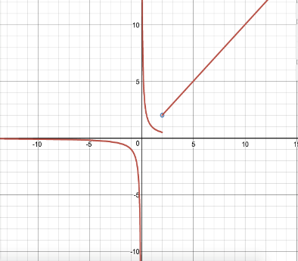

|  |  |
| --- | --- |
| x | f(x) |
| 2.5 | 2.9 |
| 2.9 | 2.999 |
| 3 | 5 |
| 3.5 | 2.999 |
| 3.9 | 2.9 |

What is the $\lim_{x→3}{f(x)}?$ At first glance, you would probably think that this limit evaluates to 5. Think again! Yes, f(x)=5, but the the $\lim_{x→3}{f(x)}=3$. This is because a limit doesn’t care about the behavior at a point, but rather the behavior around a point. As x-values get closer and closer to 3 from the left, f(x) is also getting closer and closer to 3. As x-values get closer and closer to 3 from the right, f(x) is also getting closer and closer to 3. Since the limit from the left equals the limit from the right (both of them being 3), the overall limit also equals 3.

We can use this same process when evaluating limits from graphs. Given the graph of $f(x)$ to the left, what is the $\lim_{x→2}{f(x)}?$

Looking at the graph, we see that on the left side, we see that the “j” shaped part of the curve approaches a y-value of 0.5 Looking at the right side of x = 2, we see that the linear portion of the graph *approaches* a y-value of 2, even if there is a hole at x = 2. Based upon this, we know that $\lim_{x→2}{f(x)}$ does not exist, because the limits from both sides are not equal.

## Guided Practice

1. What is the $\lim_{x→6}{f(x)}$?

|  |  |
| --- | --- |
| x | f(x) |
| 5 | 6.1 |
| 6 | 6.5 |
| 7 | 6.9 |

* 1. To determine what $\lim_{x→6}{f(x)}$ is we must look at the behavior of f(x) as it gets closer and closer to x=6 from both sides. In this case, we know that f(x)= 6.5, and that the function is linear in this portion because as the x values increase by 1, the y values increase by a constant amount, 0.4. With this information, we know that $\lim_{x→6}{f(x)}$ = f(x)= 6.5 because f(x) is getting closer and closer to 6.5 from both the left and the right of x=6.

1. What is the $\lim_{x→3}{f(x)}$?
   1. To determine what $\lim_{x→3}{f(x)}$ is we must look at the behavior of f(x) as it gets closer and closer to x=3 from both sides. From the right, the graph is continuously increasing. There is not one specific value for f(x) at x=3. Since the graph is continuously increasing in the positive direction, we can say that the $\lim_{x→3+}{f(x)}=+∞$. The limit as x approaches 3 from the right is positive infinity. Now we must look at the behavior from the left side. From the left of x=3, the graph is continuously decreasing. Since it is continuously decreasing in the negative direction, we can say that the $\lim_{x→3-}{f(x)}=-∞$. The limit as x approaches 3 from the left is negative infinity. Since the limit from the left does not equal the limit from the right, $\lim_{x→3}{f(x)}=DNE$, the limit as x approaches 3 does not exist. 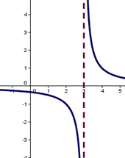

## Lola Tries

1. 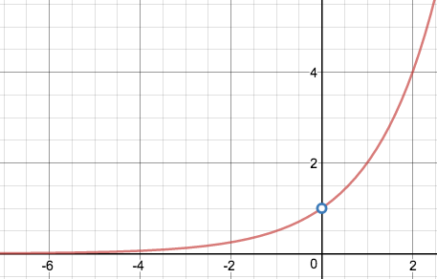On the graph to the right, what is $\lim_{x→0}{f(x)}$?
2. On the graph to the right, what is $\lim_{x→-4}{f(x)}$?
3. On the table below, what is the $\lim_{x→2}{f(x)}$?

|  |  |
| --- | --- |
| x | f(x) |
| 1.9 | 4.9 |
| 1.99 | 4.99 |
| 2 | 17 |
| 2.1 | 4.99 |

Next Stop: Costa Rica

# Welcome to Costa Rica!

Bienviendo a Costa Rica!

How do I evaluate limits algebraically? 

We have the basic skills and understanding to move into the next major part of evaluating limits: how to evaluate limits algebraically. All of previous concepts we have learned are still in play when we evaluate limits algebraically, we are just adding one more tool for evaluation.

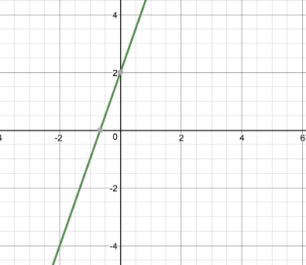 To find the limit for any continuous function, we use substitution. For example, if we have the function $f\left(x\right)=3x+2$ and we wanted to know the $\lim_{x→-2}{f(x)}$, we would simply substitute x=-2 into f(x). Therefore, $\lim_{x→-2}{f(x)}=3\left(-2\right)+2=-4$. We can see that this is in fact the case when we view the graph of f(x). If we evaluate the limit from the graph of f(x), we can see that the $\lim_{x→-2}{f(x)}$ is indeed, -4. There are two major exceptions to the substitution rule. The first exception is when substitution yields $\frac{C}{0}$, where c is any constant. We will get to this exception in a later section!

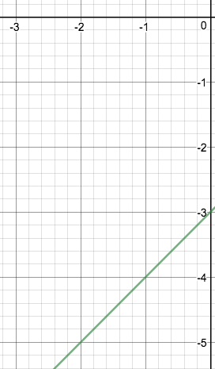 The second exception is when substitution yields the indeterminate form, $\frac{0}{0}$. In this case, we will need to change the form of the function using various algebraic techniques in order to evaluate it. For example, if we had the function $f\left(x\right)=\frac{x^{2}-x-6}{x+2}$, and if we wanted to know the $\lim_{x→-2}{f(x)}$, we would first use substitution: $\lim_{x→-2}{f\left(x\right)=}\frac{{(-2)}^{2}+2-6}{-2+2}=\frac{0}{0}$. We now must use algebraic techniques to manipulate the function into something that we can work with. Since the top is a quadratic function, a good first step may be to factor it. $x^{2}-x-6=(x-3)(x+2)$. We can change the numerator to this, so that we now have $\lim_{x→-2}{f\left(x\right)=}\frac{(x+2)(x-3)}{(x+2)}$. Since there is a (x+2) on both the top and the bottom, we can cancel, so that we have $\lim_{x→-2}{f\left(x\right)=}x-3$. Finally, we can substitute -2 in for x to evaluate the limit. $\lim_{x→-2}{f\left(x\right)=}x-3=-2-3=-5$. We can see from the graph of the function that $\lim_{x→-2}{f\left(x\right)=}-5$.

## Guided Practice

1. What is the $\lim_{x→0}{(\frac{1}{x}-\frac{1}{x^{2}+x})}$?
   1. The first thing one should try doing is substitution. With substitution we yield $\lim_{x→0}\left(\frac{1}{0}-\frac{1}{{\left(0\right)}^{2}+0}\right)=\frac{1}{0}-\frac{1}{0}=\frac{0}{0}$. Since we got the indeterminate form, we know we must use some algebraic manipulation to successfully solve the limit. The first thing to do is factor the quadratic in the denominator of the second fraction. We would then have $\lim_{x→0}{(\frac{1}{x}-\frac{1}{x(x+1)})}$. Now, we can try to combine the two fractions into one. We need to have a common denominator. The common denominator can be (x)(x+1). The first fraction is missing an x+1, so we would multiply the numerator and denominator of the first fraction by x+1 to get $\lim_{x→0}\left(\frac{x+1}{x\left(x+1\right)}-\frac{1}{x\left(x+1\right)}\right)=\frac{x+1-1}{x(x+1)}=\frac{x}{x(x+1)}$. Since we have an x on both the numerator and denominator, we can cancel them to get $\lim_{x→0}{(\frac{1}{x+1})}$. We have algebraically manipulated the limit so that we are finally able to use substitution. Now we can substitute 0 for x to get $\lim_{x→0}\left(\frac{1}{x+1}\right)=\frac{1}{0+1}=1$. So the $\lim_{x→0}{(\frac{1}{x}-\frac{1}{x^{2}+x})}=1$.
2. What is the $\lim_{x→0}{{(27.5x)}^{2}-0}$?
   1. The first thing one should try is substitution. With substitution we yield $\lim_{x→0}{{(27.5(0))}^{2}-0}$ = 0. Since substitution worked, we are done! $\lim_{x→0}{{(27.5x)}^{2}-0}$ =0!

## Lola Tries

1. What is the $\lim_{x→7}{(x^{2}+212)}$?
2. What is the $\lim_{x→4}\left(\frac{\sqrt{x}-2}{(x-4}\right)$?
3. What is the $\lim_{x→11}\left(\frac{x-4}{2x+1}\right)$

Next Stop: Panama

# Welcome to Panama!

La bienvenida a Panamá!

How do I use limits to determine vertical asymptotes? 



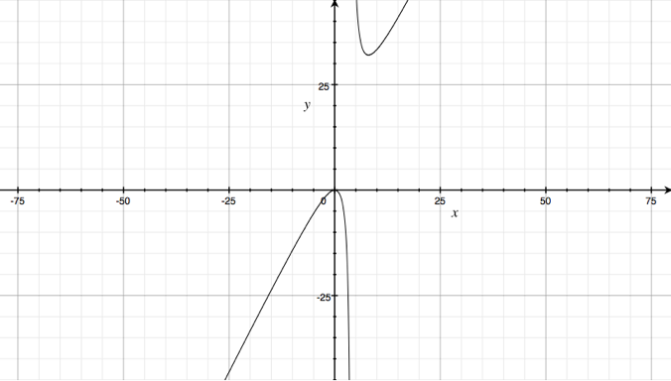 The first exception to using substitution is when substitution yields $\frac{C}{0}$, where c is any constant. Any limit resulting in $\frac{C}{0}$ will have a limit equal to $±∞$ or DNE. For example, if we had a function, $f\left(x\right)=\frac{2x^{2}}{x-4}$ and we wanted to know the $\lim_{x→4}{f(x)}$, we would first try to use substitution. $\lim_{x→4}{f(x)}=\frac{2{(4)}^{2}}{4-4}=\frac{32}{0}=\frac{c}{0}$. Since substitution did not work, we would look at the limit from either side of x=4. To evaluate the limit from the left of x=4, we would plug in a number that is a bit smaller than x=4. We would indicate this by $4^{-}$. We would then see if the numerator is positive or negative if we plugged in a number a bit smaller than 4. Then we would see if the denominator is positive or negative if we plugged in a number a bit smaller than 4. Lastly, we would see if the overall limit from the left is positive or negative. If the limit is negative, then the $\lim_{x→4-}{f(x)}=-∞$. If the limit is positive, then the $\lim_{x→4-}{f\left(x\right)=+∞}$.Now we are ready to evaluate the limit from the left: $\lim_{x→4-}{f(x)}=\frac{2{(4^{-})}^{2}}{4^{-}-4}=\frac{+}{-}=-∞$. When we substituted a number smaller than -4, we yielded a positive numerator and negative denominator. Since a positive divided by a negative is a negative, we know that the $\lim_{x→4-}{f(x)}=-∞$. Great! We are now halfway done. In order to evaluate the overall limit, we must look at the limit from both sides. We will now look at the limit as x approaches 4 from the right. To evaluate the limit from the left of x=4, we would plug in a number that is a bit larger than x=4. We would indicate this by $4^{+}$. We would then follow the same steps that we did when evaluating the limit from the left. The limit as x approaches 4 from the right: $\lim_{x→4+}{f(x)}=\frac{2{(4^{+})}^{2}}{4^{+}-4}=\frac{+}{+}=+∞$. Now that we know the limit from both the left and the right side, we can determine the overall limit. Since the limit as x approaches -4 from the left is $-∞$ and the limit as x approaches -4 from the right is $+∞$, the overall limit does not exist, as the limit from the left does not match the limit from the right. If we were to evaluate the limit from the graph of f(x) as we did in the last section, we would see that $\lim_{x→4}{f(x)}=DNE$.

## Guided Practice

1. What is the $\lim_{x→1}{(\frac{1}{x-1})}$?
   1. The first thing one should try doing is substitution. With substitution we yield $\lim_{x→1}{(\frac{1}{1-1})}=\frac{1}{0}=\frac{c}{0}$. Since we got a constant over 0, we know that the limit will evaluate to $±∞$ or DNE. This is an indication that we must look at the limit from both sides. The limit from the left: The limit from the right: $\lim_{x→1+}{(\frac{1}{1^{+}-1})}=\frac{+}{+}=+∞$. Since the limit from the left does not equal the limit from the right, the overall limit does not exist. So $\lim_{x→1}{(\frac{1}{x-1})}=DNE$
2. What is the $\lim_{x→3000}{(\frac{453.22+x}{3000-x})}$?
   1. The first thing one should try doing is substitution. With substitution we yield $\lim_{x→3000}\left(\frac{453.22+x}{3000-x}\right)=\frac{3453.22}{0}=\frac{c}{0}$. Since we get a constant over 0, we know the limit will evaluate to $±∞$ or DNE. This is an indication that we must look at the limit from both sides. The limit from the left . The limit from the right: $\lim_{x→3000+}\left(\frac{453.22+x}{3000-x}\right)=\frac{+}{-}=-∞$. Since the limit from the left does not equal the limit from the right, the overall limit does not exist. So $\lim_{x→3000}\left(\frac{453.22+x}{3000-x}\right)=DNE$

## Lola Tries

1. What is the $\lim_{x→5}\left(\frac{x-12}{{\left(x-5\right)}^{2}}\right)$?
2. What is the $\lim_{x→0}\left(\frac{cos⁡x}{\sin{x }}\right)$?
3. What is the $\lim_{x→2}\left(\frac{{(188,000x)}^{2}}{2-x}\right)$?

Next Stop: Brazil

# Welcome to Brazil!

Bem vindo ao Brazil!

What are limit laws?

There are laws for limits?! Absolutely! What are they? Limit laws are essentially shortcuts to evaluate certain limits. The first four limit laws have to do with limits of two functions. Let’s dive right in!

1. Suppose that c is a constant and the limits $\lim_{x→a}{f\left(x\right)}$ and $\lim_{x→a}{g\left(x\right)}$ exist, then $\lim_{x→a}{[f\left(x\right)+g\left(x\right)]}= \lim_{x→a}{f\left(x\right)}+\lim_{x→a}{g\left(x\right)}$
   * If we are to take the limit of f(x) plus g(x) approaching “a”, then we are able to evaluate the limit as f(x) approaches “a” and g(x) approaches “a”, separately, and simply add them together.
 $\lim_{x→a}{[f\left(x\right)-g\left(x\right)]}= \lim_{x→a}{f\left(x\right)}-\lim_{x→a}{g\left(x\right)}$  * If we are to take the limit of f(x) minus g(x) approaching “a”, then we are able to evaluate the limit as f(x) approaches “a” and g(x) approaches “a”, separately, and simply subtract them.
 $\lim_{x→a}{[f\left(x\right)g\left(x\right)]}= \lim_{x→a}{f\left(x\right)}×\lim_{x→a}{g\left(x\right)}$  * If we are to take the limit of f(x) times g(x) approaching “a”, then we are able to evaluate the limit as f(x) approaches “a” and g(x) approaches “a”, separately, and simply multiply them together.
 $\lim_{x→a}{\frac{f(x)}{g(x)}}= \frac{\lim_{x→a}{f\left(x\right)}}{\lim_{x→a}{g\left(x\right)}}$  * If we are to take the limit of f(x) times g(x) approaching “a”, then we are able to evaluate the limit as f(x) approaches “a” and g(x) approaches “a”, separately, and simply divide them.

The next seven limit laws deal with other limit situations, but we keep the assumption that c is a constant.

* + If we are to take the limit of f(x) as it approaches “a”, but f(x) is multiplied by some constant, we can take the constant out and evaluate the limit of f(x) as it approaches “a” normally, but multiply the limit by the constant at the end.
 $\lim_{x→a}{ {\left[f\left(x\right)\right]}^{n}}= {[ \lim_{x→a}{f\left(x\right)]}}^{n}$

 + If we are to take the limit of f(x) as it approaches “a”, but it is raised to the nth power, we can simply take the limit of f(x) as it approaches “a” normally, and then raise our result to the nth power. In this situation, it is important to remember that n must be a positive integer.
 $\lim_{x→a}{c}= c$

 + The limit of any constant as it approaches “a” is just the value of that constant.
 $\lim_{x→a}{x }= a$

 + The limit of the function, y=x, as it approaches “a”, is just the value of “a”, the value that the function is approaching.
 $\lim_{x→a}{x^{n} }= a^{n}$

 + The limit of the function, x raised to the nth power, as it approaches “a”, is just “a” raised to the nth power. Again, we must remember that n will have to be a positive integer.
 $\lim_{x→a}{\sqrt[n]{x}}= \sqrt[n]{a}$

 + The limit of the function, the nth root of x, as it approaches “a”, is just the nth root of “a”. Not only does n have to be a positive integer, if it is even, we must assume that a>0.
 $\lim_{x→a}{\sqrt[n]{f(x)}}= \sqrt[n]{\lim_{n→a}{f(x)}}$

 + If we are to find the limit of the function, the nth root of f(x), as it approaches “a”, we find the limit as f(x) approaches “a” like normal, and then take the nth root of our result.

## Guided Practice

1. 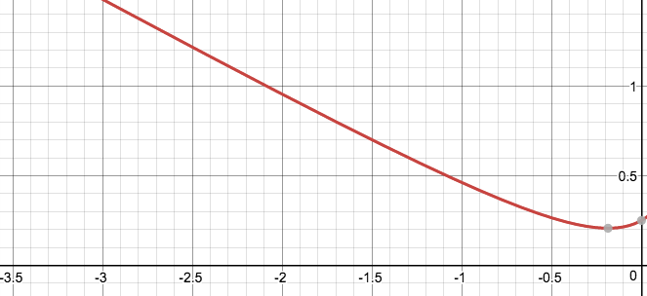What is $\lim_{x→-2}{\frac{5x^{2}+1}{4-9x}}$?
   1. The first thing we can do is identify that this would be a situation in which we could use limit laws, even though it may not look like it! We can define the numerator as f(x), and the denominator as g(x). Now we know we can use limit law #4 to evaluate this situation. We first take the limit of the numerator. We can simply use substitution in this situation. $5{(-2)}^{2}+1$ = 21. Next we take the limit of the denominator, using substitution. $4-9\left(-2\right)=22$. We can determine the overall limit now. We take the limit of the numerator (21) and divide it by the limit of the denominator (22) to get the overall limit as 21/22. So, $\lim_{x→-2}{\frac{5x^{2}+1}{4-9x}}= \frac{21}{22}$!
2. If we know that the limit of f(x) as it approaches 2 is 5 and the limit of g(x) as it approaches 2 is 2, what is $\lim_{x→2}{[{\left(f\left(x\right)\right)}^{2}+x {(g\left(x\right))}^{2}}$?
   1. In this situation, there are multiple limit laws going on! We know that when we are taking the limit of two functions added together, we can look at them as separate limits and then just add them together according to limit law #1. So let’s focus on the first function, f(x). Limit law #6 tells us that we can simply take the limit of f(x) as it approaches 2 first, then square it. We know that the limit of f(x) as it approaches 2 is 5, and if we square that it is 25. Great! We can now look at the g(x) part. In this situation, x is multiplied by g(x) squared. x is a constant because it is just an x-value. In this situation, x would be 2 because we are approaching 2 for our limit. Using limit law #5, we know we can simply multiply this constant by the limit of g(x) squared as it approaches 2. Since g(x) is squared, we must use limit law #6 again and take the limit of g(x) as it approaches 2 separately and then raise it to the second power. The limit of g(x) as it approaches 2 is 2, and if we square that it is 4. We must remember to also multiply that by the constant, 2. So the limit for that section of the overall limit is 8. When we take the limit of two functions added together, we simply add the component limits. The first section gave us 25 and the second section gave us 8, so 25+8 = 31. So, $\lim_{x→2}{[{\left(f\left(x\right)\right)}^{2}+x {(g\left(x\right))}^{2}}=31$.

## Lola Tries

1. Let $\lim_{x→-8}{f(x)}=8$ and $\lim_{x→-8}{g(x)}=-1$. What is $\lim_{x→-8}{\frac{-8f\left(x\right)-7g(x)}{g\left(x\right)-4}}$?
2. What is the $\lim_{x→10}{\sqrt{4x+49}}$?
3. What is the $\lim_{x→2}{3x^{3}-2x+4}$?

Next Stop: Peru

# Welcome to Peru!

La bienvenida a Perú!

How do I use limits to determine horizontal asymptotes?

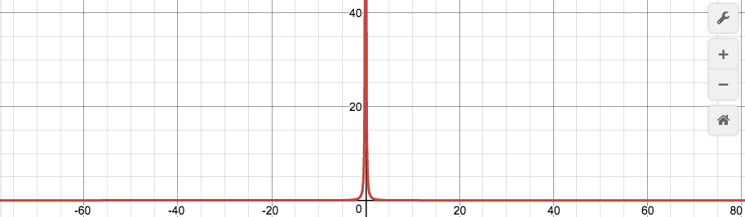Before we can use limits to determine horizontal asymptotes, we must first understand what a horizontal asymptote is! A horizontal asymptote exists if $\lim_{x→∞}{f(x)}=L$ or $\lim_{x→-∞}{f(x)}=L$, where L is just a constant. On the graph to the right, $f\left(x\right)=\frac{1}{x^{2}}$, a horizontal asymptote exists at y=0, because as the x values get closer and closer to infinity and negative infinity, the y-value gets closer and closer to 0, as the denominator is getting smaller and smaller.

Now we are ready to use limits! There is an important theorem to remember when using limits to determine horizontal asymptotes. If r>0 and r is a rational number, then $\lim_{x→∞}{\frac{1}{x^{r}}=0}$ and $\lim_{x→-∞}{\frac{1}{x^{r}}=0}$. This can be especially useful in determining limits to infinity for fractions, as we can multiply the numerator and denominator by 1 over x raised to the highest power, and a lot of the components of the limit will go to zero.

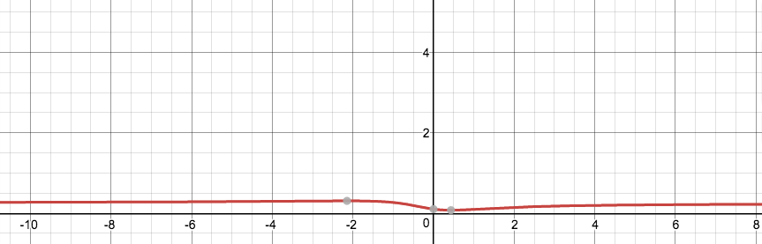For example, if we wanted to evaluate the following limit; $\lim_{x→∞}{\frac{2x^{2}-x+1}{8x^{2}+3x+500}}$, we would start by identifying the highest power. The highest power in this limit is 2. So we would multiply both the numerator and denominator by $\frac{1}{x^{2}}$. We can start by dividing each component of the polynomial in the numerator by $x^{2}$. $\frac{{2x}^{2}}{x^{2}}=2$, $\frac{x}{x^{2}}=0$, as there is a higher power on the denominator than the numerator, and $\frac{1}{x^{2}.}=0$, for the same reasoning as the previous component. So on the numerator, we are left with only a 2. We would do this same process on the denominator. $\frac{8x^{2}}{x^{2}}=8$, $\frac{3x}{x^{2}}=0$, and $\frac{500}{x^{2}}=0$. So on the denominator, we are left with only 8. We are left with the fraction $\frac{2}{8}=\frac{1}{4}$. Therefore, $\lim_{x→∞}{\frac{2x^{2}-x+1}{8x^{2}+3x+500}}=\frac{1}{4}$. We can see this by examining the graph to the left. As the x values get larger and larger towards infinity, the y values are getting closer and closer to ½ .

## Guided Practice

1. What is the $\lim_{x→∞}{\frac{\sqrt{4x^{4}-10x^{3}+1000}}{30x^{2}-4x}}$?
   1. First, we must identify the highest power in the whole fraction. The highest power is $x^{2}.$ Therefore, we would multiply both the numerator and denominator by $\frac{1}{x^{2}}.$ When multiplying it to the numerator, we must multiply it by $\frac{1}{x^{4}}$, as it’s being multiplied under square root, and $\sqrt{\frac{1}{x^{4}}}=\frac{1}{x^{2}}$. We would multiply $\frac{1}{x^{4}}$ to every component of the polynomial under the square root. In doing so, we would only be left with the $\sqrt{4}=2$ on the numerator, because $x^{4}$ is a higher power than $x^{3}$, or a constant, so those two limits would go to zero, and $\frac{4x^{4}}{x^{2}}=4$, but we have to take the square root of 4, which is 2. Then, we would multiply $\frac{1}{x^{2}}$ to the denominator, to get just 30 on the denominator, because $x^{2}$ is a higher power than just x, and so that limit would go to zero, and $\frac{30x^{2}}{x^{2}}=30$. Thus, our overall limit would go to $\frac{2}{30}=\frac{1}{15}$. Thus $\lim_{x→∞}{\frac{\sqrt{4x^{4}-10x^{3}+1000}}{30x^{2}-4x}}=\frac{1}{15}.$
2. What is $\lim_{x→∞}{\sqrt{25x^{2}+8x}-5x}$?
   1. Though this does not look like a fraction right now, we can easily make it one by multiplying by a conjugate on both the numerator and denominator. In this case, the denominator is 1. Once we multiply by a conjugate ($\sqrt{25x^{2}+8x}+5x$) and simplify on the numerator, we are left with $\lim_{x→∞}{\frac{8x}{\sqrt{25x^{2}+8x}+5x}}$. The highest power in this instance would be $\frac{1}{x}$. We must multiply $\frac{1}{x}$ to both the numerator and denominator. When we multiply it to the numerator, we get $\frac{8x}{x}=8$. On the denominator, we must multiply the inside of the radical by $\frac{1}{x^{2}}$, as $\sqrt{\frac{1}{x^{2}}}=\frac{1}{x}$. Once we do so, we get a $\sqrt{25}=5$ from the piece of the denominator inside of the radical, as $x^{2}$ is a higher power than x, and so that limit goes to zero, and $\frac{25x^{2}}{x^{2}}=25$, but we have to take the square root of 25, which is 5. Lastly, we take care of the 5x that is added outside of the radical. We multiply this by $\frac{1}{x}$ to get 5, as $\frac{5x}{x}=5$. So we are left with an 8 on the numerator and a 5+5=10 on the denominator, so our overall limit evaluates to $\frac{8}{10}=\frac{4}{5}$. Thus, $\lim_{x→∞}{\sqrt{25x^{2}+8x}-5x}=\frac{4}{5}$.

## Lola Tries

1. What is $\lim_{x→∞}{\frac{\sqrt{x^{12}+5x}-3x^{4}}{20x^{4}+8x^{2}-x}}$?
2. What is $\lim_{x→∞}{\frac{2x^{2}+4x}{x^{2}-x-6}}$?
3. What is $\lim_{x→∞}{\frac{7x^{1/2}+8x^{2/3}}{{5x}^{3/5}-15x^{4/9}}}$?

Next Stop: Argentina

# Welcome to Argentina!

La bienvenida a la Argentina!

How can I use limits to prove continuity at a point?

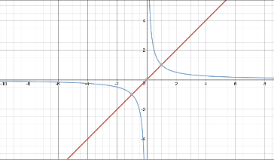A function is continuous when $\lim_{x→a}{f\left(x\right)=f(a)}$. In other words, a function is continuous at a given point, “a”, when the left-hand limit is equal to the right-hand limit and is equal to the value of the function at this point. For instance, the function $f\left(x\right)=x$, graphed in red on the right, is continuous, as there are no “breaks” in the function. The function $f\left(x\right)=\frac{1}{x}$, graphed in blue, is not at x=0 continuous, as there is a “break” at this point and the graph is separated into two different parts. There is a three-step proof in order to prove continuity at a point:

1. f(a) is defined
   * The original point must first exist before we can prove continuity! We know that f(a) is defined if “a” is in the function, f’s, domain. If f(a) did not exist, the right hand part of our definition for continuity ($\lim_{x→a}{f\left(x\right)=f(a)}$) would not work.
2. $\lim_{x→a}{f\left(x\right)}$ exists
   * We must then prove that the limit exists. In order to prove that the limit as f(x) approaches “a” exists if the limit from the left side equals the limit from the right side. If $\lim_{x→a}{f\left(x\right)}$ did not exist, the left hand part of our definition for continuity ($\lim_{x→a}{f\left(x\right)=f(a)}$) would not work.
$\lim_{x→a}{f\left(x\right)=f\left(a\right)}$

3. * We must check if the value of f(a) from step #1 equals the limit as f(x) approaches “a”. If so, we have proven that f(x) is continuous at x=a.

For example, if $f\left(x\right)=\left\{\begin{aligned}x^{2}+3x-2 ;x≥-2 \\ -x^{2};x<-2\end{aligned}\right.$, is f(x) continuous at x=-2? First, we must check if f(-2) exists, and what that value is. We know to use the top function because that piece of the function is defined when x is greater than or equal to -2. Thus, plugging in x=-2, we find that $f\left(-2\right)=-4$.

Now we must check if the limit exists, and if so, what the value is! The limit as x approaches -2 from the right is -4. The first piece of the piecewise function is when x is greater than or equal to 2, so we use this value for the limit as well; therefore, $\lim_{x→-2-}{f(x)}=-{\left(-2\right)}^{2}=-4$. Since the limit from the left equals the limit from the right, the overall limit exists at -4.

Since $\lim_{x→-2}{f\left(x\right)=f(-2)}$, both yield a y value of -4, f(x) is continuous at x=-2!

## Guided Practice

1. If $g\left(x\right)=\left\{\begin{aligned}x^{2}-3 ;x≥1 \\ 1-2x;x<1\end{aligned}\right.$, is g(x) continuous at x=1
   1. First, we would find the value of g(x) at x=1, using the top part of the piecewise function. Using substitution, we find that g(1)= -2
   2. We know the limit as g(x) approaches 1 from the right is -2, as we would substitute 1 into the top part of the piecewise function as we did in part a. Now we must find the limit from the left, substituting 1 into the bottom part of the piecewise function. $\lim_{x→1-}{g(x)}=-1$. Since the limit from the left does not equal the limit from the right, we can stop there because the right hand side of the definition of continuity is not met. Therefore, g(x) is not continuous at x=1.
2. For $f\left(x\right)=\left\{\begin{aligned}cx^{2}-3 ;x≤2 \\ cx+2;x>2\end{aligned}\right.$, find a value of c to make f continuous at x=2.
   1. To solve this, we must understand that in order for continuity to occur, the limit from the left and the right must match and f(a) must exist. For the limits to match however, $cx^{2}-3=cx+2$. Using this piece of knowledge, we can solve for c. We know x=2, so $c{(2)}^{2}-3=c\left(2\right)+2→4c-3=2c+2→2c=5→c=5/2$. Thus, c must equal 5/2 for f(x) to be continuous at x=2.

## Lola Tries

1. If $f\left(x\right)=\left\{\begin{aligned}\frac{x-4}{x^{2}-16};x≠4 \\ \frac{1}{3x-4};x=4\end{aligned}\right.$; is f(x) continuous at x=4?
2. Find the values of a and b to make the function continuous: $N\left(x\right)=\left\{\begin{aligned}3{ax}^{2}-4ax+5;x<-2 \\ x^{2}+3x-1;x=-2 \\ -bx^{2}+6x-b;x>-2\end{aligned}\right.$
3. If $f\left(x\right)=\left\{\begin{aligned}\frac{x^{2}-5x-14}{x-2};x≠2 \\ 12 ;x=2\end{aligned}\right.$ is f(x) continuous at x=2?

Next Stop: South Africa

# Welcome to South Africa!

Ukuwamukela eNingizimu Afrikha!

How do I identify different types of discontinuty?

Now that we know when a function is continuous, it is important to explore when and how a function is discontinuous! There are three major ways that a function can be discontinuous.

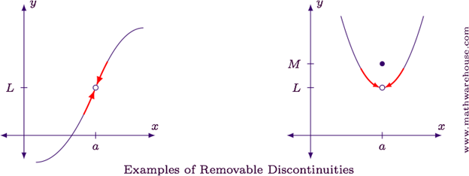The first type of discontinuity is removable discontinuity. Removable discontinuity occurs at holes. In the example shown on the right, there is a hole on both graphs at x=a. In these cases, the limit as x approaches “a” always exists, but it’s discontinuous because f(a) either doesn’t exist, as shown on the graph to the left, or the limit as x approaches “a” does not match the point at x=a, as shown on the graph to the right! A hole exists when the limit as x approaches “a” upon substitution yields $\frac{0}{0}$.

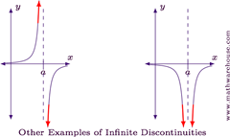The second type of discontinuity is infinite discontinuity. Infinite discontinuity occurs where there is a vertical asymptote. A limit may or may not exist depending on the situation, but f(a) never exists. With infinite discontinuity, either the limit as x approaches “a” from the right, left, or both, must be $±∞$. In the example to the left, there is infinite discontinuity in both graphs at x=a because a vertical asymptote exists and the limit as x approaches “a” for both graphs is $±∞$. In the graph to the left, a limit does not exist because one side of the graph goes towards $∞$ and the other side goes towards $-∞$ at x=a. In the graph to the right, a limit does exist because both sides of the graph are going towards $-∞$. We know that infinite discontinuity exists when the limit as x approaches “a” upon substitution yields $\frac{c}{0}$.

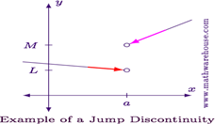The last type of discontinuity is jump discontinuity. Jump discontinuity exists when the limit as x approaches “a” from the right does not equal the limit as x approaches “a” from the left. In other words, the limit as x approaches “a” does not exist. There may or may not be a point at x=a, depending on the situation. In the example shown to the right, jump discontinuity exists because the limit does not exist at x=a. Be wary though, do not get this confused with infinite discontinuity. Sometimes in infinite discontinuity, the limit does not exist either, however with infinite discontinuity, there is always a vertical asymptote.

## Guided Practice

1. Let’s revisit question #1 from our guided practice in the last section. $g\left(x\right)=\left\{\begin{aligned}x^{2}-3 ;x≥1 \\ 1-2x;x<1\end{aligned}\right.$ We found in the last section that g(x) is discontinuous at x=1, but what kind of discontinuity is it?
   1. 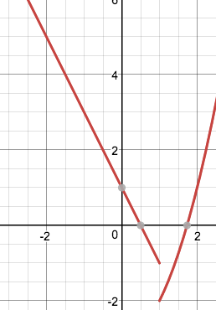We found that the limit as x approaches 1 from the left does not equal the limit as x approaches 1 from the right. That eliminates removable discontinuity, because in removable discontinuity, the limit always exists. We are then left with jump discontinuity and infinite discontinuity. With infinite discontinuity, either the limit from the left or the limit from the right must be $±∞$. The limit from the right was -2 and the limit from the left was -1, neither of which is $±∞$. Using process off elimination, we can conclude that it is jump discontinuity.
2. 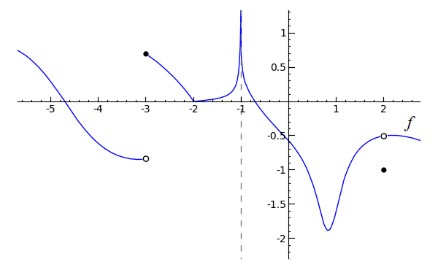Using the graph to the right, f(x), state the x values f(x) is discontinuous, the type of discontinuity, and explain why.
   1. x=-3, jump discontinuity, as the limit from the left does not equal the limit from the right, and neither the limit from the left nor from the right is approaching positive or negative infinity.
   2. x=1, infinite discontinuity, as the limit from both sides is approaching positive infinity.
   3. x=2, removable discontinuity, as f(2) does not match the limit at that point.

## Lola Tries

1. 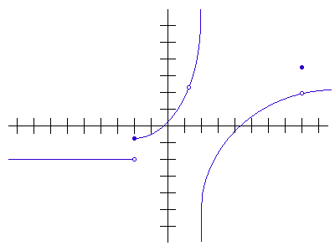What type of discontinuity, if any, exists for the function, $f\left(x\right)=\left\{\begin{aligned}\frac{1}{x};x<0 \\ x^{2};x≥0\end{aligned}\right.$ at x=0?
2. For the graph to the right, f(x), state the x-values at which f is discontinuous and the type of discontinuity.
3. For the function $f\left(x\right)=\left\{\begin{aligned}x^{2};x≤1 \\ x^{2}-2x-1;1<x<3 \\ 4;x≥3\end{aligned}\right.$ at what x values, if any does discontinuity occur, and what type?

Next Stop: Madagascar

# Welcome to Madagascar!

Welcome to Madagasikara!

What is the Intermediate Value Theorem?

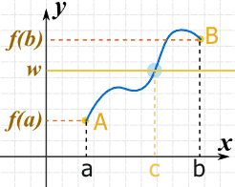

The Intermediate Value Theorem tells us that if we are given a continuous function f defined on the closed interval [a,b], for any real number d between f(a) and f(b) there exists a point c between a and b such that f(c)=d. If we look at the graph on the right, we can see the Intermediate Value Theorem in action.

The graph shoes a continuous function, f. We know that the function is continuous because there are no “breaks” in the graph. We also have a closed interval [a,b], because the graph starts at a, and ends at b. and the point (a, f(a)) exists, and so does the point (b, f(b)). In between the x-values a and b, there is an x-value, c, in which f(c), which is defined as w on the graph, exists.

Imagine you and your friend want to stretch a single piece of rope from North Carolina to California. In order to do so, the rope has to travel through other states like Kansas, Nevada, etc. It can’t just magically appear in California, because it is a continuous piece of rope. Similarly, with the Intermediate Value Theorem, if you want to go from point a to point b, you must first pass through a point in the middle, point c.

The Intermediate Value Theorem is especially useful in finding whether a continuous function has a zero, or if a certain y-value exists on an interval.

For example, if we had the function $f\left(x\right)={(sinx)}^{3}-cosx$, will the function have a zero on the interval $[0, \frac{π}{2}]$? We can use Intermediate Value Theorem to easily solve this problem. We know that the function is continuous, as both the sine and cosine functions are continuous. Then, we can find the y-values of our endpoints. $f\left(0\right)=0^{3}-1=-1$, $f\left(\frac{π}{2}\right)=1^{3}-0=1$. We know that zero is between -1 and 1, and the graph is continuous, so there is a point on the graph in which f(c)=0! Therefore, by IVT, since f(0)<0<f($\frac{π}{2}$) , there exists a “c” such that 0<c< $\frac{π}{2}$, where f(c)=0. In other words, there is a place in the function, on the specified interval, where f(c)=0.

## Guided Practice

1. Determine if your oven is at 350°, as it cools down before turning it off, at some instant must its temperature be exactly 170°?
   1. We know that temperature is a continuous function, as it decreases slowly and fairly steadily. It will turn off at room temperature, which is approximately 70°. Temperature is a function of time. We can define time “0” as when the oven begins to cool off. Time is infinite, so the interval begins at 0, and ends at “infinity.” Now, we have enough information to solve the problem. Since temperature is a continuous function, there exists a time “c” such that $0<c<∞$, and f(c)=170, because 70<170<350. The temperature we seek is between the temperature the oven starts at, and room temperature. The time at which the oven is 170° is between time 0, and infinite time, therefore IVT would apply.
2. Let h(x) be defined by $h\left(x\right)=\left\{\begin{aligned}x^{2}+1 ;-3≤x≤0 \\ -1-x^{2} ;0<x≤2\end{aligned}\right.$ on the interval [-3,2]. Is there a place in this interval where h(x)=0?
   1. We have a closed interval, but in order for this to be an IVT problem, we must first check if the graph is continuous. Since it is a piecewise function, we must check if the function is continuous at the break points. There is a break point at x=0. Using substitution on the first piece of the piecewise function, we get h(x)=1. Using substitution on the second piece of the piecewise function, we get h(x)=-1. Since 1 and -1 do not meet, the function is not continuous, therefore IVT would not apply. There is not guaranteed to be a place on the defined interval in which h(x)=0, because the function is not continuous.

## Lola Tries

1. If $f\left(x\right)=x^{5}-4x^{2}+1$ on the interval [1,2] is there a place between x=1 and x=2 where f(x)=0?
2. Does $g\left(t\right)=\frac{t}{t+1}$ take on the value 0.4999 for some t in [0,1]?
3. Does a root exist on the interval [0, $\frac{π}{2}$] for the function $y=cosx-x$?

Next Stop: Kenya

# Image result for kenyaImage result for nairobi national parkWelcome to Kenya!

Karibu Kenya!

What is a derivative and the limit definition of a derivative?

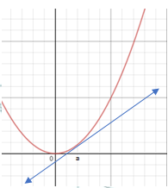Imagine a linear function, such as $f(x) = 3x + 2$. What is the slope of this function? Well, we can determine that in several ways, whether it is the slope equation ($\frac{Δy}{Δx})$, from the graph of the line, or the “m” value, as this function is in y-intercept form.

Now consider a nonlinear function, $f(x)$, shown to the right- what is its slope?

Since it is not a straight line, there is a different slope at every point along the function. How then would we find the slope at a specific point? One approach is to draw a straight line tangent to a given point, say, x = a. because we already know how to determine the slope of a straight line.

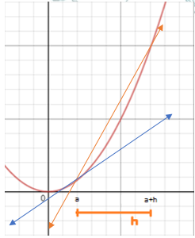Now all we have to do is determine the slope of this tangent line. It would be $\frac{Δy}{Δx}=\frac{f(a) - f(a)}{a - a}$. But wait a second- that would yield $\frac{0}{0}$! Therefore, in order to use this slope equation, we need more points.  
Although it won’t be exact, we can approximate the slope at a given point using a secant line, which is drawn between two points, say at our original point, at $x =a$, and a point $h$ units away horizontally, at $x = a+h$. This would mean that our slope becomes $\frac{f(a+h) - f(a)}{(a+h) - a}=\frac{f(a+h) - f(a)}{h}$.

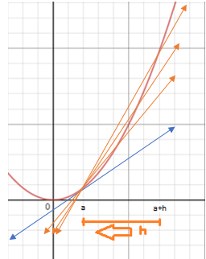However, we want to be as accurate as possible when determining the slope at a given point. Thus, we must move our secant line a little closer to the tangent line, by reducing the value of $h$, and effectively bringing the point $a + h$ closer to a.

Technically, we could bring $a + h$ closer to $a$ for eternity! But that would take a little too long on the AP Exam.Instead, we can represent this mathematically as $\lim_{h→0}$, because we reduce $h$ further and further to bring $a + h$ closer to $a$. If we make $h$ smaller and smaller, approaching 0, this also means that our secant line approaches the tangent line. Thus, determining $\lim_{h→0}\frac{f(a+h) - f(a)}{h}$ is the same thing as determining the slope for the tangent line at a given point- or as we’ll call it from now on, **the derivative!**

Now we can formally define that the limit definition of a derivative allows us to the instantaneous rate of change along a curve- i.e., the slope at a given point. Furthermore, we can notate this in two different ways; Newtonian notation and Leibnitz notation.

**Newtonian notation**: $f'(a)=\lim_{h→0}{\frac{f(a+h)-f(a)}{h}}$  
**Leibnitz notation: $\frac{dy}{dx}|_{x=a}=\lim_{h→0}{\frac{f(a+h)-f(a)}{h}}$**

Let’s take a look at an example. Given a nonlinear curve like $f(x) = x^{2}$, what is the instantaneous slope at x = 1? I.e., what is $f'(1)$? Now it's easy to figure this out using the limit definition of a derivative! Based upon this definition, we can solve for $f'(1)$.

$$f'(1)=\lim_{h→0}{\frac{f(1+h)-f(1)}{h}}=\lim_{h→0}{\frac{[{(1+h)}^{2}]-[1^{2}]}{h}}=$$

$$\lim_{h→0}\frac{\left(1+2h+h^{2}\right)-1}{h}=\lim_{h→0}\frac{h^{2}+2h}{h}=$$

$$\lim_{h→0}\frac{h(h+2)}{h}=\lim_{h→0}(h+2)=2$$

So, to recap- *we just figured out the slope at a* ***specific*** *point on a* ***nonlinear curve****!* But we can go even farther. Imagine that you wanted to find the slope at multiple points, say, at $x = -2, -1, 0, 1, 2$ on a more complex curve, like $f\left(x\right)=x^{2}+x-1$. With our new limit definition of a derivative, this might seem like a piece of cake at first- but it soon becomes difficult to quickly solve for all of these points! Instead, there is a better way- we can define a **derivative function**, which will tell us the derivative at any x value along the curve. How can we do this? Simply plug in “x”, representing any x-coordinate on our curve, into the limit definition of a derivative. $$f^{'}\left(x\right)=\lim_{h→0}\frac{f\left(x+h\right)- f\left(x\right)}{h}=\lim_{h→0}\frac{[(x+h)^{2}+(x+h)-1] - [x^{2}+x-1]}{h}=\lim_{h→0}\frac{\left[\left(x^{2}+2xh+h^{2}\right)+x+h-1\right]- \left[x^{2}+x-1\right]}{h}=\lim_{h→0}\frac{x^{2}-x^{2}+2xh+h^{2}+x-x+h-1+1}{h}=\lim_{h→0}\frac{h^{2}+h+2xh}{h}=\lim_{h→0}\frac{h\left(h+1+2x\right)}{h}=\lim_{h→0}(h+1+2x)=2x+1$$

Thus, $f'(x) =2x+1$, and this will gives us the slope of $f(x)=x^{2}+x-1$ at any point! This saves us tons of time- let’s try plugging in those points from earlier! $$f'(-2)=2(-2)+1=-3 \\ f'(-1)=2(-1)+1=-1 \\ f'(0)=2(0)+1=1 \\ f'(1)=2(1)+1=3 \\ f'(2)=2(2)+1=5$$

Clearly finding a derivate function makes more complex problem solving much easier.

Let’s try another example problem. Take a function $g\left(x\right)=\frac{1}{x}$, and we want to find $g'(0)$. If we plug this into the limit definition of the derivative, we would find the following: $$\lim_{h→0}{\frac{f\left(0+h\right)-f(0)}{h}}=\lim_{h→0}\frac{\frac{1}{h}-\frac{1}{0}}{h}=?!$$

Woah! For some reason, it appears as if we cannot determine the derivative at $x=0$ for $g(x)$- you could even say that this function is **non-differentiable** here. It makes sense that this function is non-differentiable at $x=0$ if we look at a graph; there is a vertical asymptote at this point, meaning that we cannot even determine the value of the function at this point, let alone the instantaneous slope.

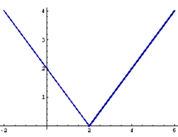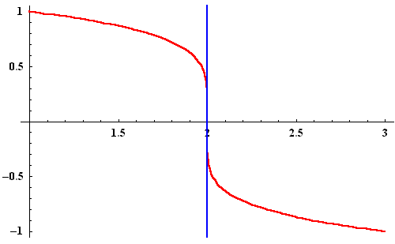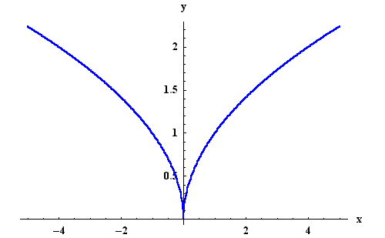This points to an important condition for differentiability; that the function must be continuous at a given point. However, there are two other states in which a function will not be differentiable. The first is when a corner or cusp occurs, shown on the right, where the slope of the function changes instantly. This means that there is a technically infinite number of possible slopes at that corner or cusp, making it impossible for us to determine a single slope at this point. The second time a function will be non-differentiable is when there is a vertical tangent, as shown on the left. This is because the derivative function will tend towards infinity, yet can never reach infinity, causing a vertical asymptote in the derivative function- making the derivative function discontinuous at the point of vertical tangency on the original function, and thus making the original function non-differentiable.

Corner

Cusp

## Guided Practice

1. Given $f(x) = x^{2}-4x+1$, determine $f'(2)$.
   1. $f'(2)$ asks for us to find the derivative, or the instantaneous slope, at x = 2 on $f(x)=x^{2}-4x+1$. To find this, we can use the limit definition of a derivative. Therefore, $f'(2) = \lim_{h→0}\frac{f(2+h) - f(2)}{h}=\lim_{h→0}\frac{[(2+h)^{2}-4(2+h)+1] - [(2)^{2}-4(2)+1]}{h}$ $$=\lim_{h→0}\frac{[(4+4h+h^{2})-8-4h+1] - [-3]}{h}=\lim_{h→0}\frac{[h^{2}-3] + 3}{h}=\lim_{h→0}\frac{h^{2}}{h}=\lim_{h→0}h=0$$ 
      So, we found that the instantaneous slope at x = 2 is 0.
2. Given $f(x)=\frac{1}{x-3}$, what is $\frac{dy}{dx}$?   
   Remember that $\frac{dy}{dx}$ means the same thing as $f'(x)$- thus, when this questions asks “what is $\frac{dy}{dx}$”, it is really asking for a function which gives the instantaneous slope at any value of x on $f(x)$. Therefore, we can solve this as follows: $$f'(x)=\lim_{h→0}\frac{f(x+h)-f(x)}{h}=\lim_{h→0}\frac{\frac{1}{(x+h)-3}-\frac{1}{x-3}}{h} \\ =\lim_{h→0}\frac{\frac{(x-3)}{(x+h-3)(x-3)}-\frac{(x+h-3)}{(x+h-3)(x-3)}}{h}=\lim_{h→0}\frac{\frac{x-3-(x+h-3)}{(x+h-3)(x-3)}}{h} \\ =\lim_{h→0}\frac{\frac{-h}{x^{2}-6x+hx+9}}{h}=\lim_{h→0}\frac{-h}{x^{2}-6x+hx+9}×\frac{1}{h} \\ =\lim_{h→0}\frac{-1}{x^{2}-6x+hx+9}=\frac{-1}{x^{2}-6x+9}$$

## Lola Tries

1. 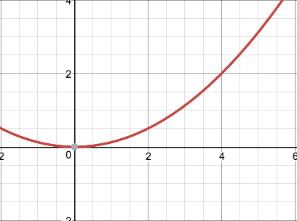From the graph of $f(x)$ shown to the right, approximate $f'(2)$ by drawing a tangent line.
2. Given $g(x)=x^{3}+1-\frac{1}{x}$, what is $g'(x)$?
3. Given $h(x) =\frac{x^{3}-2}{x}$, what is $\frac{dy}{dx}|_{x=0}$?

Next Stop: Nigeria

# Image result for nigeria tourist attractionsImage result for nigeria landmarksWelcome to Nigeria!

Barka da zuwa Nigeria!

What is the power rule, product rule and chain rule?

There are shortcuts to finding derivatives! If we had to use the limit definition of a derivative every time we wanted to find a derivative, not only would it be extremely inefficient, it would also make us hate calculus! Thus, there are three major shortcuts we can use to find a derivative!

**Power Rule:** If n is a real number, then $\frac{d}{dx}(x^{n})=n×x^{n-1}$. We simply take the power on x and multiply it by the coefficient in front of x, and subtract 1 from the existing power.

If we had the function, $f(x) = 2x^{2}+8x+709,021$, we would repeat this process for all three terms of our function ($2x^{2}$, $8x$ and $709,021$) Let’s start with the first term of our function, $2x^{2}$. By power rule, we multiply 2 by the power on x, which is 2. The new coefficient would then become 4. Then, we have to subtract 1 from the power that originally existed on x, which is 2. 2-1=1. Therefore the term $2x^{2}$ becomes $4x$ when we derive. Then, we move on to the second term of the function, $8x$. We would multiply 8 by the power on x, which is 1. Since any number times 1 is itself, the coefficient remains 8. Then we would subtract 1 from the existing power. Since the power on x was originally 1, after subtracting 1, it becomes zero. Anything raised to the power of 0 is disregarded. Therefore, the term $8x$, simply becomes 8 when we derive. Lastly, we have the term 709,021. There is no x in this term! It is just a constant. When we derive a constant, it always goes to 0. This is because the power on x is originally 0, and so we would multiply this to the existing coefficient, 709,021. Any number times 0 is 0, so the constant just gets wiped away. Therefore, the term 709,021, simply becomes 0 when we derive. Now we just piece together the individual terms that we derived to get our overall derivative. Therefore, $f'(x)=4x+8$.

**Product Rule:** If f and g are both differentiable functions, then $(fg)'=fg' +f'g$. When a function has two terms multiplied together, we take the first term and multiply it by the derivative of the second, and add that to the second term multiplied by the derivative of the first.

For example if we had the function $f(x)=(x^{2}+1)(x+3)$, we first identify the two terms as f and g. Let’s say that ${f=x}^{2}+1$ and $g=x+3$. Since both terms are continuous throughout their domain, and do not have any corners and cusps, they are differentiable. Thus, we can use product rule! First we would multiply f by the derivative of g. The derivative of x+3 is 1, by power rule. We multiply this by f left alone. $(x^{2}+1)(1)=x^{2}+1$. Then we multiply g by the derivative of f. The derivative of $x^{2}+1$ is $2x$, by power rule. We multiply this by g left alone. $(2x)(x+3)=2x^{2}+6x$. Now we add the two parts together. Thus, we would have $f'(x)=x^{2}+1+2x^{2}+6x$ = $f'(x)=3x^{2}+6x+1$.

**Quotient Rule:** If f and g are both differentiable functions, then $(\frac{f}{g})'=\frac{gf'-fg'}{g^{2}}$. When a function has one term divided by the other, we take the derivative of the numerator, leaving the denominator alone and subtract that from the derivative of the denominator, leaving the numerator alone. All of this will be over the denominator squared.

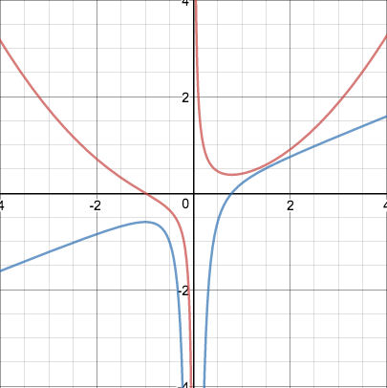For example, if we had the function $f(x)=\frac{x^{3}+1}{5x}$, we first identify f and g. F is always the numerator, $f=x^{3}+1$. G is always the denominator, $g=5x$. Since both terms are continuous throughout their domain, and do not have any corners and cusps, they are differentiable. Thus, we can use quotient rule! First we take the derivative of f and multiply it by g. The derivative of $x^{3}+1=3x^{2}$ by power rule. We then have $(3x^{2})(5x)=15x^{3}$ Then we take the derivative of g and multiply it by f. The derivative of 5x=5, by power rule. We then have $5(x^{3}+1)=5x^{3}+5$. Now, we just square g, our denominator. $(5x)^{2}=25x^{2}$. We take all of the individual components that we found and put them into $=\frac{gf'-fg'}{g^{2}}$. Therefore, we would have $f'(x)=\frac{15x^{3}-(5x^{3}+5)}{25x^{2}}$. Now all we have to do is simplify! $f'(x)=\frac{15x^{3}-5x^{3}-5}{25x^{2}}=\frac{10x^{3}-5}{25x^{2}}=\frac{5(2x^{3}-1)}{5{(5x}^{2})}=\frac{2x^{3}-1}{5x^{2}}$. To the right, you can see the graph of the original function shown in red, and the derivative function shown in blue.

## Guided Practice

1. If $f(x)=(x^{3}+4x^{2}-10x)(\sqrt{x})$, what is $f'(x)?$
   1. First, let’s identify which rule to use. Since two terms are being multiplied, we would use product rule. Now we must identify what f and g are. $f=x^{3}+4x^{2}-10x$ and $g=\sqrt{x}$. Since both terms are continuous throughout their domain, and do not have any corners and cusps, they are differentiable. Thus, we can use product rule!
   2. We first take the derivative of g. $\sqrt{x}$ can be rewritten as $x^{1/2}.$ We can use power rule! By power rule, we multiply ½ by the coefficient in front of x, which is 1. This becomes $1/2x^{1/2}$. Now, we must subtract 1 from the existing power to find our final derivative. This would give us $1/2x^{-1/2}$. We then multiply this by our first term left alone. $(x^{3}+4x^{2}-10x)(1/2x^{-1/2})=1/2x^{5/2}+2x^{3/2}-5x^{1/2}$
   3. Now we take the derivative of f. Again, we use power rule! $x^{3}+4x^{2}-10x$ has three terms. We use power rule on each of these individual terms. The derivative of $x^{3}=3x^{2}$, because we take the power on x, 3, and multiply it by the coefficient that was already on x, 1. Then we subtract 1 from the existing power, 3-1=2. We then take the derivative of the second term, $4x^{2}.$ By power rule, the derivative of $4x^{2}=8x$, because we take the power already on x, which is 2, and multiply it by the coefficient in front of x, which is 4. $4 ×2=8$. Then we subtract 1 from the existing power, 2-1=1. Next, we take the derivative of the third term, 10x. The derivative of -10x=-10. Using power rule, we take the power on x, 1, and multiply it by the coefficient in front of x, -10. Then we subtract 1 from the existing power, 1-1=0. This wipes away the x. Now we piece together each of the terms to get the overall derivative of f. $f'=3x^{2}+8x-10$. Lastly, we multiply this by g left alone. $(3x^{2}+8x-10)(\sqrt{x})=3x^{5/2}+8x^{3/2}-10x^{1/2}$
   4. Lastly, we add the two parts together. $f'(x)=(1/2x^{5/2}+2x^{3/2}-5x^{1/2})+(3x^{5/2}+8x^{3/2}-10x^{1/2})=\frac{7}{2}x^{5/2}+10x^{3/2}-15x^{1/2}$
2. If $f(x)=\frac{3-2x}{4x+1}$, what is $f'(x) at x=8?$
   1. First, let’s identify which rule to use. Since two terms are being divided, we would use quotient rule. Now we must identify what f and g are. F is always the numerator, thus $f=3-2x$ and g is always the denominator, thus $g=4x+1$. Since both terms are continuous throughout their domain, and do not have any corners and cusps, they are differentiable. Thus, we can use quotient rule!
   2. First, we must take the derivative of the numerator, f. The derivative of $3-2x$ can be found using power rule. With power rule, the derivative of any constant, in this case 3, goes to 0. The derivative of -2x=-2 because we would multiply the existing power on x, 1, by the coefficient, -2, and then subtract 1 from our power, 1-1=0. This would wipe x away. Thus, the derivative of f is simply -2. We multiply this by the denominator left alone. (-2)(4x+1)=-8x-2.
   3. Then, we must take the derivative of the denominator, g. The derivative of the denominator can also be found using power rule. With power rule, the derivative of 4x=4, because we would multiply the existing power on x, 1, by the coefficient, 4. The derivative of any constant, in this case 1, goes to 0. Thus the derivative of g is simply 4. We would multiply this by our numerator left alone. 4(3-2x)=12-8x
   4. Now, we must square the denominator, giving us $(4x+1)^{2}$.
   5. We take all of the individual components that we found and put them into $\frac{gf'-fg'}{g^{2}}$. This would give us $f'(x)=\frac{-8x-2-(12-8x)}{(4x+1)^{2}}=\frac{-14}{(4x+1)^{2}}.$
   6. We have to take it one step further, as we want the derivative at x=8. We would simply plug 8 into the derivative function to get that. $f'(8)=\frac{-14}{(4(8)+1)^{2}}=\frac{-14}{1089}$.

## Lola Tries

$f(x)=(-3+x^{-3})(-4x^{3}+3)$

$f(x)=\frac{4x^{4}-4x^{2}+5}{2x^{5/3}+3}$

$f(x)=\frac{4x^{5}+x^{2}+4}{5x^{2}-2}$

Next Step: Morocco

# Image result for moroccoImage result for moroccoWelcome to Morocco!

!مرحبا بك في المغرب   
What is the chain rule?

The power rule, product rule, and quotient rule are incredibly useful! However, what would we do if we wanted to derive a composition of a function, f[g(x)]? In this instance, one function’s output becomes the other’s input. This is often referred to as a “function in a function.” We can use chain rule to derive composite functions!

The chain rule states, if f and g are both different functions and F= f ○ g is the composite function defined by $F\left(x\right)=f(g\left(x\right))$, then F is differentiable and F’ is defined by the product: $F'(x)=f'(g(x)) × g'(x)$

What on earth does that even mean? Basically, this rule states that you do the derivative of the outside piece, leaving the inside piece alone, and then multiply it by the derivative of the inside piece.

How would we find the derivative for a function like $F(x)=(x+1)^{3}$? The first idea that probably comes to mind is to foil out $(x+1)^{3}$, and solve it using the power rule from there. However, how would we find the derivative of a function like $f(x)=(x^{3}-200x^{2}+1000x-200)^{157}$? Although, technically, we could foil this out, it would literally take hours. So, chain rule is extremely effective here!

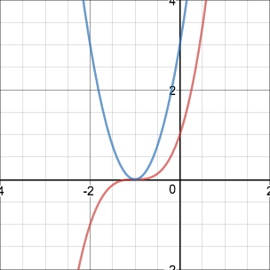Let’s revisit the example; $F(x)=(x+1)^{3}$. First, let’s identify the outside piece and the inside piece. The inside piece would be $g(x)=x+1$, as this is the function inside of the cube. Thus, the outside piece would be $f(x)=x^{3}$, and our entire function would be $F(x) = f(g(x))$. With chain rule, we take the derivative of the outside piece first. $f'(x)=3x^{2}$. However, since g(x) is the input for f(x), we would replace the x in $f'(x)=3x^{2}$ with g(x). Thus, $f'(x)=3(x+1)^{2}$. Now, we multiply $f'(x)$ by the derivative of the inside piece, g(x). The derivative for $g(x)=x+1$ is just 1, by power rule. $f'(x) ×1=f'(x)$. Therefore, $F'(x)=3(x+1)^{2}$.

Think of the chain rule as peeling an onion. Like an onion, we use chain rule with composite functions that have multiple layers. First, you take the derivative of the outer layer. Then you have to multiply this by the derivative of the inner layer. On the right, the graph of the original function is shown in red, while the graph of the derivative is in blue.

## Guided Practice

1. Find the derivative of $y=\frac{(2x-1)^{4}}{(x+1)^{2}}$
   1. First, let’s identify the rules we need to use! Since the overall function is a fraction with differentiable functions as the numerator and denominator, we can use quotient rule. However, we must also use chain rule because the numerator $(2x-1)^{4}$ is a composite function itself! The outside piece would be $f(x)=x^{4}$ and the inside piece would be $g(x)=2x-1$, with $F(x)=f(g(x))$. The same is true for the denominator. It is a composite function as well! The outside piece for the denominator would be $f(x)=x^{2}$ and the inside piece would be $f(x)=x+1$, with $F(x)=f(g(x))$.
   2. Now that we have the fundamental ideas down pat, we can start to derive. With quotient rule, we first take the derivative of the numerator and multiply it by the denominator left alone. The derivative of the numerator would use some chain rule. The derivative of the outside piece would be $4x^{3}=4(2x-1)^{3}$. Then we multiply this by the derivative of the inside piece. The derivative of $2x-1=2$ by power rule. Thus, the derivative of the numerator would be $4(2x-1)^{3}×2$. Lastly, we multiply this by the denominator left alone, giving us $4(2x-1)^{3}×2×(x+1)^{2}=8(2x-1)^{3}{(x+1)}^{2}$
   3. Now, we must subtract the derivative of the denominator times the numerator left alone. The derivative of the denominator would also use some chain rule. The derivative of the outside piece would be $2x=2(x+1)$, the derivative of the inside piece would be just 1, by power rule. Thus, the derivative of the denominator is $2({x+1)×1=2(x+1)}_{}$. Lastly we multiply this by the numerator left alone, giving us $2(x+1) ×(2x-1)^{4}$.
   4. Now, we have the numerator of the overall derivative. All we have to do is simplify. $8(2x-1)^{3}(x+1)^{2}-[2(x+1)(2x-1)^{4}]$ = $2(2x-1)^{3}(x+1)[4(x+1)-(2x-1)]$ 
       = $2(2x-1)^{3}(x+1)[2x+5]$
   5. Now all we have to do is square the denominator, to get the denominator of the derivative! This would give us $((x+1)^{2})^{2}=(x+1)^{4}$
   6. Now we just have to piece together the entire derivative! $y'=\frac{2(2x-1)^{3}(x+1)[2x+5]}{(x+1)^{4}}=\frac{2(2x-1)^{3}[2x+5]}{(x+1)^{3}}$
2. $f(x)=(4x^{3}-7)^{4}(3x+2)^{10}$; What is $f'(x)$?
   1. First, we need to identify which rules to use. Since there are two functions multiplied together, and they are both differentiable, we can use product rule! However, we must also use chain rule because the first term in the function is inside of another function, making it a composite! The outside piece would be $f(x)=x^{4}$ and the inside piece would be $g(x)=4x^{3}-7$, with $F(x)=f(g(x))$. The same is true for the second term. It is a composite function as well! The outside piece for the denominator would be $f(x)=x^{10}$ and the inside piece would be $f(x)=3x+2$, with $F(x)=f(g(x))$.
   2. Now we can start deriving. By product rule, we take the derivative of the second term and multiply it by the first term left alone. The derivative of the outside piece of the second term would be $10x^{9}=10(3x+2)^{9}$. We then multiply this by the derivative of the inside piece. The derivative of $3x+2=3$, by power rule, so we are left with $30(3x+2)^{9}$. Finally, we multiply this by the first term left alone, $30(3x+2)^{9}(4x^{3}-7)^{4}$
   3. Next, we take the derivative of the first term and multiply it by the second term left alone. The derivative of the outside piece of the first term would be $4x^{3}=4(4x^{3}-7)^{3}$. We then multiply this by the derivative of the inside piece. The derivative of $4x^{3}-7=12x^{2}$, by power rule, so we are left with $48x^{2}(4x^{3}-7)^{3}$. Finally, we multiply this by the first term left alone, $48x^{2}(4x^{3}-7)^{3}(3x+2)^{10}$.
   4. Lastly, we must piece together the overall derivative and simplify. $$f'(x)=30(3x+2)^{9}(4x^{3}-7)^{4} + 48x^{2}(4x^{3}-7)^{3}(3x+2)^{10} \\ f'(x)=6(3x+2)^{9}(4x^{3}-7)^{3}[5(4x^{3}-7)+8x^{2}(3x+2) \\ f'(x)=6(3x+2)^{9}(4x^{3}-7)^{3}[44x^{3}+16x^{2}-35]$$

## Lola Tries

1. If $y=\frac{{(x+1)}^{6}}{{(3x-2)}^{5}}$, what is y’?
2. If $y={(x^{3}+x)}^{2}$, what is y’?
3. If $y=({3x}^{3}+1){{(-4x}^{2}-3)}^{4}$, what is y’?

Next Stop: Egypt

# Image result for egyptImage result for egyptWelcome to Egypt!

مرحبا بكم فى مصر!

How do I find the equation of a tangent and normal line to a curve at a point?

All this time we have discussed how to find the slope of a line tangent to a curve at a specific point. However, what if we wanted to determine the actual equation for that tangent line, not just its slope? To do this, we will need our slope intercept form, $y -y_{1}=m(x-x_{1})$. If we start out with a curve such as $f(x) = (x-1)^{2}$, and want to determine the tangent line at x = 2, we can already plug in $x_{1}$, as our x-value is 2. As well, another easy value to find $y_{1}$, as all we need to do is plug 2 into $f(x)$, which in this case would be 1. Finally, we need to determine $m$, the instantaneous slope at this point; a.k.a., the derivative! Using the chain rule we just learned, $f'(x)$ is $2(x-1)$, which simplifies to become $2x-2$. At the point $x=2$, $f'(2)=2(2)-1=3$. Therefore, the equation for the tangent line at $x=2$ is $y-1=3(x-2)$. Most of the time this is sufficient, however, we can rewrite it as $y=3x-5$ to graph it.

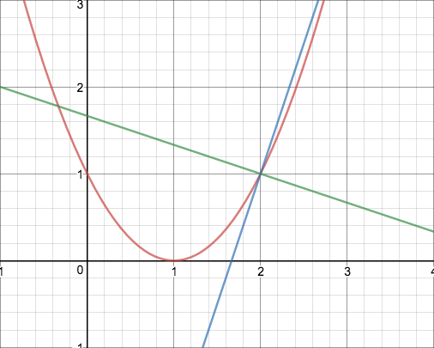Another type of line that we can determine in a similar fashion is a “normal line”. A normal line is one which is perpendicular to the tangent line as graphed on the right.

To determine a normal line, we first follow the same exact steps taken to determine the tangent line. However, when we determine the value of $m$, we must take the derivative at our specific point, and then take the negative reciprocal of this slope (i.e., the slope of the normal line = $\frac{-1}{f'(x)}$). Let’s look at this with our previous example. If we wanted to find the normal line at the point $x=2$, we would use the x and y coordinates determined earlier on (2 and 1 respectively), and then take the negative reciprocal of $f'(2)$, which would be $-\frac{1}{3}$. Thus, the equation for our normal line would be $y-1=-\frac{1}{3}(x-2)$.

## Guided Practice

1. Find the line tangent to $y = x^{5}-2x$ at $x=-1$.
   1. To determine the tangent line, we need the point of tangency and the instantaneous slope at that point. We already have the x-value of this point, and thus we can determine that the y-value is $y=(-1)^{5}-2(-1)=-1+2=1$. Next, we can determine the instantaneous slope by finding the derivative function and plugging the x-value into this function. The derivative function, per power rule, would be $y'=5x^{4}-2$. When we plug in $x=-1$, we find that the instantaneous slope is $y'(-1)=5(-1)^{4}-2=3$. Therefore, our tangent line would be $y-1=3(x+1)$.
2. Find the normal line at $x=2$ on $f\left(x\right)= 40+3x-x^{6}$
   1. The first step to find a normal line is the same as finding a tangent line; we must determine both the x and y coordinate of the point on $f(x)$ that the normal line intersects. In this case, the y-coordinate at $x=2$ would be $f(2)=40+x^{3}-x^{6}=40+(2^{3})-(2^{6})=40+8-64=-16$. The second step to find a normal line is to find the negative reciprocal of the instantaneous slope; i.e., $-\frac{1}{f'(x)}$. The derivative function in this example would be $f'(x)=3-6x^{5}$, and thus the instantaneous slope at $x=2$ is $f'(2)=3-6(2^{5})=3-6(32)=3-192=-189$. Then, the negative reciprocal, and the slope of the normal line, would be $\frac{1}{189}$. Therefore, the equation of the normal line at $x=2$ on $f(x)$ would be $y+16=\frac{1}{189}(x-2)$.

## Lola Tries

1. Find the line tangent to the curve $y=-\frac{5}{x^{2}+1}$ at $x=-1$.
2. Find the line tangent to the curve $y=-2tan(x)$ at $x=-π$.
3. Find the normal line on the curve $y=(2x-8)^{\frac{1}{3}}$ at $x=0$.

Next Stop: Ethiopia

# Image result for ethiopian cultureImage result for king lalibela churchWelcome to Ethiopia

ኢትዮጵያ ወደ አቀባበል!

How do I graph the derivative from a drawn graph and vice versa?

Let’s say that we are given the graph of a function $f(x)$, and want to find the graph of the derivative of this function, $f'(x)$. However, we are not given the actual function itself, only its graph.

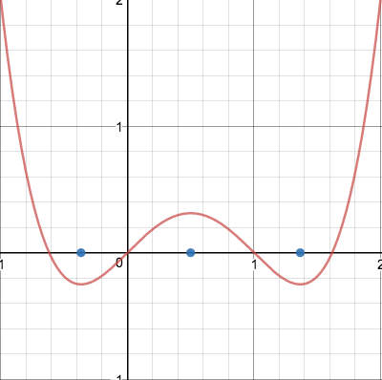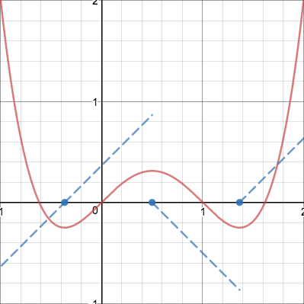To graph the derivative function, there are three main steps we must go through. First, it is important to identify where $f'(x)=0$. Generally, this will be when the graph of $f(x)$ reaches some sort of maximum/minimum or simply flattens out at a point, as the slope at these points will be 0 and the tangent line will be perfectly horizontal.

Second, it is important to identify the areas where $f'(x)>0$ and where $f'(x)<0$. Since $f'(x)$ is a graph of the instantaneous slope at a given x, this means that we can divide the graph into domains where $f(x)$ is increasing and where $f(x)$ is decreasing. When $f(x)$ is increasing, $f'(x)>0$, and when $f(x)$ is decreasing, $f'(x)<0$.

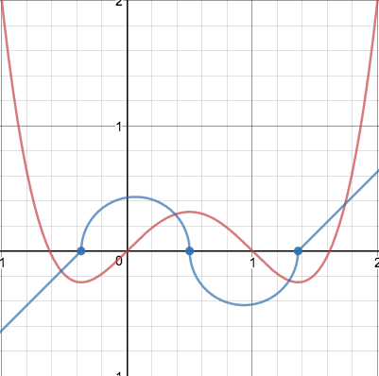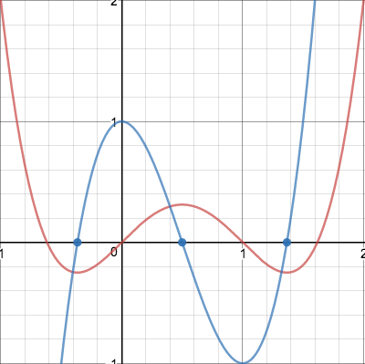After we’ve identified these regions, we can then begin to draw a general sketch, drawing a graph following the parameters determined in steps 1 and 2.

Third, it is important to identify how steep the slope of $f(x)$ generally is at a given point. For example, when $f(x)$ has a very steep upward slope, the y-value of $f'(x)$ will be relatively much higher. As well, when $f(x)$ is locally increasing with the steepest slope, $f'(x)$ will have a local maximum. Likewise, when $f(x)$ is locally decreasing with the steepest slope, $f'(x)$ will have a local minimum.

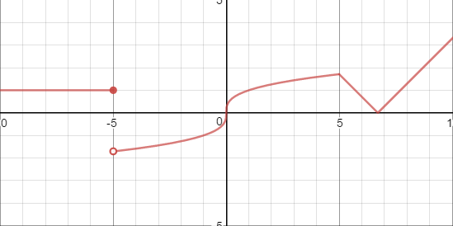This works for most functions, however, when determining the points where $f'(x)=0$ in step 1, it is also important to consider the places where $f(x)$ is non-differentiable. Let’s look at the graph to the right, which has all three conditions for differentiability.

Whenever there is a discontinuity, corner, or cusp, such as at $x=5, -5$, or the corner of the absolute value function on the right, the derivative graph will usually have a jump discontinuity. This is because these trends on the original graph represent instantaneous, and thus discontinuous, changes in the slope. When there is a vertical tangent, such as at $x=0$, the derivative function will have an infinite discontinuity, as from either side of the vertical tangent the slope of the function approaches infinity. In this example, the derivative function will approach infinity from either side of the vertical tangent because from either side the function is continually going “up.” If it were flipped about the x-axis, and the function was continually going down, then the derivative function would approach negative infinity from both sides. Understanding these rules, we can go ahead and graph the derivative of this function on the right.

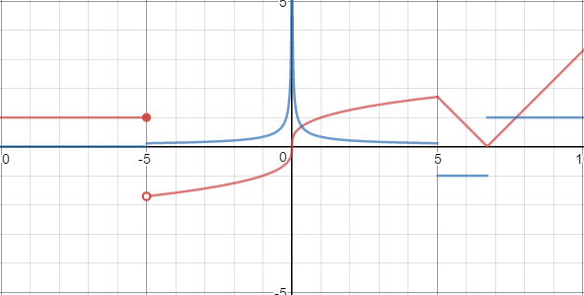The derivative function is graph in blue, and it is rife with the discontinuities we predicted above. At $x=-5$, it may be hard to see, but there is a discontinuity, which is the result of the jump discontinuity between the line of $y=1$ and $y=\sqrt[3]{x}$. Then, there is an infinite discontinuity, at $x=0$, as the result of the vertical tangent there on the original function. Finally, we see several jump discontinuities at $x=5$ and $x≈6.7$, due to the presence of corners and cusps and these locations.

Given these skills and information, it is also possible to go “backwards,” and graph the original function from the graph of the derivative! Let’s look at this using our first example.

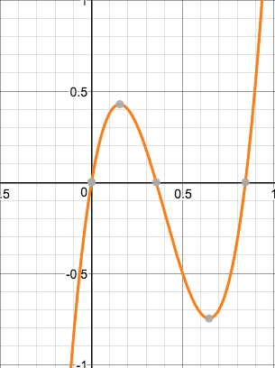 Given that the graph to the right is the graph of the derivative function, we can start off by determining the maximums/minimums of the original graph. Since the x-intercepts of the derivative function occur whenever the original function has a slope of zero, we can say that these points are likely the maximums/minimums of the original function. We can confirm this by the behavior of the derivative function on either side of these points. If the derivative function goes from positive to negative, then it is likely a maximum on the original graph, as a maximum will occur at the point where the function increases, stopped changing instantaneously at the maximum, and then decreases. Likewise, a minimum point on the original function will occur when the derivative function goes from negative to positive, as this means the original function decreases, stopped changing instantaneously at the minimum, and then increases.

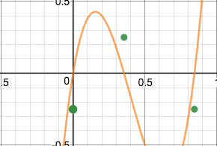 Therefore, we can sketch out these maximum/minimum points generally, even if we do not know the exact value they are at on the original function.

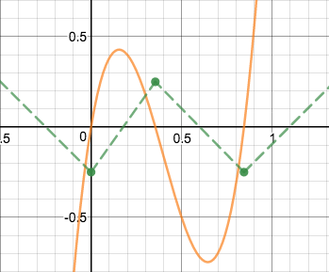 Next, we can sketch out the general pattern of the original function. For example, the derivative function describes that the original function, on $(-∞, 0)$, had a negative slope, as the derivative function is entirely below the x-axis on this interval. Therefore, we know that as the original function was approaching the minimum at $x=0$, it was going downwards. Between the minimum at $x=0$ and maximum $x≈0.35$, the derivative function describes a positive slope, and so the original function must have generally been going up between these points. From the maximum at $x≈0.35$ and the minimum at $x≈0.8$, the derivative function was again negative, and so there is a downward slope between these points. Finally, after the minimum at $x≈0.8$, the derivative function is positive on $(0.8, ∞)$, meaning that the original function continually rises past this point.

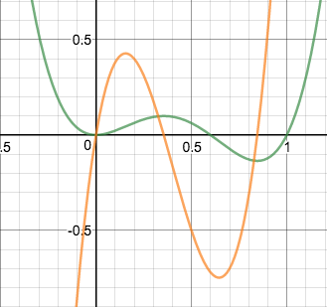 Finally, after we have sketched this general trend, there is one more factor that we must take into account- the actual steepness of the original graph at various points. When the derivative function reaches a maximum, this means that the slope of the original graph was the most “positively steep”- i.e., the original function was increasing the fastest. Similarly, when the derivative function reaches a minimum, this means that the slope of the original graph was the most “negative slope” and decreasing the fastest. With this information, we can more accurately sketch the original function. Note, the following original function graph, in green, was done using a calculator- your own graph should be accurate in terms of the general trends, but it does not have to mirror the actual points of the original function!

## Guided Practice

1. 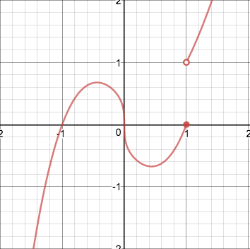Given the following graph, identify any possible discontinuities in the derivative function.
   1. 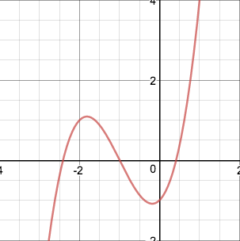Based upon this graph, there are two discontinuities. The first is at $x=0$. This is because at $x=0$ there is a vertical tangent line, and thus, the derivative function would have an infinite discontinuity, where the derivative function approaches negative infinity from both sides (as the function has a negative slope on either side of $x=0$). As well, there is a second discontinuity in the derivative graph, at $x=1$, as there is a jump discontinuity in the original function. Therefore, the slope of the original function changes instantaneously, making the derivative graph discontinuous.
2. Given the following graph, graph the derivative.
   1. First, we must make sure to graph the x-intercepts of the derivative function. Next, we sketch a general shape to the graph, per the intervals on which it is increasing/decreasing. Finally, we can refine our graph by considering how steep the original function is at different points, to successfully graph the first derivative.

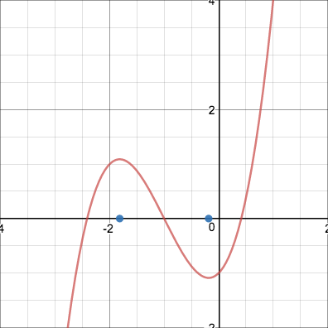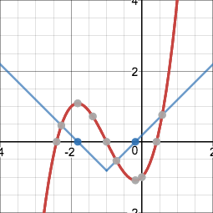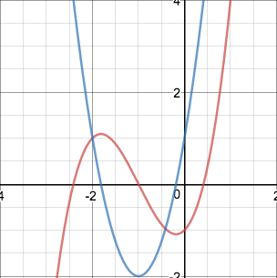

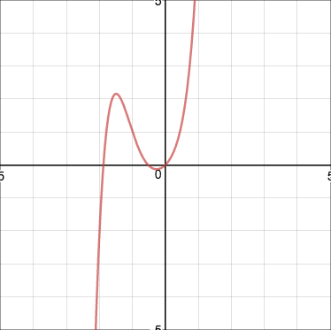

## Lola Tries

1. Given the red graph, graph the derivative function.
2. Given the blue graph to the left below, graph the derivative function.
3. 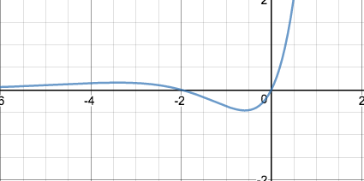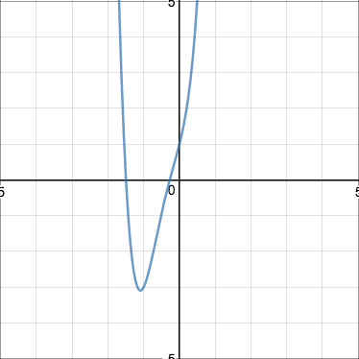Given the blue graph of the derivative to the right below, graph the original.

Next Stop: United Arab Emirates

# Image result for united arab emirates desertImage result for burj khalifaWelcome to the United Arab Emirates!

متحدہ عرب امارات میں خوش **آمدید!**

What are the derivatives for trigonometric functions?

Let’s get triggy! We can take derivatives of trigonometric functions! In fact, there is a definitive rule for the derivative of each trigonometric function!

$\frac{d}{dx}(sinx)=cosx$

$\frac{d}{dx}(cosx)=-sinx$

$\frac{d}{dx}(tanx)=\sec^{2}x$

$\frac{d}{dx}(secx)=secxtanx$

$\frac{d}{dx}(cotx)={-csc}^{2}x$

$\frac{d}{dx}(csc-cscxcotx$

The derivatives of these trigonometric functions can be used in many useful applications. But, where did they come from? All of the trigonometric functions can be proven through some algebraic manipulation. Look at the guided practice problems for one of these proofs!

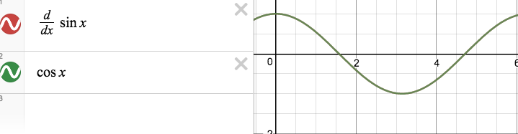For a visual, the derivative of y=sinx is cosx. The graph shows this in action!

These trigonometric derivatives are very useful for real-life applications. For example, Lola went sky diving off of the Burj Khalifa. The angle of elevation from her parents is modeled by the function $y=sin(cosx)$, in which x is the time in seconds, and y is the angle of elevation in radians. What is the rate of change in the angle of elevation at $\frac{π}{4}$ seconds?

First we must derive the function to get the rate of change in the angle of elevation. Using chain rule, we have to take the derivative of the outside piece, leaving the inside alone. The derivative of $y=sinx$ is $cosx$. We are left with $y=cos(cosx)$. We then multiply this by the derivative of the inside piece. The derivative of $y=cosx$ is $-sinx$. So, $y'=-\cos^{2}x sinx$. We can then plug in $\frac{π}{4}$ seconds. $y'=-cos^{2}(\frac{π}{4})(sin(\frac{π}{4})=-\frac{1}{2}(\frac{\sqrt{2}}{2})=-\frac{\sqrt{2}}{4} radians/second$.

## Guided Practice

1. Prove that $\frac{d}{dx}(cos x)=-sinx$
   1. First, we must put this into the limit definition of a derivative. By doing so, we yield $\lim_{h→0}\frac{cos(x+h)-cosx}{h}$.
   2. Then, we must recall that $cos(a+b)=cosa×cosb-sina×sinb$. Thus, we can separate cos(x+h) using this rule! We are left with $\lim_{h→0}\frac{cosx×cosh-sinx×sinh-cosx}{h}$.
   3. 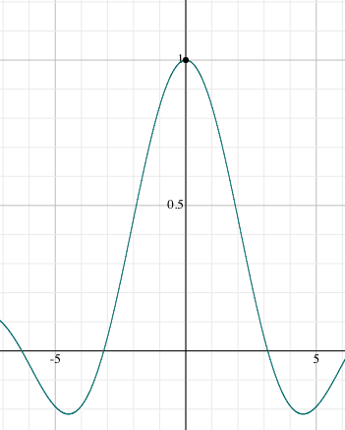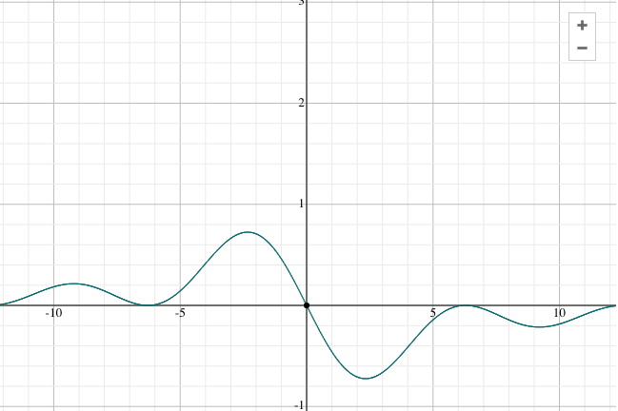Next, we can separate this limit into two different limits. Since the limit is as h approaches 0, we can evaluate the limit as $cosx\lim_{h→0}\frac{cosh-1}{h}-sinx\lim_{h→0}\frac{sinh}{h}$. To evaluate both of these limits, let’s look at the behavior of the graph as h approaches 0.
   4. $\lim_{h→0}\frac{cosh-1}{h}=0$, as you can see in the first graph to the right, because as h approaches 0, the y-value is getting closer and closer to 0.
   5. $\lim_{h→0}\frac{sinh}{h}=1$, as you can see in the second graph to the right, as h approaches 0, the y-value is getting closer and closer to 1.
   6. Thus, we are left with $cosx(0)-sinx(1)$, which leaves us with $\frac{d}{dx}(cosx)=-sinx$
2. Find the equation of the tangent line for $y=\frac{sec4x}{tan4x}$ at x= $\frac{π}{2}$.
   1. First, we must find the derivative of the function. To make it easier, let’s rewrite it with sines and cosines. $y=\frac{\frac{1}{cos4x}}{\frac{sin(4x)}{cos(4x)}}=\frac{1}{cos(4x)}×\frac{cos(4x)}{sin(4x)}=\frac{1}{sin(4x)}=csc(4x)$.
   2. Now, we derive! We can easily use our rule for the derivative of $y=cscx. y'=-cscxcotx.$ Since there is a 4 inside of the cscx, we must multiply by four, to comply by chain rule. So we are left with, $y'=-csc(4x)(cot(4x)) ×4=-4csc(4x)(cot(4x))$
   3. 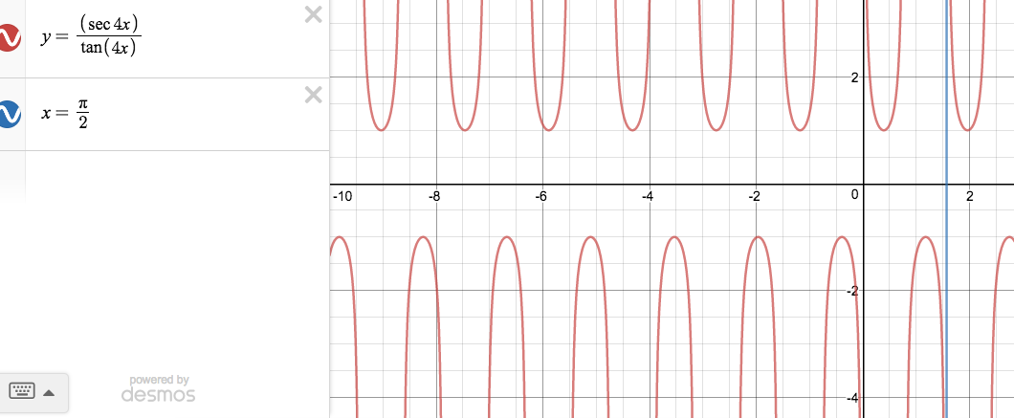Next, we can plug in $\frac{π}{2}$ into the derivative function to get the slope at that x-coordinate. $y=-4csc(4\frac{π}{2})(cot(4\frac{π}{2}))=-4csc(2π)(cot(2π)=undefined!!$ Thus, there is no slope that is tangent to that point. There is no line tangent to $y=\frac{sec4x}{tan4x}$ at x= $\frac{π}{2}$. Got you!!
   4. As you can see from the graph, there is no defined slope of the line tangent to x= $\frac{π}{2}$, as there is a vertical asymptote there.

## Lola Tries

1. Prove that $\frac{d}{dx}(tanx)=\sec^{2}x$
2. Find $y'$ given $y=cos(-3x^{2}+2)^{2}$
3. Find $y'$ given $y=\frac{-2x^{2}-5}{cos(2x^{3})}$

Next Stop: Saudi Arabia

# http://static.panoramio.com/photos/large/9225136.jpghttps://ccmtheimaginarytraveler.files.wordpress.com/2014/09/oryxsa-files-wordpress-com.jpgWelcome to Saudi Arabia!

مرحبا بكم في المملكة العربية السعودية!

What is the second derivative? What are intervals of concavity and points of inflection?

Now that we understand the derivative, we can explore **higher order derivatives!** Take a function, $f(x)=x^{2}$. Then, find its derivative- i.e., $f'(x)=2x$. Remember that even though $f'(x)$ is the derivative of $f(x)$, it is still a function itself, and we can determine the instantaneous slope on it as well. To do this, we would have to take the derivative of the derivative, also known as the **second derivative!** Therefore, $f''(x)$, the second derivative, would be 2, per power rule. And again, $f''(x)$ is also a function which we can take the derivative of- the third derivative.

Before we continue, it is important to know the basic notation for higher order derivatives.

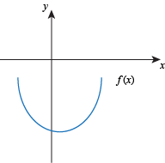**Newtonian:** For the first, second, and third derivatives, there is n-number of apostrophes, whereas any derivatives greater than third are notated as ${f(x)}^{(n)}$, where n is the order of the derivative. For example, the 4th derivative is ${f(x)}^{(4)}$  
**Leibniz:** Any derivative greater than the first is notated as $\frac{d^{n}y}{dx^{n}}$, where n is the order of the derivative. For example, the 4th derivative is $\frac{d^{4}y}{dx^{4}}$.

For now, we are going to focus on the importance of the second derivative. The second derivative describes a property of the original function known as “concavity.” When a function is “concave up like a cup” any tangent line to the curve will be below the curve, $f''(x)>0$, and the value of $f'(x)$ is increasing (as $f''(x)$ describes the slope of $f'(x)$).

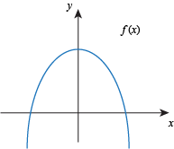When a function is “concave down like a frown”, any tangent line to the curve will be above the curve, and $f''(x)<0$, and $f'(x)$ is decreasing.

As well, a “point of concavity” is simply when the concavity of a function changes. Since $f''(x)$ is the slope of $f'(x)$, these points of concavity occur when $f'(x)$ is at a maximum or non-differentiable and $f'(x)$ changes from increasing to decreasing or vice-versa, or when $f''(x)$ is 0 or discontinuous, as this represents a continuous/instant change in the sign of $f''(x)$, and thus the concavity.

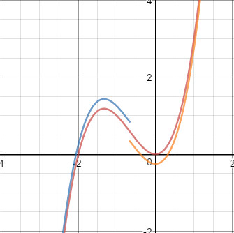Generally, it is possible to approximate these intervals of concavity by understanding the basic ideas of concavity.

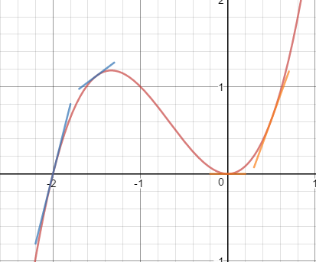For example, given the graph to the left, we can highlight when it is concave up/concave down. From the left end of the function (it’s end behavior on the left) until about $x=-\frac{2}{3}$, the function is concave down because it is “like a frown”, and the tangent lines are above the curve, while past $-\frac{2}{3}$, the function is concave up, as the shape of the graph is “like a cup” and the tangent lines are below the curve, as seen in the following graph.

Therefore, we can generally say that there is a point of inflection around $x=-\frac{2}{3}$, and that from $(-∞, -\frac{2}{3})$ the function is concave down, while from $(-\frac{2}{3}, ∞)$, the function is concave up. Note that we do not include $-\frac{2}{3}$, as $g''(-\frac{2}{3}$) is zero, as it is our estimated point of inflection.

## Guided Practice

1. 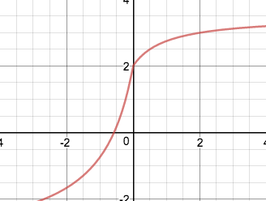Given the function graphed to the right, determine the intervals of concavity and the point(s) of inflection.
   1. 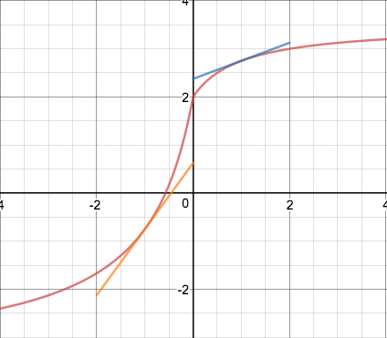Based upon the graph of this function, it appears as if on the left side of the graph, it is concave up, as it is “up like a cup.” On the right side of the graph, it appears as it is concave down, as it is “down like a frown.” As well, when the graph is zoomed in, it appears as if there is a cusp, acting as both a sudden change in the slope and concavity of the function at $x=0$, which indicates that this is the point of inflection for the graph. Therefore, it is possible to say that the function is concave up o n $(-∞, 0)$ and concave down on $(0, ∞)$, with a point of inflection at $x=0$.
2. Using the function in the previous problem and the intervals of concavity, draw a sketch of the derivative function.
   1. 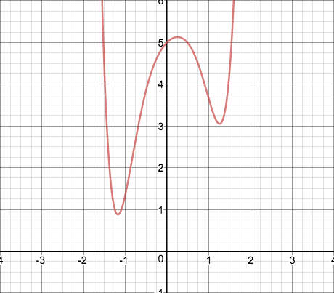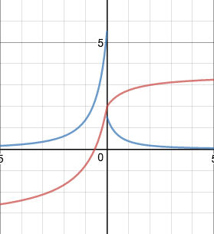An extra application of concavity is that it allows us to draw more accurate derivative functions! This is because concavity describes the slope of the derivative function. Therefore, we can say that on $(-∞, 0)$, the slope of the derivative function is positive. More importantly, the graph of the original function shows that it becomes more and more concave up as the function approaches $x=0$ from the left, and then the concavity abruptly changes, meaning that the slope of the derivative function grows greater and greater approaching this point, before it abruptly changes as well. Similarly, as the function approaches $x=0$ from the right, the function becomes more and more concave downward, indicating that the slope decreases faster in this area. Using this information, we can sketch a more accurate derivative function, which should look close to the graph on the right.

## Lola Tries

1. Given $y=2x^{3}-10x^{2}+4x+5$, determine $\frac{dy}{dt}, \frac{d^{2}y}{dt^{2}}, \frac{d^{3}y}{dt^{3}},$ and $\frac{d^{4}y}{dt^{4}}$.
2. What is the definition of “concave up” and “concave down”?
3. Approximate the intervals of concavity and point(s) of concavity on the graph to the right.

Next Stop: Turkey

# Image result for pictures of turkey countryRelated imageWelcome to Turkey!

Türkiye'ye hoşgeldiniz!

What is the Mean Value Theorem and Rolle’s Theorem?

The Mean Value Theorem is basically the intermediate value theorem, but for slope!

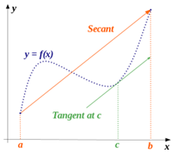**Mean value theorem:** If f(x) is continuous on the interval [a,b] and differentiable on (a,b), then there is at least one value “c” on the interval (a,b) that is a<c<b, such that $f'(c)=\frac{f(b)-f(a)}{b-a}$.

In other words, the slope of the line through (a, f(a)) and (b, f(b)) is the same as the tangent line of some point “c” on the interval (a,b). Look at the graph for a visual description!

There are a few steps with Mean Value Theorem problems:

1. Check for continuity
2. Check for differentiability
3. Find slope of secant line
4. Determine where f’(x)=slope of secant line
5. Determine which x’s are in given interval.

For example, determine if the hypotheses for Mean Value Theorem is satisfied for $f(x)=x^{2}-2x+1$ on the interval [1,3]. If so, find c. If not, tell why.

Since f(x) is a simple polynomial function, it is continuous on the interval! Then, to check differentiability, we must first find the derivative function. Using power rule, $f'(x)=2x-2$. Again, since this is a simple polynomial function, we know it is differentiable on the entire interval!

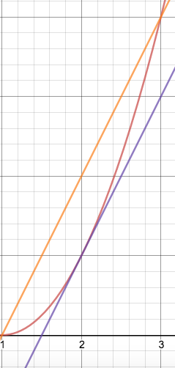Now, we must find the slope of the secant line. $m_{sec}=\frac{f(b)-f(a)}{b-a}=\frac{f(3)-f(1)}{3-1}$, and $f(3)=(3)^{2}-2(3)+1=4$ while $f(1)=(1)^{2}-2(1)+1=0$, making $m_{sec}=\frac{4-0}{3-1}=\frac{4}{2}=2$.

Now, we set this slope equal to to f’(x) to find where f’(x)= slope of secant line. $2=2x-2$, $x=2$

Since x=2 is on the interval from [1,3], we know at c=2, the instantaneous slope $f'(2)=average slope$ The graph shows this in action! The original function is in red, the secant line is in orange, and the tangent line at x=2 is in blue.

Rolle’s Theorem is simplify a specific application of Mean Value Theorem!

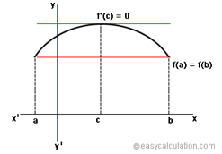**Rolle’s Theorem:** If f(x) is continuous on [a,b] and differentiable on (a,b), and if f(a)=f(b), then there is some “c” in the interval (a,b) that f’(c)=0.

In other words, if f(x) is continuous and differentiable on an interval (a,b) and if f(a)=f(b), then at some point there will be a maximum or minimum or other point with a zero slope on that interval.

Like Mean Value Theorem, there are a few steps with Rolle’s Theorem problems:

1. Check for continuity
2. Check for differentiability
3. Check if f(a)=f(b)
4. Set f’(x)=0, to determine where slope is 0
5. Check for values of x where f’(x)=0, on the given interval.

For example, determine if the hypotheses for Rolle’s Theorem are 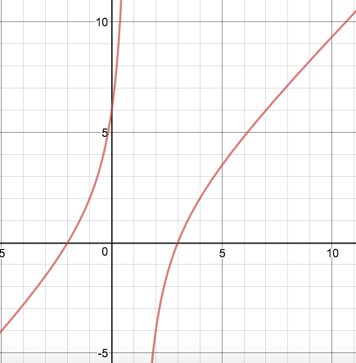satisfied for $f(x)=\frac{x^{2}-x-6}{x-1}$ on the interval [-1,4] . If so, find c. If not, tell why.

First, we must check for continuity on the interval. $f(x)$ is not continuous on the entirety [-1,4], specifically at x=1, because if we plug x=1 into f(x), we get $f(-1)=\frac{(-1)^{2}-(-1)-6}{1-1}=\frac{-4}{0}=undefined!$

Thus, Rolle’s Theorem does not apply in this situation, as it is not continuous throughout the interval. Since this hypothesis is not met, we can stop there! On the graph, you can see the discontinuity at x=1.

## Guided Practice

1. Determine if the hypotheses for Mean Value Theorem is satisfied for $f(x)=\frac{x^{2}-4}{x+1}$ on the interval [0,2]. If so, find c. If not, tell why.
   1. First, we must check for continuity. The only point of discontinuity is at x=-1, as this would yield a constant over 0. Since x=-1 is not on the interval, this is ok. All other points on the interval from [0,2] are continuous.
   2. Next, we must check for differentiability. To do so, we must first find the derivative using quotient rule. $f'(x)=\frac{2x(x+1)-[1(x^{2}-4]}{(x+1)^{2}}=\frac{x^{2}+2x+4}{(x+1)^{2}}$. We already know that the point at x=-1 is not differentiable, as it is not continuous. Again, since this is not on the interval from [0,2], this is ok. There are no other points of non-differentiability.
   3. Now, we must find the slope of the secant line, where $m_{sec}=\frac{f(b)-f(a)}{b-a}=\frac{f(2)-f(0)}{2-0}$. We can calculate that $f(2)=\frac{(2)^{2}-4}{2+1}=0$ and $f(0)=\frac{0^{2}-4}{0+1}=\frac{-4}{1}=-4$, making $m_{sec}=\frac{0-(-4)}{3-1}=\frac{4}{2}=2$.
   4. We then set this slope equal to f’(x) to find where f’(x)= slope of secant line.
 $2=\frac{x^{2}+2x+4}{(x+1)^{2}}=2(x+1)^{2}=x^{2}+2x+4$

 $2x^{2}+4x+2=x^{2}+2x+4$

 $x^{2}+2x-2=0$

   1. We can then plug this into the quadratic formula! $x=\frac{-2±\sqrt{(2)^{2}-4(-2)}}{2}$
      2. For $x=\frac{-2±\sqrt{(2)^{2}-4(-2)}}{2}$, we can only use the positive version, as the negative version is not in the given interval. Therefore, $f'(\frac{-2+\sqrt{(2)^{2}-4(-2)}}{2})=average slope$
2. Mean Value Theorem and Rolle’s Theorem also work with trigonometric functions! Determine if the hypotheses for Rolle’s Theorem are satisfied for $f(x)=sinx$ on the interval [0, π]. If so, find c. If not, tell why.
   1. First, we must check for continuity on the interval. We know the nature of the function f(x)=sinx is continuous everywhere, so it would definitely be continuous from [0, π].
   2. Next, we must check for differentiability on the interval. The first step in doing so is to find the derivative function. Using our trigonometric function derivatives, we know that $f'(x)=cosx.$ Since f’(x) is continuous everywhere, we know that f(x) is differentiable everywhere as well (including the interval from 0 to π)
   3. Now, we must check if f(0)=f(π). We find that $f(0)=sin(0)=0$ and $f(π)=sin(π)=0$; since f(π)=f(0) Rolle’s Theorem applies!
   4. Next, we must see where $f'(x)=0$. Setting $0=cosx$, we find $x=\frac{π}{2},\frac{3π}{2}$. Lastly, we must check and see if these two x-coordinates are on the interval [0, π]. $\frac{3π}{2}$ is not on this interval. So, $c=\frac{π}{2}$, and at $x=\frac{π}{2}, f'(x)=0$.

## Lola Tries

1. Determine if the hypotheses of Rolle’s Theorem are satisfied for $f(x)=x^{3}-x$ on [0,1]. If so, find c. If not, tell why.
2. Determine if the hypotheses of Mean Value Theorem are satisfied for $f(x)=x^{2/3}$ on   
   [-1,1]. If so, find c. If not, tell why.
3. Determine if the hypotheses of Mean Value Theorem are satisfied for $f(x)=4x^{3}-8x^{2}+7x-2$ on [2,5]. If so, find c. If not, tell why.

Next Stop: Iran

# Image result for iranImage result for iranWelcome to Iran!

به ایران خوش آمدید!

How do I find local maxima and minima using the 1st and 2nd derivative tests?

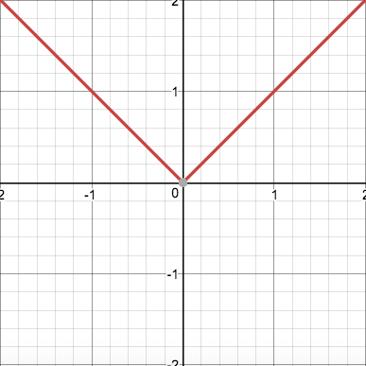When graphing derivatives, we said that the local, or relative, maximum or minimum of a graph will generally be an x-intercept of the derivative graph. Essentially, this says that a function will have a slope of zero at a maximum or minimum; this makes sense when picturing the maximum of a parabola, as it levels off and has a horizontal tangent line right at the maximum.

Fundamentally, on a continuous and differentiable function, the derivative will be zero at local maxima and minima because there is a sign change in the derivative. For example, on the left side of a minimum point, the slope will be negative, and on the right side it will b e positive. Even if the graph is not differentiable at the local maximum or minimum, there is still some sort of sign change. The function $y=|x|$ is non-differentiable at $x=0$, as there is a corner, yet $x=0$ is a local minima because there is an instantaneous sign change in the derivative; on the left of $x=0$, the slope is -1, and on the right it is $+1$.

In order to put these principles into practice, we can use the **First Derivative Test**. This test involves the creation of a sign chart for the derivative of a function, in order to determine the sign of the derivative on either side of a “critical point,” the points where the derivative is either 0 or does not exist.

Let’s try this out on the function $f(x)=x^{3}+2x^{2}$. First, it is necessary to find the critical points for this function. Without doing any calculations, it is possible to tell that there will be no critical points resulting from non-differentiability, as polynomials are continuous and differentiable for all real numbers. However, critical points can also occur where the derivative is 0. The derivative of $f(x)$ would be $f'(x)=3x^{2}+4x$, and setting this equal to 0 yields the following, $3x^{2}+4x=0$, $x(3x+4)=0$ and thus $x=0,-\frac{4}{3}$.

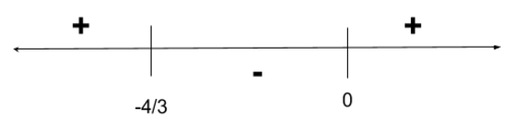Therefore, we have two critical points at $x=0$ and $x=-\frac{4}{3}$. Next, we must set up a sign chart for $f'(x)$ and ascertain the sign of $f'(x)$ on either side of the critical points. To the left of $x=-\frac{4}{3}$, we can plug in -2 ($-\frac{6}{3}$), which will yield a positive value. Between the critical points, we can plug in -1 ($-\frac{3}{3}$), which will yield a negative value. Finally, to the right of $x=0$ we can plug in 1, which will yield a positive value.

Based upon this sign chart, it is possible to tell that there is a local maximum at $x=-\frac{4}{3}$, as the slope goes from positive to negative, and a local minimum at $x=0$, as the slope goes from negative to positive.

Yet the first derivative test is not the only way to determine local maxima and minima. We can say that when a curve is concave down and the slope is 0, there will be a local maximum, and when the curve is concave up and with a slope of zero, there will be a local minimum. This is based upon the principle that local maxima and minima occur when there is a sign change in the first derivative. For the sign of the first derivative to change requires that the slope goes from negative to positive, or positive to negative, this requires that the first derivative itself has a positive or negative slope, respectively. Thus, since the second derivative is the derivative of the first derivative and tells us the slope of the first derivative, if the function is concave down ($f''<0$), meaning that the slope of $f'$ is less than 0, and $f'=0$, there is a maximum, while if the function is concave up ($f''>0$), meaning that the slope of $f'$ is greater than 0, and $f'=0$, there is a minimum.

However, it is important to note that this approach does not work in two cases. The first is if $f'$ does not exist at the given point, as this means that $f''$ will not exist either. As well, it will not work if $f''=0$, as this does not tell us if the graph is concave up or down at the given point.

All of this information leads us to the aptly named **Second Derivative Test** which states that, given a function $f(x)$, there will exist a local maxima when $f(x)''<0$ and $f'(x)=0$, given that $f(x)$ is continuous and differentiable and that point, and a local minima will exist when $f''(x)>0$ and $f'(x)=0$, given the same conditions. If, for some reason, $f(x)$ is not differentiable at the given point (such as at a corner), or $f''(x)=0$ (at a point of inflection), we will have to use the first derivative test.

Let’s use the second derivative test with the same function that we used for the first derivative test, $f(x)=x^{3}+2x^{2}$. First, it is important to determine where $f'(x)=0$. As we already know, $f'(x)=3x^{2}+4x$, and $f'(x)=0$ when $x=-\frac{4}{3}$ or 0. Next, for the second derivative test, we need to plug these points into $f''(x)$ and determine the concavity at these points. In this case, $f''(x)=6x+4$. Plugging in $x=-\frac{4}{3}$ yields -4, indicating that the concavity is downward at this point and that it is a local maximum. Plugging in $x=0$ yields 4, indicating that the concavity is upward at this point, and that it is a local minimum. Thus, the second derivative test is another effective tool we can use to determine local maxima and minima!

## Guided Practice

1. Given the function $f(x)=|x-2|$, identify any local maxima or minima.
   1. 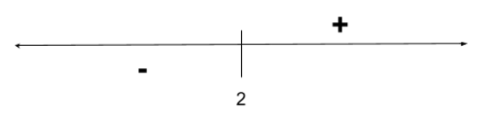Whether using the first or second derivative test, it is important to find the critical points, where $f'$ is either 0 or undefined. To find the derivative of an absolute value function, we will have to treat it as a piecewise function, as there is a corner where the slope instantaneously changes, and thus the derivative function is not continuous at that point. In practice, consider how a piecewise function, such as $y=|x|$ is essentially composed of two linear functions, meeting at $x=0$. Right of $x=0$, there is a line with a slope of +1 ($y=x$), while left of $x=0$ there is a line with a slope of -1($y=-x)$. Therefore, $y=|x|$ can be represented by (piecewise garbage). Similarly, we can $f(x)=|x-2|$ and represent it by 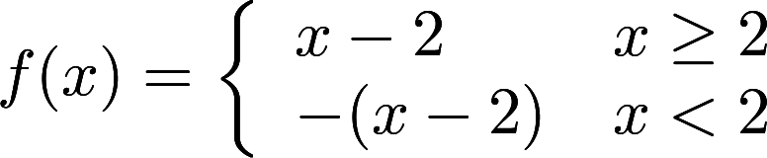, as there is a corner at $x=2$ (as this function is $|x|$ shifted two to the right horizontally), and left of this point is a line of $y=-1(x-2)$ (the same line as on the right, but with a negative slope) and on the right there is a line $y=x-2$. Finally, we can derive this! Deriving each part of the piecewise separately, we would find that 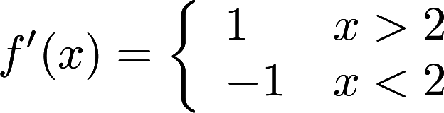. Note that we do not include $x=2$ in either domain, as $f'(2)=DNE$. Now, we must determine the critical points. There is one possible critical point at $x=2$, as $f'(2)$ does not exist. As well, we can attempt to set both parts of the derivative function equal to 0 to find other critical points- however, there is no point at which the lines $y=1$ or $y=-1$ equal 0; therefore, the only critical point is at $x=2$. Finally, we can do the first or second derivative test to determine if this is a local maxima/minima. The second derivative test won’t be useful here, as $f'(2)$ is undefined, meaning $f''(2)$ is undefined as well.
   2. Therefore, since the sign of the first derivative changes from negative to positive at $x=2$, there is a local minima at $x=2$.

1. Given the piecewise function 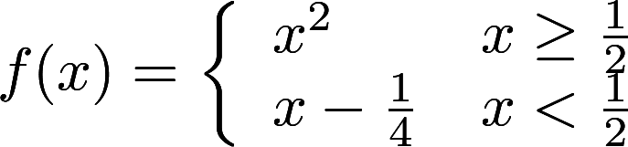, determine the coordinates of any local maxima or minima.
   1. Since this is a piecewise function, just as we saw in the first example, we must find the derivative by taking the derivative of each part independently. Therefore, 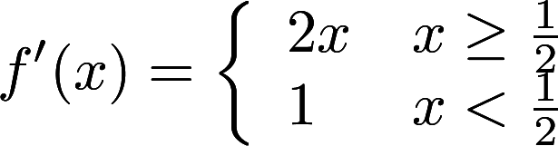. Next, we must determine the critical points! We can first test for critical points when $f'(x) = 0$ by setting each piece of the derivative equal to 0. For $f'(x) = 1$, $f'(x)=0$, and for $f'(x)=2x$, $f'(x)=0$ when $x=0$- however, this is not in the given domain of $2x$, so we throw this point out. As well, we can test for critical points when $f'(x)=DNE$. On all of $x^{2}$ and $x-\frac{1}{4}$, these functions are differentiable. However, there is a possible break in the overall piecewise function at $x=\frac{1}{2}$. Therefore, we must test for continuity on both the original function and the derivative function, to determine if it is continuous and differentiable at this point. Following the three-step process to determine continuity outlined earlier, we find that our function is continuous and differentiable at every point- indicating that there is no point where $f'(x) = DNE$. Thus, there are no critical points anywhere on this function, and no local maxima or minima.

## Lola Tries

1. Determine the coordinates of the local maxima and minima for $f(x)=x^{3}-12x+5$ on [-5,3]
2. Determine the critical points for $f(x)=x⋅tan(x)$.
3. Determine x-coordinates of the local maxima and minima for $f(x)=ln(x)$.

Next Stop: India

# http://cdn1.buuteeq.com/upload/18138/india-tours-jaipur-gangaur-festival.jpg.1340x0_default.jpghttp://www.luxurysociety.com/media/uploads/de/a9/dea9a4f8-07c6-4f57-96ba-b91752181a31/india-.jpgWelcome to India!

भारत में आपका स्वागत है!

What is the Extreme Value Theorem?

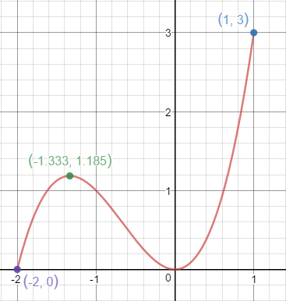

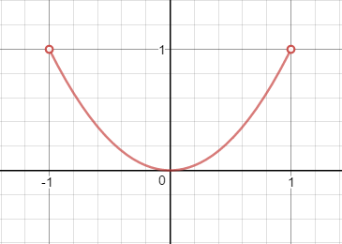Up to this point, we’ve only discussed **local** maxima and minima; essentially, points which are the maxima or minima on very small, or “local”, intervals. However, these points are not necessarily the highest or lowest point on a graph, whether across the entire function, or even a specific interval. Local maxima and minima are not the same **absolute** maxima and minima- points which are *absolutely* the highest/lowest on an interval. For example, on the graph to the right, there may be a local maximum at (-1.333, 1.185), however, the absolute maximum is at (1, 3), and the absolute minima is at (-2, 0).  
 These absolute values are also known as extreme values, and they are governed by the **Extreme Value Theorem**. This theorem states that if a function, f, is continuous on the closed interval [a, b], then f must achieve an absolute maximum and an absolute minimum on [a, b]. These extreme values will either occur at the endpoints (a and b) or at a critical point on [a, b]. In less math-y terms, this basically means that if a function is continuous on a closer interval, there has to be an absolute maximum and minimum value. It is important to note that there can be multiple instances of the absolute maximum or minimum value, such as on a periodic function like sine or cosine. As well, it is even more important that the interval [a, b] is closed. For the graph on the left, we would not be able to apply EVT on [-1, 1], as there are holes at x = -1 and 1! Finally, it is important to remember that the function does not have to be differentiable. Even if the function is a series of cusps or corners, these can still be absolute maxima and minima.

Let’s take a look at the Extreme Value Theorem in practice. Take the function $f(x)=\frac{x^{2}-2x+1}{x+1}$, where we want to determine the absolute minima and maxima on the interval [-10, 10]. First, we must determine the critical points, to find any local maxima or minima. In this case, $f'(x)=\frac{x^{2}+2x-3}{(x+1)^{2}}$. We can determine the critical points where $f'(x)=0$ or DNE. We know that $f'(x)=0$ when the numerator is 0. Therefore, we know there are two critical points at $x=1$ and $x=-3$. As well, $f'(x)$ will be DNE when the numerator is 0, as this would result in a $\frac{0}{0}$ scenario. Therefore, there is another critical point at $x=-1$. Then, to determine if this critical points are at local maxima or minima, we can apply the first derivative test.

After completing the first derivative test, we find that there is a local maximum at $x=-3$ and a local minima at $x=1$, and an asymptote at $x=-1$ (due to the $\frac{c}{0}$ scenario) which we throw out. In order to determine the absolute maxima and minima however, we must then compare the y-value of the endpoints with the y-value of the local maxima and minima. Doing so yields the following:

$$f(-3)=\frac{(-3)^{2}-2(-3)+1}{-3+1}=\frac{9-6+1}{-2}=\frac{4}{-2}=-2 \\ f(1)=\frac{(1)^{2}-2(1)+1}{1+1}=\frac{1-2+1}{2}=0 \\ f(-10)=\frac{(-10)^{2}-2(-10)+1}{-10+1}=\frac{100+20+1}{-9}=-\frac{121}{9} \\ f(10)=\frac{(10)^{2}-2(10)+1}{10+1}=\frac{100-20+1}{11}=\frac{81}{11}$$

Based upon these results, that, for the curve $f(x)=\frac{x^{2}-2x+1}{x+1}$ on [-10,10], the absolute maximum is at (10, $\frac{81}{11}$) and the absolute minimum is at (-10, $-\frac{121}{9}$).

## Guided Practice

1. Determine the number of absolute maxima and minima for the curve graphed below on [0, 5]
   1. 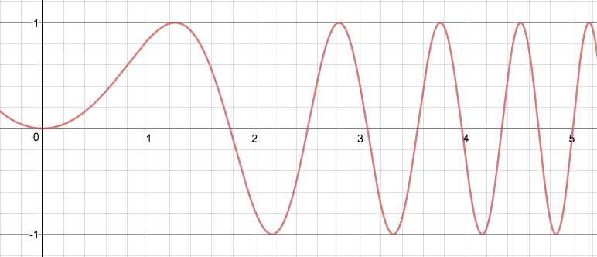Although we do not have a function with which to test critical points or exact y-values, we can still follow the basic principle of Extreme Value Theorem. That is, as long as a function is continuous on the given closed interval, there will be absolute extrema which are the highest/lowest points on the curve. In this example, there would be 5 absolute maxima, and 4 absolute minima. There are 5 absolute maxima, as there are 5 peaks which reach the highest y-value of 1. There are 4 absolute minima as only 4 valleys reach the lowest y-value of -1. As well, the point at $x=0$ is **not** an absolute minimum as there are points which are lower, and the same logic applies for the point at $x=5$.
2. Determine if any maxima or minima are guaranteed per EVT for the function 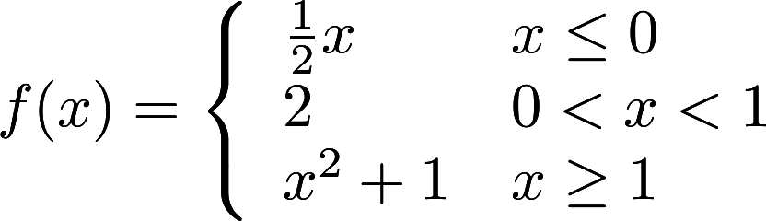 on [-2, 2].
   1. Since this is a piecewise function, it is especially important to ensure that it is continuous, so that we can apply the Extreme Value Theorem. To check it’s continuity, we simplify use the three-step process outlined earlier on!
   2. We’ll first test for continuity at the possible breakpoint when $x=0$. At $x=0$, $f(0)=\frac{1}{2}(0)=0$. The limit from the left of 0 evaluates as $\lim_{x→0^{-}}f(x)=\lim_{x→0^{-}}\frac{1}{2}x=\frac{1}{2}(0)=0$, and the limit from the right of 0 evaluates as $\lim_{x→0^{+}}f(x)=\lim_{x→0^{+}}2=2$. Since the limit from the left does not agree with the limit from the right, the function is not continuous at $x=0$. This makes the problem much easier! If the function is not continuous, EVT does not apply, and thus we cannot guarantee any maxima or minima occur on the function.

## Lola Tries

1. Find the absolute minima and maxima for $f(x)=-x^{3}-6x^{2}-9x+3$ on [-3, -1].
2. Find the absolute minima and maxima for $f(x)=\frac{8}{x^{2}+4}$ on [0, 5].
3. Find the absolute minima and maxima for $f(x)=\frac{x^{2}}{3x-6}$ on [3, 6].

Next Stop: Sri Lanka

# http://wildspace.biz/Images/WildSpace/itineary/SL%20Image%201%20Buddha.jpghttps://brightcove04pmdo-a.akamaihd.net/5104226627001/5104226627001_5222667804001_5219436382001-vs.jpg?pubId=5104226627001&videoId=5219436382001Welcome to Sri Lanka!

ශ්රී ලංකා වෙත ඔබව සාදරයෙන් පිළිගනිමු!

What is implicit differentiation?

Take a relation such as $x+4y=2$. Usually, to derive this **implicit relationship**, we would attempt to put it into $y=x$ form- i.e., an **explicit** **relationship**, where we solve for one variable, and derive from there. However, take an implicit relation such as $x^{2}+2xy+y^{2}=9$. Although it *might* be *technically* possible to put this into $y=x$ form, it would be a lot easier if there were a way to derive it in this form- and there is! To derive an implicit relationship requires the aptly-named **implicit differentiation**

Typically, implicit differentiation relies on Leibnitz notation (i.e., $y' = \frac{dy}{dx}$). If we want to implicit derive a relation with respect to x, that is, x is the independent variable, we would write it like $\frac{d}{dx}(x^{2}+2xy+y^{2}=9)$. Although it looks like we are multiplying by “ $\frac{d}{dx}$”, this simply means that we are attempting to find how each variable changes as x changes. Let’s attempt to derive this example function. Although the notation is different, we still follow many of the same rules. The derivative of $x^{2}$, according to power rule, is $2x$. However, for implicit differentiation, we will multiply $2x$ by $\frac{dx}{dx}$. One way to understand this is that $x^{2}$ can be thought of as a chain rule, where $x$ is the interior function. In a chain rule sense, we follow power rule, bringing a 2 down in front, and subtracting one from the exponent. Then, we must derive the interior function, x. Since the derivative describes how a variable changes with respect to the independent variable, when we derive x in terms of x we represent this as $\frac{dx}{dx}$.Next, we must derive $2xy$ using the product rule, as x and y are separate terms. We would first derive $2x$, yielding $2\frac{dx}{dx}$ multiplied by y left alone, and then add on the derivative of y times 2x. However, when deriving y, we would not just get 1- we would get $1\frac{dy}{dx}$, as $\frac{dy}{dx}$ represents the derivative of y itself, how y changes with respect to x, and this would be multiplied by 2x left alone. Thus, product rule would yield $2\frac{dx}{dx}y + 2x\frac{dy}{dx}$. Now we must derive $y^{2}$ which, according to these new principles of implicit differentiation, would be $2y\frac{dy}{dx}$. Finally, we would have to derive 9- and since it is a constant, it would just be 0. Overall, the derivative of our implicit relation would be $2x\frac{dx}{dx}+[2\frac{dx}{dx}y + 2x\frac{dy}{dx}] +2y\frac{dy}{dx}=0$. Yet we can simplify this a little further, since $\frac{dx}{dx}$ will always simplify to 1, as anything divided by itself is always 1. Therefore, our derivative would be $2x + 2y + 2x\frac{dy}{dx}+2y\frac{dy}{dx}=0$.

Just like a normal derivative, we can use the derivative of an implicit relation to determine the derivative at a specific point. There are two ways which we can approach this, depending on how complex the derivative is. Let’s continue our earlier example, and attempt to find the derivative at the point (2,1). The first way we can do this is to simplify plug in $x=2$ and $y=1$ into the derivative, and solve for $\frac{dy}{dx}$- i.e., the slope (like $\frac{Δy}{Δx}$). In this example, plugging in (2,1) would yield the following, $2(2)+2(1)+2(2)\frac{dy}{dx}+2(1)\frac{dy}{dx}=0$ We can simplify this to $5+5\frac{dy}{dx}=0$. Next, we can move the 5 to the other side, to isolate the $\frac{dy}{dx}$. $5\frac{dy}{dx}=-5$. Thus $\frac{dy}{dx}=-1$.

However, we can also attempt to solve the derivative at a specific point by symbolically solving for $\frac{dy}{dx}$. In this example, we would begin by isolating the $\frac{dy}{dx}$ terms, by subtracting 2x and 2y to the right side, giving us $2x\frac{dy}{dx}+2y\frac{dy}{dx}=-2x-2y$. From there, we can factor out a $\frac{dy}{dx}$ term on the left side, yielding $\frac{dy}{dx}(2x+2y)=-2x-2y$ 
. Finally, we can divide both sides by $2x+2y$ in order to fully isolate $\frac{dy}{dx}$, and thus we find that $\frac{dy}{dx}=\frac{-2x-2y}{2x+2y}$. Now we can solve for the derivative, $\frac{dy}{dx}$, at (1,1) by plugging this point into $\frac{dy}{dx}=\frac{-2x-2y}{2x+2y}$. Evaluating $\frac{dy}{dx}|_{(1,1)}$ will gives us $\frac{dy}{dx}=\frac{-2\left(2\right)-2(1)}{2\left(2\right)+2(1)}$, which simplifies to $\frac{dy}{dx}=\frac{-4-2}{4+2}=\frac{-6}{6}=-1$

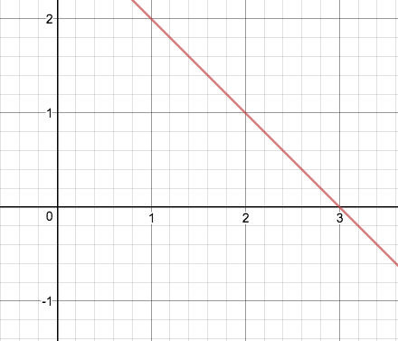As a quick *tangent*, we can confirm that this is true by graphing our relation- though sometimes this is more difficult with more complex ones! In this case, our relation would be the red graph, and it is clear to see that at (2,1), $\frac{dy}{dx}=-1$ if we were to draw a tangent line there.  
 Ultimately, the first method is always possible, even if the original relation cannot be solved explicitly.

When implicitly deriving at a specific point, there are three important results which can tell us a lot about our relation. The first is when $\frac{dy}{dx}=0$- just like in the derivative of an explicit function, this indicates a horizontal tangent line as it means there is a slope of 0. The second is when $\frac{dy}{dx}=\frac{c}{0}$, where $c$ is some constant, which indicates a vertical tangent line. The third is when $\frac{dy}{dx}=\frac{0}{0}$. It is important to remember that this is not 1 or 0, as anything divided by 0 is undefined! However, $\frac{0}{0}$ is different than $\frac{c}{0}$, which is also undefined, but which indicates a vertical tangent. When $\frac{dy}{dx}=\frac{0}{0}$, this indicates that there is no tangent line at the point at all and that the point does not exist on the graph.

## Guided Practice

1. Find the derivative of $y=x+sec(y)$
   1. Although this looks like it is explicit form, watch out for the y in $sec(y)$! In fact, in this situation it is not possible to put it in explicit form. Therefore, we must implicitly derive it. In this example, the first thing we will derive is $y$, which, as we established earlier, will become $\frac{dy}{dx}$. Similarly, the $x$ immediately to the right of the equals sign will go to $\frac{dx}{dx}$, which simplifies to 1. Then, we need to derive secant- and make sure that we don’t forget the chain rule! First, we will derive the outside, which is the secant function itself, and we know that the derivative of $sec⁡(y)$ will become $\sec\left(y\right)tan⁡(y)$. Secondly, however, we must remember to take the derivative of the inside and multiply it by the outside derivative as well. The derivative of the inside, y, will be $\frac{dy}{dx}$, and so the derivative of $sec⁡(y)$ will be $\sec\left(y\right)tan⁡(y)\frac{dy}{dx}$. Combining all of this together, the implicit derivative of our function will be $\frac{dy}{dx}=1+\sec\left(y\right)tan⁡(y)\frac{dy}{dx}$.
2. Find $\frac{dy}{dx}$ at $x=1$ for $y^{2}+x=2xy$
   1. To find $\frac{dy}{dx}$ at a specific point, we must first implicitly derive! Going from left to right, we find that the derivative of $y^{2}$, according to power rule, will become $2y\frac{dy}{dx}$ and the derivative of $x$ will become $\frac{dx}{dx}$. To handle $2xy$ will require product rule. We will first derive $2x$, which would be $2\frac{dx}{dx}$, and multiply it by $y$ left alone. Then we will derive $y$, becoming $\frac{dy}{dx}$, and multiply it by $2x$ left alone. Adding these terms together to complete product rule, we find that the derivative of $2xy$ is $2\frac{dx}{dx}\left(y\right)+2x\frac{dy}{dx}$. Putting everything together, we find that our initial, un-simplified derivative is $2y\frac{dy}{dx}+1\frac{dx}{dx}=2\frac{dx}{dx}\left(y\right)+2x(1\frac{dy}{dx})$.
   2. From there, we can simplify our derivative and “clean it up” a little. The main way to do this is recognize that $\frac{dx}{dx}$ goes to 1. Replacing all $\frac{dx}{dx}$ terms with 1, our derivative becomes $2y\frac{dy}{dx}+1=2y+2x\frac{dy}{dx}$. Next, we will algebraically maneuver our derivative to isolate $\frac{dy}{dx}$. First, we can subtract the from the left side 1 to the right side, and the $2x\frac{dy}{dx}$ from the right side to the left side, giving us $2y\frac{dy}{dx}-2x\frac{dy}{dx}=2y-1$. Then, we can factor out a $\frac{dy}{dx}$ on the left side, and our derivative becomes $\frac{dy}{dx}\left(2y-2x\right)=2y-1$. Finally, we can divide both sides by $2y-2x$ in order to isolate $\frac{dy}{dx}$, giving us $\frac{dy}{dx}=\frac{2y-1}{2y-2x}$  
      .
   3. Now, we must plug in our point, $x=1$. However, based upon our general derivative for this relationship, we need an x and a y coordinate. Therefore, we can plug in $x=1$ into the original relation in order to determine the y-coordinate (or coordinates!) which occur when $x=1$. Therefore, plugging in $x=1$ into the original relation would give us $y^{2}+(1)=2\left(1\right)y$, which can be quickly simplified to $y^{2}+1=2y$. From there, we can subtract the $2y$ to the left side, so that it is in a more recognizable form- a quadratic equation! $y^{2}-2y+1=0$. Now all we have to do is find the points at which this equation equals 0, which can be accomplished by factoring it into $\left(y-1\right)\left(y-1\right)=0$. Setting these individual terms equal to 0, we find that the only valid y-coordinate is 1.
   4. Therefore, the y-coordinate at $x=1$ is $y=1$, and the point we plug into the derivative is $(1,1)$.
   5. Finally, we can plug this into the derivative function, which would evaluate as $\frac{dy}{dx}|_{(1,1)}=\frac{2(1)-1}{2(1)-2(1)}=\frac{1}{0}=DNE!$
   6. Remember the special cases from earlier? $\frac{c}{0}$, such as $\frac{1}{0}$, will result in a vertical tangent line. Thus, at the point $(1,1)$ on this relation there is a vertical tangent line.

## Lola Tries

1. Solve for $\frac{dy}{dx}$ given the relation $x^{2}-5xy+3y^{2}=7$.
2. Solve for $\frac{dy}{dx}$ given the relation $\sqrt{xy}=x+3y$
3. Find the derivative, given $4sin(2y)cos(x)=2$.

Next Stop: Australia

# Image result for australian outback*Image result for australia*Welcome to Australia!

What are the derivatives for exponential and logarithmic functions?

We can also take derivatives of exponential and logarithmic functions! Like the derivatives of trigonometric functions, the derivatives of exponential and logarithmic functions have definitive rules!



$\frac{d}{dx}(e^{x})=e^{x}$

$\frac{d}{dx}(lnx)=\frac{1}{x}$

$\frac{d}{dx}(a^{x})=lna ×a^{x}$

$\frac{d}{dx}(\log_{a}x)=\frac{1}{lna × x}$

One of these rules may stick out to you; $\frac{d}{dx}(e^{x})=e^{x}$. How can the derivative of a function be itself?! Looking at the graph, you can see this derivative in action, and we can prove it using the limit definition of a derivative below!

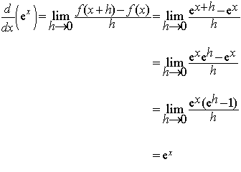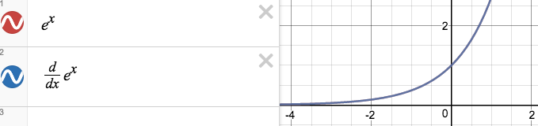

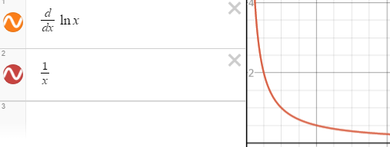We can also prove the derivative of $y=lnx$ through implicit differentiation. First, you can rewrite the equation as $e^{y}=x$. Now we implicitly derive. $\frac{d}{dx}(e^{y}=x)=e^{y}\frac{dy}{dx}=1$. Then, we divide $e^{y}$ to the other side. We then have $\frac{dy}{dx}=\frac{1}{e^{y}}$. We earlier stated that $e^{y}=x$, so this becomes $\frac{dy}{dx}=\frac{1}{x}$.

The other two rules are simply special cases of the derivatives of $y=lnx$ and $y=e^{x}$.

For example, what is $\frac{d}{dx}(\log_{15}(9x^{15}))$?. First we identify the rule to use. We have to use $\frac{d}{dx}(\log_{a}b)=\frac{1}{lna × x}$. Using this rule, we would have $y'=\frac{1}{ln(15)×9x^{15}}$. We also have to use chain rule and power rule. The derivative of the inside piece, $9x^{15}$, is $135x^{14}$. Our overall derivative would become $y'=\frac{1}{ln(15)×9x^{15}}×135x^{14}$. This can be simplified to $y'=\frac{15}{ln(15) ×x}$

See! It’s not that hard! As long as you remember the derivative rules, derivatives of exponential and logarithmic functions are quite simple.

## Guided Practice

1. If $y=3^{x}+11^{x}+5^{x^{2}+ 8x}+2^{cos(e^{6x})}$. What is y’?
   1. To do this derivative, we can take it piece by piece. The first piece, $3^{x}$, would have a derivative $ln(3) ×3^{x}$.
   2. We can then can take the derivative of the next piece, $11^{x}$. It will have a similar derivative to $3^{x}$, as is uses the same rule. The derivative would be $ln(11)×11^{x}$. Next, we take the derivative of $5^{x^{2}+8x}$. We would use the same rule as the first two derivatives, but we would have to use chain rule as well! First, we do the derivative of the “outside” part. The derivative of $5^{x^{2}+8x}$ is $ln(5)×5^{x^{2}+8x}$. Then, we take the derivative of the “inside” part. The derivative of $x^{2}+8x=2x+8$ using power rule. So the derivative of $5^{x^{2}+8x}=ln(5)×5^{x^{2}+8x}(2x+8)$.
   3. Now, all we have to do is take the derivative of $2^{cos(e^{6x})}$. We are using the same rule again, just with the chain rule component. ${\frac{d}{dx}2}^{cos(e^{6x})}=ln(2) ×2^{cos(e^{6x})}$. Now we take the derivative of the “inside” part $cos(e^{6x})=-sin(e^{6x})$. There is still another layer to take the derivative of! $\frac{d}{dx}e^{6x}=e^{6x}$. Finally, we take the derivative of the last layer of chain rule, $6x$. $\frac{d}{dx}6x=6$. If we piece this entire derivative together, we get $-6ln(2)sin(e^{6x})(e^{6x})(2cos^{(e^{6x})}).$
   4. Finally, we can put the derivatives of all the pieces together! We are left with $y'=ln(3)3^{x}+ln(11)11^{x}+ln(5)5^{x^{2}+8x}(2x+8)-6ln(2){sin(e}^{6x})(e^{6x})(2cos^{{(e}^{6x})})$
   5. Though this looks overwhelming, since we took it piece by piece, it wasn’t actually too bad!
2. State $\frac{dy}{dx}$ at (1,8) for $\log_{2}y-ye^{1-x^{3}}=-5$
   1. Since we have x’s and y’s in our function, we will have to implicitly derive! The derivative of $\log_{2}y=\frac{1}{yln(2)}\frac{dy}{dx}$, as we are deriving with respect to x!
   2. Next, we must use some product rule for the next piece $-ye^{1-x^{3}}.$ We first take the derivative of the first function, -y, and multiply it by the second function, $e^{1-x^{3}}$, left alone. This would yield $-\frac{dy}{dx}(e^{1-x^{3}})$. Then we add the derivative of the second function, $e^{1-x^{3}}$, and multiply it by the first function, -y, left alone.  
       To take the derivative of the second function, we would first use our exponential derivative rule, and then some chain rule. The derivative of the “outside” part $e^{1-x^{3}}$. This would give us $e^{1-x^{3}}$. Then we multiply it by the derivative of the “inside” part, $1-x^{3}=-3x^{2}$. We would have $-3x^{2}(e^{1-x^{3}})\frac{dx}{dx}.$ Since $\frac{dx}{dx}=1$, we can simply leave it out, giving us $-3x^{2}(e^{1-x^{3}})$. Lastly, we multiply it by the first function, -y, left alone. This gives us $3x^{2}y(e^{1-x^{3}})$. Our overall derivative for this piece would be $-\frac{dy}{dx}(e^{1-x^{3})}+3x^{2}y(e^{1-x^{3}})$
   3. We can then take the derivative of -5. $\frac{dy}{dx}-5=0$, as it is a constant.
   4. We are now left with the derivative function $(\frac{1}{yln(2)}\frac{dy}{dx})-\frac{dy}{dx}(e^{1-x^{3}})+3x^{2}y(e^{1-x^{3}})=0$.
   5. Since we have to find the derivative at a specific point, we can plug this point in, as we have x’s and y’s in the function! We plug in 8 for every spot we see y, and 1 for every spot we see x, as we want $\frac{dy}{dx}$ at (1,8). We then get $(\frac{1}{8ln(2)}\frac{dy}{dx})-\frac{dy}{dx}(e^{1-({1)}^{3}}) +3({1)}^{2}(8)(e^{1-({1)}^{3}})=0$. This simplifies to $(\frac{1}{8ln(2)}\frac{dy}{dx})-\frac{dy}{dx}+24=0$. We can subtract the 24 over to give us $\frac{1}{8ln(2)}\frac{dy}{dx}-\frac{dy}{dx}=-24$. Next we factor out a $\frac{dy}{dx}$ on the left side, giving us $\frac{dy}{dx}(\frac{1}{8ln(2)}-1)=-24$. Finally, we can divide the $\frac{1}{8ln(2)}-1$ to the other side.
   6. $\frac{dy}{dx}=\frac{-24}{\frac{1}{8ln(2)}-1}$ To simplify this, we first need to get a common denominator between $\frac{1}{8ln(2)}$ and -1. We can multiply $8ln(2)$ to both the top and the bottom of -1, giving us $\frac{-8ln(2)}{8ln(s)}$. Thus, combining $\frac{1}{8ln(2)}-1$ gives us $\frac{1-8ln(2)}{8ln(2)}$. We then have $\frac{dy}{dx}=\frac{-24}{\frac{1-8ln(2)}{8ln(2)}}$ which simplifies to $\frac{dy}{dx}=\frac{-192ln(2)}{1-8ln(2)}$.

## Lola Tries

1. What is y’ when $y=e^{x^{3}}+x^{3}$?
2. State the normal line for the coordinate (1,0) of $e^{3y}+cos(xy)=2x$
3. Differentiate $f(x)=4\log_{3}x-ln(x)$.

Next Stop: Indonesia

# http://www.globalindonesianvoices.com/wp-content/uploads/2013/10/indonesian-people.jpghttp://i.cdn.cnn.com/cnn/.e/img/3.0/branding/backgrounds/on-the-road-indonesia/on-the-road-indonesia-background-full.jpgWelcome to Indonesia!

Selamat Datang di Indonesia!

How do I apply derivatives to solve related rates?

Imagine you have two **related rates**, such as in a circle whose radius is expanding at one rate, and you want to find the rate at which the area is increasing. The rate that the area increases is somehow related to the rate that the radius increases. Normally, this would sound pretty tough- but using calculus we can make it even tougher in a different (yet solvable) way!

To explore the concept of related rates, let’s take a look at a specific example.

*Oil from a leaking boat spills onto a lake in a perfectly circular pattern (see “Sukian” circle). If the radius of this circle increases at a constant rate of 3 feet/minute, at what rate is the area of the oil spill increasing at the end of ten minutes?*

In order to tackle this problem, there are a few key pieces of information we must first identify. First of all, it helps to identify that we are dealing with a circle! This problem also tells us the rate at which the radius changes with respect to time, in feet per minute- i.e, $\frac{dr}{dt}=3 ft/min.$ Using this information, it wants us to determine the rate at which the area increases with respect to time- $\frac{dA}{dt}$- at the end of 10 minutes, where $t=10$ in this context.

After identifying these pieces of information we are either given or asked to find, it is important to identify the mathematical relationships which likely apply in the given problem. In this case, since we are given a circle there are two which could be relevant: $A=πr^{2}$ and $C=πd=2πr$.

Since this problem gives us the rate at which the radius changes, and wants us to determine the rate at which the area changes, we need to use $A=πr^{2}$. However, you are probably asking yourself, “How the heck does this tell me anything about *rates*? It only describes the nonlinear relationship between the fixed distance from a center point to any other point, on a locus where every point is the same distance from the center, and the area inside that locus!” If you are asking yourself this, please promptly close this Calculus Manual and resume progress on your mathematics degree- you clearly have much better things to do with your time at the moment. However, if you asked yourself something similar, simpler, and more sensical, please continue.

Although $A=πr^{2}$ itself only describes the relationship between area and radius at a specific radius/area, regardless of time, we have a trick up our selves- implicit differentiation! We need to only implicitly derive this function with respect to time, and that will show us how these variables change with respect to time- also known as their respective rates of change! Following our rules of implicit differentiation and the power rule, we know that the derivative of $A$ with respect to time will become $\frac{dA}{dt}$, while the derivative of $πr^{2}$ will become $2πr\frac{dr}{dt}$, giving us a complete derivative of $\frac{dA}{dt}=2πr\frac{dr}{dt}$.

Now we have a relationship between the *rates*! From here, we only need to plug in the information given to us in order to solve for $\frac{dA}{dt}$, right? Almost! We have $\frac{dr}{dt}$- it is 3- yet we do not have $r$ itself. Remember, this problem asks us to find $\frac{dA}{dt}$ at the end of 10 minutes- and since $\frac{dr}{dt}≠0$, $r$ must be changing. Therefore, using the fact that $\frac{dr}{dt}=3$, we can determine that at $t=10$, $r=3 \frac{ft}{min}*10 min=30 ft$. Then, we can go ahead and plug it all in, giving us $\frac{dA}{dt}=2π(30 ft)(3 \frac{ft}{min})$. In this example, I included the units so that we remember them, however, units are typically not included until the final answer. Speaking of which, our final answer would be $2π$ times 30 times 3, or $\frac{dA}{dt}=180π \frac{ft^{2}}{min}$.

In related rates problems, **always remember your units**- even if the problem asks it in such a way that it sounds like you don’t need to write in the units, the problem is likely trying to trick you- so **always remember your units**. In this problem, the unit for $\frac{dA}{dt}$ will be feet-squared per minute, which makes sense, because area is typically measured in units-squared.

Another common type of related rates problem deals with proportions and cones. For some reason, a lot of mathematicians build their water coolers or containers as inverted cones- why this occurs is a greater mystery than the answers to the word problems themselves. The following problem below is a prime example of this.

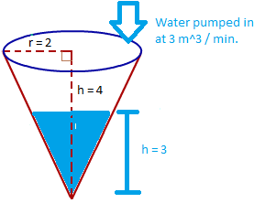*A water tank has the shape of an inverted circular cone with a base radius of 2 meters and a height of 4 meters. If water is being pumped into the tank at a rate of 2 cubic-meters per minute, find the rate at which the water level is rising when the water is 3 meters deep.*

Just like in the first problem, it is important to highlight the most important details and discern their meaning. Firstly, the problem tells us that there is a water tank the shape of an inverted circular cone with a radius of 2 meters and 4 meters- essentially, a big ice cream cone. For our purposes, we can ignore the “slant height” detailed in the diagram to the right. As well, it tells us that the volume, $V$, increases by 2 $\frac{m^{3}}{min}$; therefore, $\frac{dV}{dt}=2 \frac{m^{3}}{min}$. As well, it wants us to determine the rate at which the water level is rising, which means that we must determine the rate at which the height of the waterline is changing, $\frac{dh}{dt}$. Finally, we must determine $\frac{dh}{dt}$ when $h=3 meters$, as it asks for $\frac{dh}{dt}$ when the water is 3 meters deep. We can combine all of this information into an efficient diagram, displayed on the right. With all of our information assembled, we can now begin the actual process of solving. Again, a good next step is to identify the mathematical relationships which are relevant to the context of the problem. In this scenario, we know that the volume of a circular cone is $V=\frac{1}{3}πr^{3}$.   
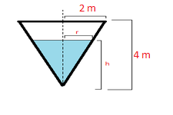However, when we derive it, we encounter what is known mathematically as a **problem**, which would rank, in terms of severity, somewhere between dividing by 0 and realizing there is a back page to your calculus test 5 minutes before third block is over. When we implicitly derive the volume formula with respect to time, the derivative for $V$ is $\frac{dV}{dt}$, and according to power rule, the derivative for $\frac{1}{3}πr^{3}$ will be $πr^{2}\frac{dr}{dt}$, giving us an overall derivative of $\frac{dV}{dt}=πr^{2}\frac{dr}{dt}$.

Although our derivative includes $\frac{dV}{dt}$, we have no idea what $r$ or $\frac{dr}{dt}$ is! Furthermore, we are not even looking for $\frac{dr}{dt}$, we are looking for $\frac{dh}{dt}$! Therefore, we need some way to relate $r$ and $h$, so that we can replace $r$ in the volume equation. Consider the circular cone water tank again. As water is pumped in, the water in the cone will look like the artwork to the right. As the water rises, it will form a triangle of base $r$ and height $h$, and importantly, these triangles will always be similar to the big triangle formed when the tank is completely full. This big triangle will have a radius/base of 2 meters and a height of 4 meters, and since this triangle is similar to the smaller triangles formed as the tank fills, we can make a proportion between the base and height of a smaller triangle and the bigger triangle! Specifically, it will look like $\frac{r}{h}=\frac{2}{4}$, as we know that the ratio between the base and the height will always be proportional to the ratio between the base and height of the big triangle.

How is this useful though? Through some *mathemagical* algebra! Remember, we want to substitute $r$ for $h$ in the volume equation, as we don’t have $r$ or $\frac{dr}{dt}$. Therefore, we can maneuver the equation to solve for $r$ in terms of $h$, by first cross-multiplying the 4 to $r$ and 2 to $h$, giving us $4r=2h$, and then dividng both sides by 4 to isolate $r$, yielding $r=\frac{1}{2}h$

Finally, we can substitute $r$ in with $\frac{1}{2}h$ in the volume formula and derive! Substituting r would yield $V=\frac{1}{3}π(\frac{1}{2}h)^{2}h$, which, once the $\frac{1}{2}h$ is squared, becomes $V=\frac{1}{3}π(\frac{1}{4}h^{3})$ and simplifies to $V=\frac{1}{12}h^{3}$. Next, we must derive it. The derivative for $V$, as established earlier, is $\frac{dV}{dt}$. Then, the derivative of $\frac{1}{12}h^{3}$ will be $\frac{1}{4}πh^{2}\frac{dh}{dt}$ according to the power rule. Thus, $\frac{dV}{dt}=\frac{1}{4}πh^{2}\frac{dh}{dt}$.

Now, we have a usable derivative and information we can plug into it. We already know $h$, as we wanted to find $\frac{dh}{dt}$ when $h=3$. As well, we were told that $\frac{dV}{dt}=2$. Therefore, we can solve for $\frac{dh}{dt}$! Plugging in these values will give us $(2)=\frac{1}{4}π(3^{2})\frac{dh}{dt}$, which simplifies to $2=\frac{9}{4}π\frac{dh}{dt}$. Then, all we need to do is to divide by $\frac{9}{4}π$ on both sides to isolate $\frac{dh}{dt}$, yielding $\frac{dh}{dt}=\frac{8}{9π}$. Therefore, we know that the water level, $h$, is rising at a rate of $\frac{8}{9π}$ meters per minute.

There is one last type of related rates problem. Imagine, for a moment, you see someone on the street at night and want to determine how quickly the length of their shadow is changing. Be sure that when conducting this experiment you are discreet- they may be startled by someone with a yard stick and calculator randomly approaching them.   
However, once you have collected vital information, such as the length of their shadow at various times and the height of the person, you can return home and use calculus to determine any number of different rates. Let’s take a look at an example problem to demonstrate this.

*A street light is mounted at the top of a 15 foot-tall pole. A man 6 feet tall walks away from the pole with a speed of 5 feet per second along a straight path. How fast is the tip of his shadow moving when he is 40 feet from the pole?*

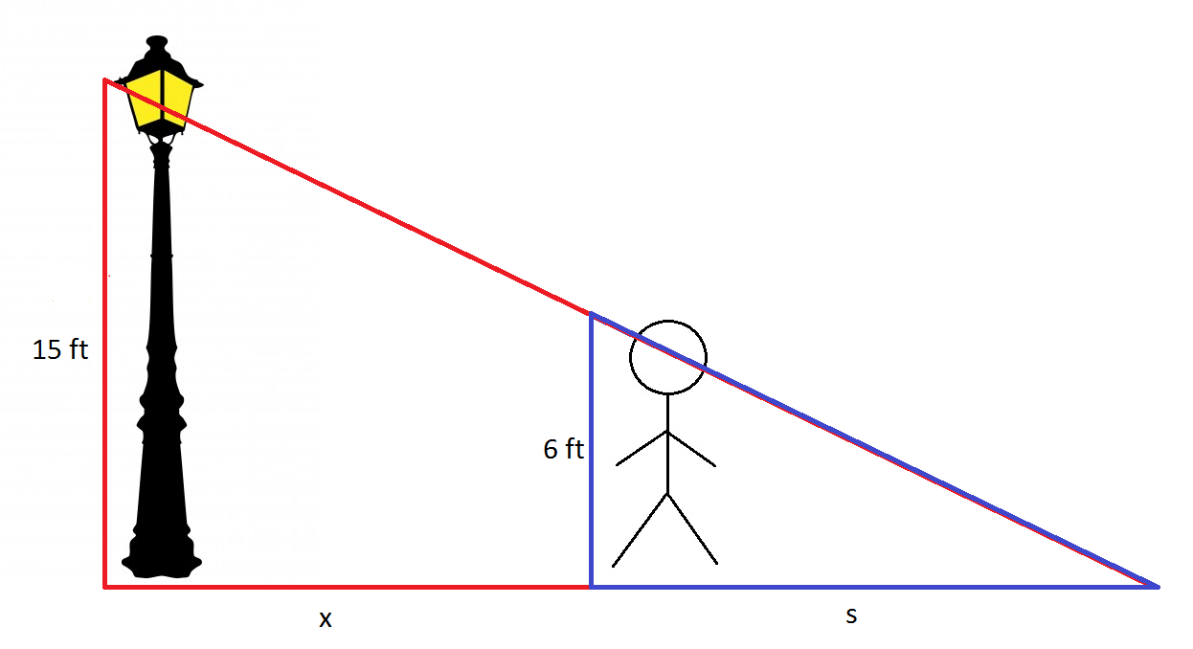 To visual this problem, we can draw a triangle representing the man and his shadow, and a larger one representing the shadow and the light pole. In the diagram to the right, $x$ represents the man’s distance from the pole, $s$ represents the length of his shadow, and his height of $6 ft$ represents an unrealistic personal dream. In order to begin, we must determine the correct mathematical relationship between all of these variables. Although we could use the Pythagorean theorem, that would make the problem much more difficult as we do not know what the hypotenuses of either triangle are at any moment, nor do we have the rates they are changing. Instead, we can employ the same mathematical trick from the last problem- similar triangles! Since the blue triangle, between the man and his shadow, is squarely inside the larger triangle between the shadow and the light pole, we know that they are similar. Therefore, if the base of the big triangle is $x+s$ and it’s height is 15, while the base of the small triangle is $s$ with a height 6, we can set up a proportion such that $\frac{15}{x+s}=\frac{6}{s}$. From there, we can cross multiply the $s$ to 15 and $x+s$ to 6, which gives us $15s=6(x+s)$. Finally, we can distribute the 6, and our equation becomes $15s=6x+6s$.

Note that we use $x+s$ to represent the base of the larger triangle, as the base is composed of both the length between the base of light pole and the man, and the length between the man and the tip of his shadow! Note also that we algebraically maneuvered the relationship so that it is no longer a fraction, and thus easier to derive and deal with emotionally later on (for quotient rule can be very taxing). Now, let’s try to derive this and see what we can do! Going from left to right, we start by deriving $15s$ with respect to time, which will simply become $15\frac{ds}{dt}$. Then, on the right side, the derivative of $6x$ will be $6\frac{dx}{dy}$ and the derivative of $6s$ will be $6\frac{ds}{dt}$. In total, the derivative is $15\frac{ds}{dt}=6\frac{dx}{dt}+6\frac{ds}{dt}$.

Before we continue, remember that we are attempting to find the rate at which the distance between the base of the light pole and the tip of the shadow is changing- i.e., we are attempting to find how $x+s$ changes, which can be represented as $\frac{dx}{dt}+\frac{ds}{dt}$. Since we already know that $\frac{dx}{dt}=5$ (as the man is walking away from the pole at 5 feet per second), we need to find $\frac{ds}{dt}$ by plugging in everything else we know into the derivative. After plugging everything in, we find that $15\frac{ds}{dt}=6(5)+6\frac{ds}{dt}$. We can then isolate the $\frac{ds}{dt}$ terms by subtracting $6\frac{ds}{dt}$ to the left side, so that $9\frac{ds}{dt}=30$. Finally, we can divide by 9 to solve for $\frac{ds}{dt}$, which is $\frac{ds}{dt}=\frac{30}{9}=\frac{10}{3}$.

Thus, if $\frac{ds}{dt}=\frac{10}{3}$ feet per second, then $\frac{ds}{dt}+\frac{dx}{dt}=\frac{10}{3}+5=\frac{10}{3}+\frac{15}{3}=\frac{25}{3}$ feet per second!

## Guided Practice

1. A ladder 10 feet long rests against a vertical wall. If the bottom of the ladder slides away from the wall at a rate of 1 feet per second, how fast is the top of the ladder sliding down the wall when the bottom of the ladder is 6 feet from the wall?
   1. It always helps to start out by visualizing our problem! In this case, the problem would look like this:  
      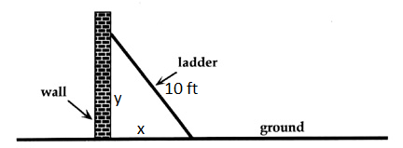  
      Note that we are calling the distance between the base of the ladder and the base of the wall $x$, and the distance between the base of the wall and the top of the ladder $y$.
   2. The most likely mathematical relationship we’ll use in this case is the Pythagorean theorem, as it relates the hypotenuse (which we know) to the base and the height, which we have information regarding the rates.
   3. Therefore, we would set the Pythagorean theorem up where $h$ is the hypotenuse, such that $x^{2}+y^{2}=h^{2}$. Then, we can plug in the hypotenuse, as it stays constant, which becomes $x^{2}+y^{2}=(10)^{2}$. Then, we can derive this function. On the left side, the derivative of $x^{2}$ is $2x\frac{dx}{dt}$, the derivative of $y^{2}$ is $2y\frac{dy}{dt}$, and the derivative of 100 goes to 0. Therefore, our implicit derivative is $2x\frac{dx}{dt}+2y\frac{dy}{dt}=0$.
   4. Since we want to find the rate at which the top of the ladder is sliding down the that to solve for $\frac{dy}{dx}$! However, we are also missing y. Luckily, we can use the Pythagorean theorem from earlier in order to solve for the length of y, since we know x at a specific time and have a constant hypotenuse. Setting this up, we would find $(6)^{2}+y^{2}=(10)^{2}$, which simplifies to $36+y^{2}=100$. Then, we can subtract 36 to the right side, such that $y^{2}=64$. Taking the square root, we get $y=±8$, yet we can throw out the -8, as a negative height does not make sense in this context. Thus, our y-value is 8.
   5. Now, we can plug all of this in to solve for $\frac{dy}{dx}$! Doing so will give us $2(6)(1)+2(8)(\frac{dy}{dt})=0$, which simplifies to become $12+16\frac{dy}{dt}=0$. Then, we only need to subtract the 12 to the left side to isolate $\frac{dy}{dt}$, where $16\frac{dy}{dt}=-12$, and then divide both sides by 16 to get $\frac{dy}{dt}=-\frac{12}{16}=-\frac{3}{4}$.
   6. Thus, the ladder is sliding down the wall at a rate of $\frac{3}{4}$ feet per second! It is important to remember that it is sliding down the wall, as $\frac{dy}{dt}$ is negative.
2. Air is being pumped into a perfectly spherical balloon (the three dimensional version of a “Sukian” circle) so that its volume increases at a rate of 100 cubic-centimeters per second. how fast is the radius of the balloon increasing when the diameter is 50 cm?
   1. In this case, it is easy to visualize a sphere in one’s mind, so for this problem we will practice solving related rates without a diagram, which can be useful on a test.
   2. For the mathematical relationship in this problem, we know that the volume of a sphere is related to the radius by $V=\frac{4}{3}πr^{3}$. When we derive this with respect to time, we will find that the derivative of volume, $V$, will be $\frac{dV}{dt}$, while the derivative of $\frac{4}{3}πr^{3}$ will become, according to power rule, $4πr^{2}\frac{dr}{dt}$, giving us $\frac{dV}{dt}=4πr^{2}\frac{dr}{dt}$.
   3. This should fit well with our problem, as we are given the rate at which the volume changes, a specific radius (as diameter is simply twice the radius), and we need to find the rate at which the radius is changing, $\frac{dr}{dt}$. Since the diameter is 50 cm, and diameter is simply twice the radius, we know that the radius will be 25 cm. Now, we can plug everything in.
 $(100)=4π(25)^{2}(\frac{dr}{dt})$

 $\frac{dr}{dt}=\frac{100}{4π(25)(25)}$    1. To make our lives easier here, we can simply divide 100 by one of the 25’s, which would be 4! This would leave a 4 on top, which would then cancel with the 4 on the bottom.
 $\frac{dr}{dt}=\frac{1}{25π}$

  4. Thus, the radius of the balloon is increasing at a rate of $\frac{1}{25π}$ centimeters per second when the radius is 25 centimeters.

## Lola Tries

1. Car A is traveling west at 50 miles per hour, and car B is traveling north at 60 miles per hour. Both are headed for the intersection of the two roads. At what rate are the cars approaching each other when car A is 0.3 miles and car B is 0.4 miles from the intersection?
2. A particle moves along the curve $y=\sqrt{1+x^{3}}$. As it reaches the point (2, 3), the y-coordinate is increasing at a rate of 4 centimeters per second. How fast is the x-coordinate of the point changing at that instant?
3. A plane flying horizontally at an altitude of 1 mile and a speed of 500 miles per hour passes directly over a radar station. Find the rate at which the distance from the plane to the station is increasing when it is 2 miles away from the station.

Next Stop: Thailand

# https://brightcove04pmdo-a.akamaihd.net/5104226627001/5104226627001_5230017882001_5219455722001-vs.jpg?pubId=5104226627001&videoId=5219455722001Image result for thailand Welcome to Thailand

ยินดีต้อนรับสู่ประเทศไทย!

How do I find the derivative and tangent line for an inverse function?

If you weren’t already mildly confused all the derivatives of “normal” functions, we are going to up the ante even further- now almost *every* function can have an inverse, and we can find the derivative on that function too!

For a brief overview of those (including this author) who have a very hazy memory of precalculus, an inverse function is simply one which switches the x and y coordinates. Thus, (1, 1) on $f(x)$ becomes (1, 1) on $f^{-1}(x)$! Similarly, (1, 2) would become (2, 1) on the inverse function. Furthermore, we can extend this to the principles of derivatives. If we find $\frac{dy}{dx}$ on the original function, and then switch the x and y coordinates to get an inverse function, than $\frac{dy}{dx}$ will switch to $\frac{dx}{dy}$ as well, and we can use this principle in order to find the derivative and tangent line at a point on an inverse function.

Let’s take a look at this in practice. Given the function $m(x)=3x-5x^{3}$, we must determine the tangent line on the inverse when $y=2$. One of the most important parts of determining a tangent line is the actual coordinate, which requires both x and y values. Therefore, we can set our original equation equal to 2 in order to determine the x-coordinate, such that $2=3x-5x^{3}$. For more astute observers, it may take only a moment to see that plugging in $x=-1$ will yield 2. However, if you have been granted the mercy of a calculator, the slightly lazier can simply graph the line $3x-5x^{3}-2$ and determine its x intercepts. Once we have the x and y coordinates, we need to determine the slope of the inverse function. Initially, one might think of simply finding the inverse function and deriving that, however, due to the behavior of inverse functions this can cause some problems. However, there is an easier method which is guaranteed to probably always work! Remember earlier how we established that when the x and y coordinates flip, $\frac{dy}{dx}$ will switch to become $\frac{dx}{dy}$, the reciprocal of $\frac{dy}{dx}$? Using this principle, all we really have to do is find $\frac{dy}{dx}$- the slope on the original function.

In this case, we derive $f(x)$ to find $f'(x)=3-15x^{2}$, and all we have to do to find $\frac{dy}{dx}$ is plug in $x=-1$ into $f'(x)$. This would yield $f'(x)=3-15(-1)^{2}=3-15=-12$. Thus, if $\frac{dy}{dx}=-12$, the derivative of the inverse at that point, $\frac{dx}{dy}$, will be $-\frac{1}{12}$.

Finally, all we have left to do is plug it into the general tangent line form of $y-y_{1}=m(x-x_{1})$. Remember that for an inverse we will flip the x and y coordinates; if the point on our original function is (-1, 2), the point on the inverse function will be (2, -1). Finally, after plugging everything in, we find that the tangent line is $y+1=-\frac{1}{12}(x-2)$.

## Guided Practice

1. In some cases, we won’t be given the original function at all! Instead, the College Board will work tirelessly to build a table of exactly the values we need. For example, given the following table, determine the tangent line for $g^{-1}(3)$.

|  |  |  |
| --- | --- | --- |
| x | g(x) | g’(x) |
| -2 | 2 | 3 |
| -1 | 3 | -2 |
| 0 | -2 | -1 |
| 1 | -1 | 0 |
| 2 | 0 | 1 |
| 3 | 1 | 2 |

* 1. The first thing to notice is $g^{-1}(3)$. Since we don’t have $g^{-1}$, we will have to find a way to utilize $g(x)$. If $g^{-1}(3)$ references the y-coordinate on $g^{-1}$ at an x-coordinate of 3 on $g^{-1}$. More importantly, we can correspond this to a coordinate on $g$ with a y-value of 3, due to the nature of inverse functions. Based upon the chart below, we can see that $g(x)=3$ when $x=-1$. Thus, the point on our original function is (-1, 3), and the point on the inverse function will be (3, -1). From there, we can determine $\frac{dy}{dx}|_{(-1, 3)}$ from the chart as well, which tells us that $g'(-1)=-2$. Finally, we know that the slope of the inverse function at (3, -1), $\frac{dx}{dy}$ will be the reciprocal of $\frac{dy}{dx}$, which would be $-\frac{1}{2}$. Thus, the tangent line on the inverse for $g^{-1}(3)$ will be $y+1=-\frac{1}{2}(x-3)$.

1. Given the function $y=x+\frac{1}{x}$ when $y=\frac{17}{4}$ and $x>1$.
   1. Just as in the other examples, the first step we want to take is to determine the coordinate being referenced on the original function. Since we are given the y-value, we can set our equation equal to this value and solve for x, giving us $\frac{17}{4}=x+\frac{1}{x}$. Then, we can multiply the 4 to all sides, so that $17=4x+\frac{4}{x}$. Next, we can do the same with the $x$ and multiply it to all sides, which would give us $17x=4x^{2}+4$. This can then be maneuvered into the form of a quadratic equation by subtracting $17x$ on both sides, which becomes $4x^{2}-17x+4=0$. Finally, we can factor this into $(4x-1)(x-4)$, and set each term equal to 0, giving us $x=\frac{1}{4}, 4$. At this step, you might be a bit confused- there are two possible x-coordinates! However, remember our initial condition- $x>1$. Therefore, the only relevant x-coordinate is $x=4$. Thus, the coordinate on the original function is (4, $\frac{17}{4}$) and the coordinate on the inverse will be ($\frac{17}{4}$, 4).
   2. Next, we must determine the slope on the inverse. To do so, we will find $\frac{dy}{dx}$ and then take the reciprocal.
   3. In this example, $y'=1-\frac{1}{x^{2}}$, and at $x=4$, $y'(4)=1-\frac{1}{(4^{2})}=1-\frac{1}{16}=\frac{15}{16}$. Therefore, the slope on the inverse will be $\frac{16}{15}$.
   4. Finally, our tangent line in this example will be $y-4=\frac{16}{15}(x-\frac{17}{4})$.

## Lola Tries

1. Given the curve $y=e^{x}$, determine the derivative of the inverse when $y=e$ on the original.
2. Given the curve $y=ln(x)$, determine the tangent line when $y=0$ on the original.
3. Given the curve $h(x)=x^{2}-2x$, determine the tangent line when $y=3$ on the original, where $x<0$.

Next Stop: China

# http://www.telegraph.co.uk/content/dam/Travel/Destinations/Asia/China/china-overview-greatwall-xlarge.jpghttps://cdn.geekwire.com/wp-content/uploads/2015/05/china-street-shutterstock_157021067-620x414.jpgWelcome to China

欢迎来到中国！

How do I find the derivative of an inverse trigonometric function?

We now know the derivatives of trigonometric functions! Remember functions like $y=sin^{-1}(x)$. Yes, you guessed it right! It’s time for derivatives for inverse trigonometric functions! Luckily for us, there are definitive rules for the derivatives of inverse trigonometric functions.

$\frac{d}{dx}sin^{-1}x=\frac{1}{\sqrt{1-x^{2}}}$

$\frac{d}{dx}cos^{-1}x=\frac{-1}{\sqrt{1-x^{2}}}$

$\frac{d}{dx}tan^{-1}x=\frac{1}{x^{2}+1}$

$\frac{d}{dx}cot^{-1}x=\frac{-1}{x^{2}+1}$

$\frac{d}{dx}sec^{-1}x=\frac{1}{\left|x\right|\sqrt{x^{2}-1}}$

$\frac{d}{dx}csc^{-1}x=\frac{-1}{\left|x\right|\sqrt{x^{2}-1}}$

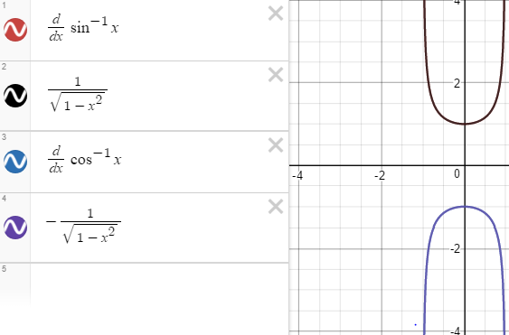 You may notice a pattern about these inverse trigonometric derivatives. The derivative of $sin^{-1}x$ and $cos^{-1}x$ differ by only a negative sign! Same with the derivatives of $tan^{-1}x and cot^{-1}x$, as well as $sec^{-1}x$ and $csc^{-1}x$. To examine this further, let’s look at the derivatives of $sin^{-1}x$ and $cos^{-1}x$ on a graph!

We can also find these inverse trigonometric function derivatives if you happen to forget them.

For instance, if we wanted to find the derivative rule of $y=sin^{-1}x$, we can do so through implicit differentiation! First, we can take the sine of both sides, to get rid of the sine inverse on the right side. We then have $sin(y)=x$. Now we can start deriving! $\frac{d}{dx}(sin(y)=x)$ Using our trigonometric function derivative rules, we get $cos(y)\frac{dy}{dx}=1$. Then we divide the $cos(y)$ over to get $\frac{dy}{dx}=\frac{1}{cos(y)}$. For the next part, we must remember that $sin^{2}y+cos^{2}y=1.$ Then, we can solve for $cos(y)$. $1-sin^{2}y=cosy\sqrt{1-sin^{2}y}=cos(y)$. Earlier, we said that $sin(y)=x$ Thus, $\sqrt{1-x^{2}}=cos(y)$. Our derivative then becomes $\frac{dy}{dx}=\frac{1}{\sqrt{1-x^{2}}}$. For the graph of the derivative of $y=sin^{-1}x$, look above.

The proof of the derivative of $y=sin^{-1}x$ is done in a similar fashion!

The proof of the derivative of $y=tan^{-1}x$ is also quite simple. We use implicit differentiation for this proof as well. First, we can take the tangent of both sides to get rid of the tangent inverse on the right side. We then have $tan(y)=x$. Now we can start deriving! $\frac{d}{dx}(tan(y)=x)$  
. Using our trigonometric function 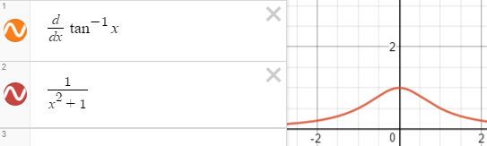derivatives, we get $sec^{2}y\frac{dy}{dx}=1$. Then, we divide the $sec^{2}y$ over to get $\frac{dy}{dx}=\frac{1}{sec^{2}y}$. For the next part, we must recall that $sin^{2}y+cos^{2}y=1$. We are trying to get secant squared. We know that secant is $\frac{1}{cosy}$, Thus, we would divide both sides by $cos^{2}y$. $\frac{sin^{2}y+cos^{2}y}{cos^{2}y}=\frac{1}{cos^{2}y}$. This simplifies to $tan^{2}y+1=sec^{2}y$. From earlier, we defined that $tan(y)=x$. Thus, $x^{2}+1=s{ec}^{2}y$. Our derivative then becomes $\frac{dy}{dx}=\frac{1}{x^{2}+1}$. The proof of the derivative of $y=cot^{2}x$ is done in a similar fashion!

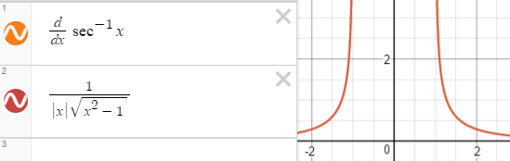We can also do the proof of the derivative of $y=sec^{-1}x$! Like the other two proofs, we will be using implicit differentiation! But first, we must take the secant of both sides to get rid of the secant inverse on the right side. We then have $sec(y)=x$. Now we can begin deriving! $\frac{d}{dx}(sec(y)=x)$. With our trigonometric function derivatives, we get $sec(y)tan(y)\frac{dy}{dx}=1$. Then, we divide the $sec(y)tan(y)$ to the other side to get $\frac{dy}{dx}=\frac{1}{sec(y)tan(y)}$. We already know that $sec(y)=x$ from earlier, so we get $\frac{dy}{dx}=\frac{1}{xtan(y)}$. Now, we must recall that $sin^{2}y+cos^{2}y=1$. In this case, we are trying to get tangent. We know that tangent is $\frac{siny}{cosy}$. Thus, we divide both sides by $cos^{2}y$ to get $\frac{sin^{2}y+cos^{2}y}{cos^{2}y}=\frac{1}{cos^{2}y}$ which simplifies to $tan^{2}y+1=sec^{2}y$. To get tangent alone, we must first subtract the 1 over to the other side and take the square root. We would then get $tany=\sqrt{sec^{2}y-1}$. We know that $sec(y)=x$. Thus, we get $tan(y)=\sqrt{x^{2}-1}$. =We can replace this in our earlier derivative function of $\frac{dy}{dx}=\frac{1}{xtan(y)}$ to get $\frac{dy}{dx}=\frac{1}{\left|x\right|\sqrt{x^{2}-1}}$. The proof of the derivative of $y=csc^{2}x$ is done in a similar fashion!

Now, it’s time to apply these rules! For example, what is $y=cot^{-1}(\sqrt{x})$. First, we can identify which rule to use. $\frac{d}{dx}cot^{-1}x=\frac{-1}{x^{2}+1}$. We just replace x with the argument of $y=cot^{-1}(\sqrt{x})$. In this case, the argument is $\sqrt{x}$. Thus, $y'=\frac{-1}{(\sqrt{x})^{2}+1}$. However, we still have to use chain rule. The derivative of the argument, $\sqrt{x}$ is $\frac{1}{2}x^{-1/2}$. Our overall derivative becomes $y'=\frac{-1}{(\sqrt{x})^{2}+1}×\frac{1}{2\sqrt{x}}$ which simplifies to $y'=\frac{-1}{2\sqrt{x}(x+1)}$.

## Guided Practice

1. What is y’ at $x=e$ for $y=arccot(lnx)$?
   1. An arc tangent? What does that mean? Don’t fret so easily! Remember from previous math classes that arc tangent simply means tangent inverse. If it makes you feel better, we can rewrite it to $y=cot^{-1}(lnx)$.
   2. Now, we can identify which rule to use. We know that $\frac{d}{dx}cot^{-1}x=\frac{-1}{x^{2}+1}$. We can just plug in our argument into this general derivative rule! $y'=\frac{-1}{(lnx)^{2}+1}$.
   3. Next, we have to multiply by the derivative of the argument. The derivative of $lnx=\frac{1}{x}$. Thus, our derivative is $\frac{-1}{x((lnx)^{2}+1)}$.
   4. Lastly, we have to plug in e for x, as we are trying to find the derivative at that specific x-coordinate. Therefore, we have $\frac{-1}{e((lne)^{2}+1)}=\frac{-1}{2e}$
2. Find the equation of the tangent line to the graph of $x^{2}+xarctany=y-1$ at $(\frac{-π}{4},1)$.
   1. To construct a line, we need a point and a slope. We have a point, so all we have to do is find the slope at that specific point. We can do this through deriving our function! Since we have both x’s and y’s in the function, we can use implicit differentiation. $\frac{d}{dx}(x^{2}+xarctany=y-1)$.
   2. We first derive $x^{2}$. The derivative of $x^{2}$ is $2x×\frac{dx}{dx}$. Since $\frac{dx}{dx}=1$, we do not have to write it! Therefore, the derivative of the first piece is simply 2x.
   3. Next, we take the derivative of $xarctany$. We can use some product rule! First, we take the derivative of the first function, x, leaving the second function, arctany, alone. This gives us $\frac{dx}{dx}arctany$, which simplifies to $arctany$. We then take the derivative of the second function, arctany, leaving the first function alone. The derivative of tangent inverse of y is $\frac{1}{y^{2}+1}$ times $\frac{dy}{dx}$, as we are deriving with respect to x. Then, we multiply by the first function, x, left alone, giving us $\frac{dy}{dx}\frac{1}{y^{2}+1}x$. Therefore, the overall derivative of that piece would be $arctany+\frac{dy}{dx}\frac{1}{y^{2}+1}x$.
   4. Now, we must take the derivative of $y-1$. Using power rule, we simply get $1$. We must multiply this by $\frac{dy}{dx}$, as we are deriving with respect to x. This gives us $1\frac{dy}{dx}=\frac{dy}{dx}$.
   5. We can piece the entire derivative function together to get $2x+arctany+\frac{dy}{dx}\frac{1}{y^{2}+1}x=\frac{dy}{dx}$. Now we just have to plug in our point, $(\frac{-π}{4},1)$. $2(\frac{-π}{4})+arctan(1)+\frac{dy}{dx}+\frac{1}{(1)^{2}+1}\frac{- π}{4}=\frac{dy}{dx}$. We know that the tangent at $\frac{ π}{4}$ is 1, and it is in the domain of tangent inverse (D: $(\frac{-π}{2},\frac{ π}{2})$) Thus, this simplifies to $\frac{-π}{2}+\frac{ π}{4}-\frac{ π}{8}\frac{dy}{dx}=\frac{dy}{dx}$. We can simplify this even further to give us $\frac{-π}{4}-\frac{π}{8}\frac{dy}{dx}=\frac{dy}{dx}$.
   6. Next, we can move the $\frac{dy}{dx}$ to the same side, as this is what we are solving for. We get $\frac{-π}{4}=\frac{dy}{dx}+\frac{π}{8}\frac{dy}{dx}$. We can factor out a $\frac{dy}{dx}$ on the left side, giving us $\frac{-π}{4}=\frac{dy}{dx}(1+\frac{π}{8})$. Now, we can divide the $1+\frac{π}{8}$ to the other side to isolate $\frac{dy}{dx}$, giving us $\frac{\frac{-π}{4}}{1+\frac{π}{8}}=\frac{dy}{dx}$. After simplifying using common denominators, we should get $\frac{dy}{dx}=\frac{-2π}{8+π}$.
   7. Finally, to get the tangent line equation, we need to plug it into the point slope form general formula. We have the point, $(\frac{-π}{4},1)$, and the slope, $\frac{-2π}{8+π}$. Therefore, the tangent line formula will be $y-1=\frac{-2π}{8+π}(x+\frac{π}{4})$

## Lola Tries

1. What is $y'$ when $y=cos^{-1}(x^{2})$?
2. Derive $y=\sqrt{1-x^{2}}arcsinx$.
3. What is the equation of the line tangent to $y=sec^{-1}(5x)$ at $x=\frac{2}{5}$?

Next Stop: South Korea

# *Image result for south korea pictures*Image result for south korea picturesWelcome to South Korea!

한국에 오신 것을 환영합니다!

What is L’Hospital’s Rule and how do I use it?

Lola went to the hospital. Just kidding! She is learning about L’Hospital’s Rule though! It’s not as pesky as it seems. It is actually a very useful tool in doing indeterminate limits.

Let’s go back for a second to those annoying indeterminate limits! For example, when we have $\lim_{x→2}\frac{x^{3}-8}{10x-20}$, if we simply plug in 2, we get a 0/0 situation. $\lim_{x→2}\frac{x^{3}-8}{10x-20}=\frac{(2)^{3}-8}{10(2)-20}=\frac{0}{0}$. In this situation, we would need to “cancel the 0/0 part” by algebraically manipulating the limit. In this case, we would factor the top using difference of cubes, and factor a 10 out of the denominator, allowing us to cancel an x+2, which is the 0/0 part. $\lim_{x→2}\frac{(x-2)(x^{2}+2x+{4)}_{}}{10(x+2)}=\frac{x^{2}+2x+4}{10}$. We were then able to determine our limit! $\lim_{x→2}\frac{x^{2}+2x+4}{10}=\frac{(2)^{2}+2(2)+4}{10}=\frac{4+4+4}{10}=\frac{12}{10}=\frac{5}{3}$. In this situation, it was not too bad, but sometimes the algebraic manipulation got kind of hefty!

Now that we know how to do derivatives, we don’t have to do algebraic manipulation anymore! Instead, we can go to the hospital!

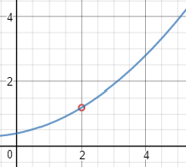Suppose that we have one of the following cases, $\lim_{x→a}\frac{f(x)}{g(x)}=\frac{0}{0}$ or $\lim_{x→a}\frac{f(x)}{g(x)}=\frac{±∞}{±∞}$, where a can be any real number, infinity or negative infinity. L’Hospital’s rule states that in these cases we have $\lim_{x→a}\frac{f(x)}{g(x)}=\lim_{x→a}\frac{f'(x)}{g'(x)}$. In other words, if a is a real number, infinity or negative infinity, we can simply take the derivative of the numerator and the derivative of the denominator until we no longer have a 0/0 situation.

If we revisit the example from earlier, we can use L’Hospital’s rule, as our a value, 2, is real. First, we take the derivative of the numerator, $x^{3}-8$. By power rule, the derivative of $x^{3}-8$ is $3x^{2}$. Then, we take the derivative of the denominator, $10x-20$. By power rule, the derivative of $10x-20$ is 10. Thus, $\lim_{x→2}\frac{x^{3}-8}{10x-20}=\lim_{x→2}\frac{3x^{2}}{10}$. Let’s try to plug in our x-coordinate! $\lim_{x→2}\frac{3x^{2}}{10}=\frac{3(2)^{2}}{10}=\frac{12}{10}=\frac{6}{5}$. That’s the same answer we got using algebraic manipulation! We know to stop with L’Hospital’s rule because we no longer got a 0/0 situation. By looking at the graph of this function, we can see that the limit as x approaches 2 is clearly $\frac{6}{5}$.

Now we have two tools to use with indeterminate limits! This should significantly aid us in solving them.

## Guided Practice

1. What is $\lim_{x→0}\frac{e^{5x}-1}{3x}$?
   1. Let’s try plugging 0 into our limit. $\lim_{x→0}\frac{e^{5x}-1}{3x}=\frac{e^{5(0)}-1}{3(0)}=\frac{0}{0}$! Since we have an indeterminate limit, and a is a real number, we can use L’Hospital’s Rule to aid us in determining this limit.
   2. Using L’Hospital’s rule, we must take the derivative of both the numerator and the denominator, until we “cancel the 0/0 part”. If we take the derivative of the numerator, $e^{5x}-1$, we are left with $5e^{5x}$, using our exponential derivative rules and chain rule. If we take the derivative of the denominator, it is simply 3, using power rule. Thus, we have $\lim_{x→0}\frac{5e^{5x}}{3}$.
   3. Now, we can try plugging in 0 again! $\lim_{x→0}\frac{5e^{5x}}{3}=\frac{5e^{5(0)}}{3}=\frac{5}{3}$. Since we no longer got a 0/0 situation, we know that L’Hospital’s rule is done and that $\lim_{x→0}\frac{e^{5x}-1}{3x}=\frac{5}{3}$!
2. What is $\lim_{x→0}\frac{xe^{3x}-x}{1-cos(2x)}$?
   1. Let’s try plugging in 0 into our limit. $\lim_{x→0}\frac{xe^{3x}-x}{1-cos(2x)}=\frac{0e^{3(0)}-0}{1-cos(2(0)}=\frac{0}{0}$! Since we have an indeterminate limit, and a is a real number, we can use L’Hospital’s Rule to aid us in determining this limit.
   2. Using L’Hospital’s rule, we must take the derivative of both the numerator and the denominator, until we “cancel the 0/0 part”. If we take the derivative of the numerator, $xe^{3x}-x$, we get $3x(e^{3x})+e^{3x}-1$, using some product rule, chain rule, power rule and exponential derivative rules. If we take the derivative of the denominator, $1-cos(2x)$, we get $2sin(2x)$ using our trigonometric derivative rules and chain rule. Thus, we have $\lim_{x→0}\frac{3x(e^{3x})+e^{3x}-1}{2sin(2x)}$
   3. Now, we can try plugging in 0 again! $\lim_{x→0}\frac{3x(e^{3x})+e^{3x}-1}{2sin(2x)}=\frac{3(0)e^{3(0)}+e^{3(0)}-1}{2sin(2x)}=\frac{0}{0}$! Uh oh! What do do now? We simply have to use L’Hospital’s rule again, as the 0/0 part is not canceled out. If we take the derivative of the numerator of our new limit, we would get $3e^{3x}+9x(e^{3x})+3e^{3x}=6e^{3x}+9x(e^{3x})$, using some product rule, power rule, chain rule and the exponential derivative rules. If we take the derivative of the denominator of our new limit, we would get $4cos(2x)$ using our trigonometric derivative rules and chain rule. Thus, we have $\lim_{x→0}\frac{6e^{3x}+9x(e^{3x})}{4cos(2x)}$.
   4. We can try plugging in 0 again! $\lim_{x→0}\frac{6e^{3x}+9x(e^{3x})}{4cos(2x)}=\frac{6e^{3(0)}+9(0)e^{3(0)}}{4cos(2(0))}=\frac{6}{4}=\frac{3}{2}$. Since we no longer got a 0/0 situation, we know that L’Hospital’s rule is done and that $\lim_{x→0}\frac{xe^{3x}-x}{1-cos(2x)}=\frac{3}{2}$!

## Lola Tries

1. What is $\lim_{x→∞}\frac{x}{(lnx)^{5}}$?
2. What is $\lim_{x→-4}\frac{sin(πx)}{x^{2}-16}$?
3. What is $\lim_{x→1}\frac{xln(x)}{x^{2}-1}$?

Next Stop: Japan

# http://japan-magazine.jnto.go.jp/jnto2wm/wp-content/uploads/1608_special_TOTO_main.jpghttp://www.swap.ca/img/destinations/japan/swap-japan-splash.jpgWelcome to Japan!

ようこそ日本へようこそ！

How do I find the antiderivative of a function?

Finally, you have reached the end of the derivatives section...

Just kidding! Well, sort of- you won’t have to do a *single* derivative in this section. Now it’s time to find *antiderivatives*!

Take a derivative function $f'(x)=2x$. If we wanted to **antiderive**, that is, to find $f(x)$ from $f'(x)$, we will have to apply the derivative rules, such as power rule. Consider this example; what function would yield a derivative of 2x? Well, take $x^{2}$- when we derive this according to power rule, we would find that the derivative of $x^{2}$ is $2x$. Therefore, we can reasonably conclude that $f(x)=x^{2}$. However, there is one other property of derivatives to consider; if we have a constant, such as $2$, then the derivative of a constant will always go to zero. Thus, the derivative for the same function with different constants will have the same derivative. For example, $f(x)=x^{2}+2$ and $f(x)=x^{2}+1000$ will have the same derivative, $f'(x)=2x$, as the constants go to 0 when deriving. Therefore, after successfully antideriving, we include $+C$ to represent the family of possible functions resulting from the antiderivative. In this case, $f(x)=x^{2}+C$.

However, there are some situations where we can *see* the C value. Given a function $g'(x)=x^{2}+3x+1$, such that $g(3)=5$. To start out, we would antiderive $g'$ just as in the previous problem. As a side note, we can notate the operation of the antiderivative as $\int{g'(x) dx}$. Don’t worry about the fact that it is notated as a very lanky S or dx- that will become apparent later. For now, we can use our derivative rules to find the antiderivative. First and foremost, according to power rule, we know that if our derivative has $x^{2}$, it must have originally had $x^{3}$, as the power decreases by when deriving. However, we also know that power rule will bring the power down in front of the x. Therefore, if we began with $x^{3}$, it would become $3x^{2}$- which doesn’t match our derivative! In order to achieve $x^{2}$, we will have to include a $\frac{1}{3}$ in front of the original $x^{3}$, so that when we bring a 3 down it cancels to 1. This means that the first part of $g(x)$ will be $\frac{1}{3}x^{3}$. Next, we have to antiderive $3x$. Again, following the power rule, the power will have decreased by 1 to reach the derivative, meaning that $3x$ must have come from $x^{2}$. Yet we encounter a similar problem- if we bring down the 2 while deriving $x^{2}$ it would become $2x$, yet we have $3x$. Therefore, we must find a number which multiplies by 2 to become 3, and the best way to do this is use fractions. If we put $\frac{3}{2}$ in front of $x^{2}$, we know that when we bring down a 2 it will cancel with the 2 in the denominator of $\frac{3}{2}$, making the derivative $3x$, which is just what we need. In short, the antiderivative of $3x$ will be $\frac{3}{2}x^{2}$.

Finally, we must determine the antiderivative for 1- which would just be $x$, according to power rule! Thus, the general antiderivative in this instance (the antiderivative without a specific value for $C$) will be $\int{g'(x) dx}=g(x)=\frac{1}{3}x^{3}+\frac{3}{2}x^{2}+x+C$. Yet there is one more step we can take- since we know that $g(3)=5$, we can plug this into $g(x)$. $5=\frac{1}{3}(3)^{3}+3+C$. Now, we simply solve for C! After some simplifying we get, $5=\frac{27}{3}+2+C$ which simplifies even further to $5=9+2+C$. Thus, $-6=C$

Therefore, $g(x)=\frac{1}{3}x^{3}+\frac{3}{2}x^{2}+x-6$.

## Guided Practice

1. Given the graph of $f$ shown to the right, which graph ($a,b, or c$) would describe the antiderivative of $f$?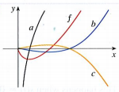
   1. Not only can we determine the antiderivative by analyzing the function, we can also determine the antiderivative of the graph of the function.
   2. If we are attempting to find the antiderivative of $f$, which we will refer to as $F$, this means that $f$ describes the slope of $F$. Therefore, we can start out by looking at $f$ and approximating the type of curve it would describe.
   3. From $x=0$ to the second x-intercept of $f$, $f<0$, which describes a curve with a decreasing slope. Past this second x-intercept of $f$, $f>0$, which similarly describes a curve with a positive slope. As well, we know that there is likely a local minimum on $F$ at the second x-intercept of $f$, because at this second x-intercept $f=0$ (i.e., $F'=0$), and $f$ goes from negative to positive. Finally, at $x=0$, $f=0$, and thus we know that there is a zero slope on $F$ at $x=0$.
   4. With these basic properties of the antiderivative curve in hand, we can compare each given curve to the predicted antiderivative curve. Immediately, the graph of $a$ cannot be $F$, as $a$ has a constantly increasing slope. The graph of $b$, on the other hand, appears as if it may fit the criteria for $F$. At approximately the second x-intercept of $f$, $b$ displays the predicted minimum. Correspondingly, it also has negative slope, and then positive slope, on the intervals predicted by $f$. At $x=0$, $b'=0$, and until the second x-intercept of $f$, $b'<0$, while afterwards, $b'>0$. However, before settling on a definite answer, it is important to check the graph of $c$, in case it might fit better. Yet, on further analysis, it appears as if $c$ cannot be $F$. The graph of $c$ is similar to $b$, however, it flips the intervals of positive and negative slope. From $x=0$ to the second x-intercept of $f$, $c'>0$, while after the second x-intercept of $f$, $c'<0$, meaning that $c$ cannot be $F$.
   5. Therefore, we can conclude that the antiderivative of $f$, $F$, is $b$.
   6. It is important to note that this general process can be applied to all antiderivative graphing- find the points which indicate local maxima/minima, and follow the derivative curve given to determine when the original has a positive or negative slope.
2. Determine $\int{\frac{cos(x)}{1-cos^{2}(x)}dx}$.
   1. Although this might seem a bit scary at first, don’t panic! The best way to tackle chain rule is with one’s bare hands and trigonometric identities, giving us a number of possible ways to determine the general antiderivative.
   2. Initially, you might consider solving this problem by working the quotient rule backwards- however, except in the very simplest of situations, that is a patently **bad idea,** because it quickly becomes unwieldy and complex.   
      Instead, it is best to try and algebraically maneuver the function such that there is no longer a fraction. This same basic principle applies to the product rule- we want to maneuver the function into a number of simple terms added/subtracted to one another.
   3. In this example, we can do that using our trigonometric identities. Given $\frac{cos(x)}{1-cos^{2}(x)}$, we know that $1-cos^{2}(x)=sin^{2}(x)$ from the pythagorean identity, $sin^{2}(x)+cos^{2}(x)=1$. Therefore, our function becomes $\frac{cos(x)}{sin^{2}(x)}$, which can be broken up into $\frac{cos(x)}{sin(x)}*\frac{1}{sin(x)}$. There is one more step we can take which may make the antiderivative even more evident; again, using our trigonometric identities, we know that $\frac{cos(x)}{sin(x)}=cot(x)$ and $\frac{1}{sin(x)}=csc(x)$, making our function $cot(x)csc(x)$.
   4. Now all we have to do is antiderive $cot(x)csc(x)$, which is a lot easier than the original problem. To antiderive a trigonometric function requires a similar process as antideriving any other function; we need to identify a function whose derivative would yield the desired result.
   5. Although $cot(x)csc(x)$ might seem like a scenario where product rule would have originally applied, we know that the derivative of $csc(x)$ is $-cot(x)csc(x)$. Therefore, if our original function was $-csc(x)$, the derivative of the original would yield $cot(x)csc(x)$- the derivative function we were given to antiderive.
   6. Finally, don’t forget $+C$, even for trigonometric functions! In conclusion, our general antiderivative would be $-csc(x) + C$.

## Lola Tries

1. 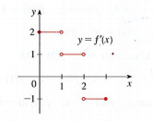Given the graph of $f'$ shown to the right, sketch the graph of $f$ such that $f(0)=-1$.
2. Given $f(x)=(1+3x)x^{2}$, determine the antiderivative, $F(x)$.
3. Given $f(x)=xln(3)$, and $F(2)=14$, determine the antiderivative, $F(x)$.

Next Stop: Russia

# Welcome to Russia!

**Добро** пожаловать **в Россию!**

How do I solve rectilinear motion problems with derivatives and antiderivatives?

What is the point of derivatives and antiderivatives? Like really? If you are like Lola and constantly ponder on the reasons for education, this may have been bothering you the entire time that you have learned about derivatives. Well, I’m here and glad to tell you that there is a point to this blob of madness!

Let’s take a quick primer in basic rectilinear motion (i.e., motion along nice, straight lines). Generally, when someone discusses the concept of velocity, they are describing the *rate* at which position of an object changes, with respect to a direction. This is an important distinction from speed, which simplify describes the magnitude by which position is changing, but not its direction. For example, take the position of a particle changes with respect to time, moving horizontally along the x-axis, defined by a function $x(t)$. The velocity for this particle, $v(t)$, will be positive when the particle is moving to the right, and negative when it is moving to the left. It is important to note that this is a completely arbitrary distinction, and that the “positive” and “negative” directions can technically be defined as any pair of directions; however, for our purposes, up or right is positive, and down or left is negative. This is all pretty interesting- yet prepare yourself for the *real* fun. Remember how we said that velocity describes how the rate that the position of an object is changing? A function which describes the rate at which the value of another function changes… that sounds familiar… almost like…

A derivative!

Yes! $v(t)$ is the same thing as $x'(t)$! Yet we can make another leap, from velocity to acceleration. Acceleration is, essentially, the rate at which the velocity changes. Think, the acceleration due to gravity on Earth is (roughly) -9.8 meters per second-squared- this means that the velocity of any object, with no other forces acting upon it, will decrease by 9.8 meters per second, each second! Hmm… again we find a similar scenario- the acceleration describes the rate at which the velocity changes; hey, wouldn’t that be-

Yes! Another derivative!

That’s right! $a(t)$ (acceleration) $=v'(t)=x''(t)$! Fantastic!

With this knowledge in hand, we can now apply derivatives to real world situations- especially the ones with one-dimensional point particles which, assuming they have non-zero mass, should be naked singularities which are not currently understood by modern relativity and physics, but would likely release a supernova-equivalent amount of energy in a picosecond due to the functionally infinite gravity that matter near it would experience, moving along a straight line. For example, take a particle which is moving vertically up and down, whose position is defined as $y(t)=t^{3}-12t+3$, where $t≥0$ (as it generally doesn’t make sense to talk about negative time, in a physics sense). There are a number of questions we can answer regarding the motion of this particle; specifically:

1. Determine the velocity and acceleration functions.
2. When is the particle moving upward, and when is it moving downward?
3. What is the farthest upwards and farthest downwards the particle reaches on $0≤t≤3$?
4. What is the displacement of the particle in the first 3 seconds?
5. What is the total distance traveled by the particle on $0≤t≤3$?
6. Create a graph of the position, velocity, and acceleration functions on $0≤t≤3$.
7. When is the particle speeding up? When is the particle slowing down?
8. Draw a diagram to illustrate the motion of the particle.

Let’s take these one by one. To start out, we know that the velocity function is the derivative of position, and that the acceleration function is the derivative of velocity. Therefore, we can use power rule to find that $y'(t)=v(t)=3t^{2}-12$, and that $v'(t)=a(t)=6t$.

Next, we know that the particle is moving upward when $v(t)>0$, and downward when $v(t)<0$. Therefore, we can apply the first derivative test in order to determine the intervals where $v(t)>0$ and $v(t)<0$. First, we must determine where $v(t)=0$. Setting $3t^{2}-12=0$, we can immediately factor out a three, such that $3(t^{2}-4)=0$. Then, we can factor $(t^{2}-4)$ into $(t+2)(t-2)$. From there, we set each term equal to zero, and find that $v(t)=0$ when $t=-2$ or $t=2$, and we can throw out $t=-2$, as it does not make much sense to 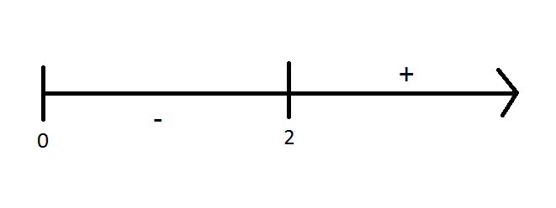discuss when $t<0$ in the context of a real world situation. Therefore, we know that $v(2)=0$, and can set up a sign chart from there.

Note that we added 0 as a lower boundary on the left side, simply to remind us that we are not going to discuss $t<0$. Looking at this sign chart, we find that $v(t)<0$ on $[0, 2)$ and $v(t)>0$ on $(2, ∞)$, meaning that the particle is moving downward on $[0, 2)$ and upward on $(2, ∞)$.

Understanding these intervals and completing this sign chart is also very helpful in determining the farthest distance traveled upward (the absolute maximum of position), and the farthest distance traveled downward (the absolute minimum of position). Since $v(t)=y'(t)$, we can use $t=2$ as a critical point for the Extreme Value Theorem.

From there, we want to test our endpoints ($t=0,3$) and critical point on $y(t)$ to determine the absolute minima and maxima for position. $y(0)=(0)^{3}-12(0)+3=3$, $y(2)=(2)^{3}-12(2)+3=-13$, $y(3)=(3)^{3}-12(3)+3=-6$.

Thus, we can conclude that the farthest down the particle reaches occurs at $t=2$, and the farthest up the particle reaches occurs at $t=0$.

The next question asks for the displacement of the particle on $0≤t≤3$. **Displacement** can be thought of as the **net change** in the particle's position over the course of the time interval. In this example, it is essentially asking what is the net change in position from $t=0$ to $t=3$- i.e., what is $s(3)-s(0)$? We can quickly solve this out, finding that our displacement is $s(3)-s(0)=-6-3=-9$.

After this, we’re asked to find the total distance the particle traveled- yet how is this different than displacement? In fact, displacement may cover the *net* change in the particle’s position, but total distance can be thought of as the total change affected- i.e., a particle can have a displacement of 0, but a huge total distance, if it travels in one direction and then eventually returns to its initial position. In order to calculate the total distance, we want to find every point at which the direction of the particle changes. Then, we want to determine the total distance (regardless of direction) that a particle changes between two direction changes. Practically, we want to first find where $v(t)$ changes sign, and then find the absolute value of the displacement between direction changes. The absolute value makes sure that we do not account for the direction the particle travels- for example, if you discuss the distance you drive in your car, you don’t account for travelling north/south/west/east, but just add up the distance you traveled along any direction (5 miles east + 10 miles north + 2 miles south = 17 miles total distance). From the sign chart earlier on, we already know that the sign of velocity changes at $t=2$, and thus there is a direction change at $t=2$. We can easily find distance from there! Distance from $t=0$ to $t=2$: $\left|s(2)-s(0)\right|=\left|-13-3\right|=16$, Distance from $t=0$ to $t=3$: $\left|s(3)-s(2)\right|=\left|-6-(-13)\right|=7$. Thus, our total distance will be $16+7=23$.

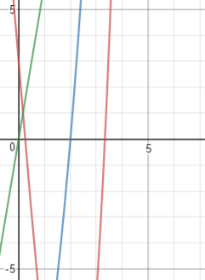 The graphing of position, velocity, and acceleration is most easily accomplished when we have the actual functions, or a way to determine the functions. However, if none of the functions are given, and one is only given a graph of, say, velocity, it is still possible to determine the other graphs using our skills with derivative and antiderivative graphing. In this case, our position, velocity, and acceleration are graphed to the right. y(t) is graphed in red, v(t) is graphed in blue and a(t) is graphed in green.

It has taken a page or two, but we are almost done! When we discuss whether an object is “speeding up” or “slowing down,” we are discussing how the magnitude of the velocity is changing. Since the magnitude of velocity is speed, we can disregard the direction component of velocity when attempting to answer this question. So, how do we know if a particle is speeding up or slowing down? If the velocity and acceleration have the same sign! Even if the particle is moving faster in the negative direction, where $v(t)<0$, if $a(t)<0$ this indicates that the particle is accelerating, or increasing velocity, further in the negative direction- meaning that the speed value, which is the absolute value of velocity, is increasing.

We already know the intervals for when $v(t)>0$ and when $v(t)<0$ from the sign chart previously, and we 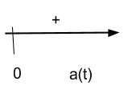can complete a sign chart for $a(t)$ as well. Setting $a(t)=0$, we find that this occurs when $t=0$. Therefore, for our sign chart, we only need to plug in a value of $t$ into $a(t)$ past $t=0$, which yields a positive result.

Comparing the sign charts for $v(t)$ and $a(t)$, we find that they have the same sign when $t>2$. Therefore, the particle is slowing down from $[0,2)$ and speeding up on $(2, ∞$).

This is a lot of information all at once! Yet there is an easy way we can display a lot of it in a single diagram- a motion diagram! The first step to drawing a motion diagram is to create a horizontal axis, which represents the position (vertical or horizontal) of the particle at a given time. Generally, it does not have to be scaled perfectly accurately, and should include position 0, as well the positions at which the velocity changes sign. Then, at the positions where velocity changes sign, or at the initial position (when $t=0$) place a dot. The dots for velocity sign changes which occur later on should be higher above the axis than dots which represent earlier sign changes. Then, next to each dot, notate the time at which that velocity sign change occurs. Finally, draw a curve between each dot. Along the line, make sure to write an arrow to notate the direction the particle is travelling; this should be towards the dot which is next chronologically. As well, when the curve reaches a dot, except for the initial position dot, the curve should become locally vertical.

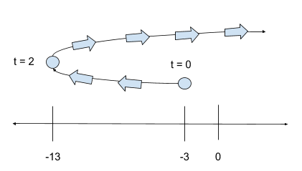 To practice, we can draw a motion diagram for the big example problem we’ve been working on. To start out, we want to draw the horizontal axis. Since we know there is a sign change for velocity at $t=2$, we will put down a marker for $-13$ on our horizontal line, as $y(2)=-13$. Then, we will also include a marker at $-3$ for the initial position, as $s(0)=-3$. And don’t forget to include a marker at 0! After that, we will place a dot above the $-3$ marker to indicate the initial position, and next to that, write $t=0$ to indicate that, indeed, this is where the particle was initially. Then, we will place a dot slightly higher, above the $-13$ marker, to represent the particle’s position at the velocity sign change when $t=2$, and notate $t=2$ next to this dot. Since the velocity is positive past $t=2$, we can draw our curve off to the right without an endpoint to indicate that the particle travels in the positive direction (in this context, up) from $(2, ∞)$, Finally, we will want to draw arrows along the curve, pointing from the $t=0$ to $t=2$ dot, and then to the right after the $t=2$ dot to indicate the particle’s motion.

## Guided Practice

1. Given that the position of a particle in meters at any time in seconds $t$ is defined by $s(t)=sin(\frac{π}{6}t)+cos(\frac{π}{6}t)$ on $0≤t≤2$, determine the acceleration at the instant when velocity is 0.
   1. To approach this problem, remember that acceleration is the derivative of velocity, which itself is the derivative of position. Therefore, we can start out by finding our functions for velocity and acceleration.
   2. Given $s(t)=sin(\frac{π}{6}t)+cos(\frac{π}{6}t)$, we know that $s'(t)=v(t)=\frac{π}{6}cos(\frac{π}{6}t)-\frac{π}{6}sin(\frac{π}{6}t)=\frac{π}{6}[cos(\frac{π}{6}t)-sin(\frac{π}{6}t)]$, due to our trigonometric derivatives and chain rule. From there, we can further derive for acceleration, finding $v'(t)=a(t)=\frac{π}{6}[-\frac{π}{6}sin(\frac{π}{6}t)-\frac{π}{6}cos(\frac{π}{6}t)]=-\frac{π^{2}}{36}[sin(\frac{π}{6}t)+cos(\frac{π}{6}t)]$.
   3. Next, we want to determine when the velocity is 0.First, we will set velocity equal to 0, yielding $0=\frac{π}{6}[cos(\frac{π}{6}t)-sin(\frac{π}{6}t)]$
 $0=cos(\frac{π}{6}t)-sin(\frac{π}{6}t)$

     1. From here, we can take a number of approaches to determine what time(s) $t$ will work- one of the easier ones to see begins by adding the sine over, effectively setting the sine and cosine equal to each other.
 $sin(\frac{π}{6}t)=cos(\frac{π}{6}t)$

     2. Then, dividing both sides by the cosine will give us a tangent which is a bit easier to see.
 $tan(\frac{π}{6}t)=1$

     3. Therefore, we must find the points at which $tan(\frac{π}{6}t)$ is 1. In general, we know that the tangent is 1 at $\frac{π}{4}$ and $\frac{5π}{4}$, and so we can set the interior term of our given tangent equal to these possible values, as we want to know when the interior term will evaluate such that the overall tangent is 1.
 $\frac{π}{6}t=\frac{π}{4}$

 $t=\frac{6}{4}=\frac{3}{2}$

 $\frac{π}{6}t=\frac{5π}{4}$

$t=\frac{30}{4}=\frac{15}{2}$

4. Almost there! We can throw out the second point, as $\frac{15}{2}$ does not fall in the given interval for the function, and all we have left to do is plug $t=\frac{3}{2}$ into the acceleration function.
 $a(\frac{3}{2})=-\frac{π^{2}}{36}[sin(\frac{π}{6}⋅\frac{3}{2})+cos(\frac{π}{6}⋅\frac{3}{2})]$

 $a(\frac{3}{2})=-\frac{π^{2}}{36}[sin(\frac{π}{4})+cos(\frac{π}{4})]$

 $a(\frac{3}{2})=-\frac{π^{2}}{36}[\frac{\sqrt{2}}{2}+\frac{\sqrt{2}}{2}]$

$a(\frac{3}{2})=-\frac{π^{2}}{36}\sqrt{2}$

5. And we have our answer! The acceleration at the instant the velocity is 0 on $[0,2]$ is $-\frac{π^{2}}{36}\sqrt{2}$ meters per second-squared.
2. Take a ball which is thrown up in the air from a height of 200 meters at a speed of 20 meters per second. What is the velocity of the ball when it hits the ground?
   1. ***Woah!*** This, like many other problems in AP Calculus, seems impossible, and indeed, even insane at first. However, there is one more crucial piece of information which the problem implies, yet does not explicitly tell us. Since it is reasonable to assume that this problem takes place on Earth (interplanetary travel has, sadly, not been mastered), we know that the acceleration due to gravity on Earth will always be -9.8 meters per second-squared, or -16 feet per second. That is, due to the mass of the planet, the acceleration of any object, such as a ball, can be defined as $a(t)=-9.8$ or $a(t)=-16$, depending on the units of the problem. In this case, we’ll use $a(t)=-9.8$.
   2. Remember, the function for acceleration is always the derivative of velocity, which is in turn the derivative for position. Therefore, knowing the function for acceleration we can antiderive in order to find the functions for velocity and position, and answer the question.
   3. The antiderivative for $a(t)$ is actually pretty simple; following the power rule as outlined above, we find that $\int{a\left(t\right)dt}=v(t)=-9.8t+C$. We can determine $+C$ from the context of this problem. It tells us that the ball was thrown up with an initial velocity of 20 meters per second; thus $v(0)=200$. Plugging this into the general form determined for v(t) will yield:
 $20=-9.8t+C$

 $C=20$

 4. Therefore, $v(t)=-9.8t+20$.
   5. Great! All that is left to find is the position function, $h(t)$. Since we know that velocity is the derivative of position, we can antiderive once again. In this instance, since $v(t)=-9.8t+20$, we know that 20 will become $20t$ according to power rule, and that $-9.8t$ comes from some $t^{2}$. For the derivative to become $-9.8t$, the initial $t^{2}$ term will have to be $\frac{1}{2}$ of $-9.8$, as we bring down a 2 with power rule, meaning that the initial term is $-4.9t^{2}$. Therefore, $h(t)=-4.9t^{2}+20t+C$.   
        
      Since we know that the initial height is 200 meters, as the ball is thrown upwards from a height of 200 meters, we can plug that in as $h(0)=200$, giving us $200=-4.9(0^{2})+20(0)+C$. Ths quickly solves so tha $C=200$.
   6. Thus, $h(t)=-4.9t^{2}+20t+200$. From here, we are asked to determine the velocity when the ball hits the ground. To determine when the ball hits the ground, all we need to do is find when $h(t)=0$.
 $h(t)=0$

 $0=-4.9t^{2}+20t+200$

    1. From here, although we *can* use the quadratic formula, it is much easier to find the x-intercepts on a graph. Doing so will show us that the height is 0 at $t=-4.666$ and $t=8.748$. We can throw out the negative time, telling us that the ball will hit the ground at 8.748 seconds.
   7. Finally, all we need to do is plug this time into the velocity function to determine the velocity when the ball hits the ground.
 $v(8.748)=-9.8(8.748)+20=-65.7304$

  8. Therefore, the ball has a velocity of $-65.7304$ meters per second when it hits the ground.

## Lola Tries

1. Given the position of a particle in meters at any time in seconds $t$, such that $t≥0$, is $s(t)={2t}^{3}-15t^{2}+36t+2$, determine the acceleration of the particle when velocity is 0.
2. Given a particle moving along the x-axis with a position of $x(t)=\frac{t}{1+t^{2}}$ where $t≥0$, where position is in meters and time $t$ is in seconds, determine the intervals upon which the particle is speeding up and slowing down.
3. Given that the position of a particle, in feet, at a time $t$, in seconds, is defined by $s(t)=t^{3}-9t^{2}+15t+10$, draw a diagram to illustrate the motion of the particle.